**THE ARCHIVAL ALCHEMIST: TRANSFORMING CAPSTONE**

**INTO DISCOVERABLE KNOWLEDGE**

A Capstone Project Presented to the Faculty of

College of Computer, Information and Communications Technology

Cebu Technological University - Main Campus

In Partial Fulfillment

Of the Requirements for the Degree

Bachelor of Science in Information Technology

By

Jeylsie A. Caro

Kyla A. Hubahib

Maria Carmel A. Tabada

David Jhonson M. Basnillo

Narcisan S. Galamiton, Ph.D.

Adviser

May 2024

# APPROVAL SHEET

The Capstone Project entitled **Archival Alchemist: Transforming Capstone Into Discoverable Knowledge** prepared and submitted by Jeylsie Caro, Kyla Hubahib, Maria Carmel Tabada and David Jhonson Basnillo has been examined and is recommended for approval and acceptance.

Recommended:

**NARCISAN S. GALAMITON, Ph.D.**

Adviser



APPROVED by the Committee on ORAL DEFENSE with a verdict of **APPROVED WITH MINOR REVISIONS** on **May 22, 2024.**

**PET ANDREW P. NACUA, MIT**

Chairman

**BELL S. CAMPANILLA, Ph. D. GERRY RITZ R. DENSING, Ph. D.**

Member Member



ACCEPTED and APPROVED in partial fulfillment of the requirements in Bachelor of Science in Information Technology.

**GERRY RITZ R. DENSING, Ph. D.**

Associate Dean, CCICT

## JOSE MARIA S. GARCIA II, Ph. D.

Dean, CCICT

# ACKNOWLEDGMENT

# 

# We extend our heartfelt gratitude to all those who contributed to the completion of this capstone project. Our deepest appreciation goes to Narcisan S. Galamiton, Ph.D. for her invaluable guidance, unwavering support, and insightful feedback throughout the entire process.

# We would also like to express our thanks to Cebu Technological University, particularly the College of Computer Information and Communications Technology (CCICT), for providing us with the resources and opportunities essential for this endeavor.

# 

# To our friends and family, your encouragement and understanding have been our pillars of strength. We are immensely grateful for your patience and belief in us.

# 

# 

# 

# 

# 

# 

# 

# 

# DEDICATION

# 

# This endeavor is dedicated to our beloved families, whose unwavering belief in our abilities has been a constant source of inspiration. Your encouragement and support have been instrumental in our journey. This achievement is as much yours as it is ours.

# 

# 

# TABLE OF CONTENTS

**Preliminaries Page**

Title page ………………………………………………………….…………...…....……….….. i

Approval Sheet …...……………………………………………….…………...…....……….….. ii

Acknowledgment ……………………….……………………………...……...……..……….... iii

Dedication ………………………………………………….………........................................... iv

Table of Contents ………………………………………………….……………..……..………. v

List of Tables ……………………………………….………….…...…………..…..………..... vii

List of Figures ………………………………………………….…….….………..……….….. ix

**CHAPTER I - Introduction**

Rationale of the Study …………………………………….……..…….….…….….….. 1

Objectives of the Study …………………………………….……….……..…………. 3

Scope of the Study…………………….…………………….…….….….….....……….. 3

Limitations of the Study ……………...………………………….………....………….. 9

Significance of the Study ………………………………….…….….…………..…….. 9

Flow of the Study …………………………………….……..…………...…………... 11

Definition of Terms …………………………………….……..………...………….... 12

**CHAPTER II - Review of Related Literature and Studies**

Related Literature ………………………………….….……..…………...…………. 13

Related Studies ……………………………………..……..…..………..…….……… 15

**CHAPTER III - Research Methodology**

Software Engineering Methodology ………….…………….…..…….……….……... 22

Business Model Canvas …………………………….…………...…………….……... 23

Program Workflow ……………………………….….…..………….….…….………. 24

Gantt Chart ………………………………….……..….……………..………….……. 29

Functional Decomposition Diagram ………………….……………..………. ……….32

Use-Case Diagram ……………………………………..……..…….………..……… 33

Storyboard …………………………………….……..….…..……….……...……..… 39

Database Design ………….. ………………………….…...…..…….……...……..… 72

Data Dictionary …………………………………….……..……………………...…. 73

Network Model …………………………………….……....………………………... 82

Network Topology ……………………………………...……………….…...……… 83

Technology Stack Diagram ……………………………...……………….…...……… 84

Software Specification ……………..………………….……...……………….….… 85

Hardware Specification ……………………..……….………….…..…..……...….… 87

Program Specification …………………………………..…..….…….………………. 88

**REFERENCES**..……………………….……….……..…………….…..…….……….…..…. 92

**CURRICULUM VITAE**..………….……………………….……..………….….……..……. 96

**APPENDICES.**……………..………………………….……..…….…...…………..………... 100

Appendix A: Capstone 1 Oath of Confirmation ……………..……....….…………. .. 100

Appendix B: Capstone Project Team Composition Form …………….……..………. 104

Appendix C: Acceptance of Capstone Adviser ……………………….………...…… 105

Appendix D: Research Working Title Form……………………………....……...….. 106

Appendix E: Capstone 1 Consultation Logs Form ………………..…….………..... 107

Appendix F: Capstone Project & Research (Proposal Sheet) ……….…………....... 110

# LIST OF TABLES

Table 1: Comparative Matrix .................................................................................................... 18

Table 2: Comparative Analysis ................................................................................................. 20

Table 3: Gantt Chart Chapter I and II ....................................................................................... 30

Table 4: Gantt Chart Chapter III ............................................................................................... 31

Table 5: Gantt Chart Capstone 2 ............................................................................................... 31

Table 6: User Table ................................................................................................................... 73

Table 7: Student Table .............................................................................................................. 73

Table 8: Faculty Table .............................................................................................................. 73

Table 9: Institution Table .......................................................................................................... 75

Table 10: University Table ....................................................................................................... 74

Table 11: University Branch Table ........................................................................................... 74

Table 12: Department Table ...................................................................................................... 74

Table 13: Course Table ............................................................................................................. 75

Table 14: Section Table ............................................................................................................. 75

Table 15: Class Table ................................................................................................................ 75

Table 16: Class Student Table ................................................................................................... 75

Table 17: Capstone Document Table ........................................................................................ 76

Table 18: Revision History Table ............................................................................................. 76

Table 19: Author Table ............................................................................................................. 76

Table 20: Tag Table .................................................................................................................. 76

Table 21: Capstone Document Tag Table ................................................................................ 77

Table 22: Saved Projects Table ................................................................................................ 77

Table 23: Subscription Plan Table ........................................................................................... 77

Table 24: Personal Subscription Table .................................................................................. 77

Table 25: Institutional Subscription Table ............................................................................ 78

Table 26: Transaction Table .................................................................................................. 78

Table 27: Subscription History Table .................................................................................... 78

Table 28: Chat Table ............................................................................................................. 78

Table 29: Document Comment Table ................................................................................... 79

Table 30: Forum Table .......................................................................................................... 79

Table 31: Post Table .............................................................................................................. 79

Table 32: Replies Table ......................................................................................................... 79

Table 33: Forum Tag Table ................................................................................................... 79

Table 34: Notification Table ................................................................................................. 80

Table 35: User Logs Table .................................................................................................... 80

Table 36: Access Control Table ............................................................................................ 80

Table 37: Feedbacks Table .................................................................................................... 80

Table 38: Reports Table ........................................................................................................ 81

Table 39: Reports Type Table ............................................................................................... 81

Table 40: Custom Content Table .......................................................................................... 81

Table 41: Software Specification for Web Development Implementation Stage ................. 85

Table 42: Software Specification for Web Development Development Stage ..................... 86

Table 43: Hardware Specification for Web Development Implementation Stage ................ 87

Table 44: Hardware Specification for Web Development Implementation Stage ................ 87

Table 45: List of Modules ..................................................................................................... 88

# 

**LIST OF FIGURES**

Figure 1: Flow of the Study ...................................................................................................... 11

Figure 2: Research Gate ........................................................................................................... 16

Figure 3: Academia .................................................................................................................. 17

Figure 4: Google Scholar ......................................................................................................... 17

Figure 5: Agile Development Methodology ............................................................................ 22

Figure 6: Archival Alchemist Business Model Canvas ........................................................... 23

Figure 7: Program Workflow for Guest ................................................................................... 24

Figure 8: Program Workflow for Institution Admin ................................................................ 25

Figure 9: Program Workflow for Student ................................................................................ 26

Figure 10: Program Workflow for Faculty................................................................................ 27

Figure 11: Program Workflow for Super Admin ..................................................................... 28

Figure 12: FDD for Web Application ...................................................................................... 32

Figure 13: UCD for Guest ....................................................................................................... 33

Figure 14: UCD for Institution admin ..................................................................................... 34

Figure 15: UCD for Student .................................................................................................... 35

Figure 16: UCD for Faculty..................................................................................................... 36

Figure 17: UCD for Super admin ............................................................................................ 37

Figure 18: Landing Page .......................................................................................................... 39

Figure 19: User Guide Page ..................................................................................................... 39

Figure 20: Privacy and Terms Page ......................................................................................... 40

Figure 21: First Step of Sign Up .............................................................................................. 40

Figure 22: Second Step of Sign Up .......................................................................................... 41

Figure 23: Third Step of Sign Up ............................................................................................ 41

Figure 24: Verification of Registered Account ........................................................................ 42

Figure 25: Sign in Page ........................................................................................................... 42

Figure 26: Forgot Password (Send Email) .............................................................................. 43

Figure 27: Forgot Password (Enter Verification Code) ........................................................... 43

Figure 28: Forgot Password (Enter New Password) ............................................................... 44

Figure 29: User Profile ............................................................................................................ 44

Figure 30: Browse Project Documents .................................................................................... 45

Figure 31: View a Project Document ...................................................................................... 45

Figure 32: Open a Project Document ...................................................................................... 46

Figure 33: Commenting a Specific Documents ....................................................................... 46

Figure 34: View Save Project Documents ............................................................................... 47

Figure 35: Forum ..................................................................................................................... 47

Figure 36: Forum (Start a discussion) ..................................................................................... 48

Figure 37: Forum (Title Suggestion) ....................................................................................... 48

Figure 38: Class (Student) ....................................................................................................... 49

Figure 39: Join Class (Student) ................................................................................................ 50

Figure 40: Upload a Capstone Project Document .................................................................... 50

Figure 41: Track Approval Status of Capstone Project Document .......................................... 50

Figure 42: View Approved Capstone Project Document ......................................................... 51

Figure 43: Class (Faculty) ........................................................................................................ 51

Figure 44: Class Members ........................................................................................................ 52

Figure 45: Class Queue ............................................................................................................ 52

Figure 46: Class Records .......................................................................................................... 53

Figure 47: Trash ........................................................................................................................ 53

Figure 48: Add New Class (Faculty) ...................................................................................... 54

Figure 49: Chat ........................................................................................................................ 54

Figure 50: Premium Subscription (Student) ............................................................................ 55

Figure 51: Premium Subscription (Faculty) ............................................................................ 55

Figure 52: Dashboard ............................................................................................................... 56

Figure 53: Users ....................................................................................................................... 56

Figure 54: Users (Add Co-admin) ........................................................................................... 57

Figure 55: Users (Admin Access Control Permission) ............................................................ 57

Figure 56: Archives .................................................................................................................. 58

Figure 57: Subscription & Billing ............................................................................................ 58

Figure 58: View User’s Subscription ........................................................................................ 59

Figure 59: View User’s Transaction History ............................................................................ 59

Figure 60: View User’s Subscription ReceiptClass Queue ...................................................... 60

Figure 61: View User’s Billing AgreementClass Queue .......................................................... 60

Figure 62: Reports & Feedbacks ............................................................................................... 61

Figure 63: Terms & Conditions ................................................................................................. 61

Figure 64: Add Terms & Conditions ......................................................................................... 62

Figure 65: Subscription Plans .................................................................................................... 62

Figure 66: Add Subscription Plans ............................................................................................ 63

Figure 67: Frequently Asked Questions .................................................................................... 63

Figure 68: Add Frequently Asked Questions ............................................................................ 64

Figure 69: Advanced ................................................................................................................. 64

Figure 70: Advanced(Add University) ...................................................................................... 65

Figure 71: Profile Setting .................................................................................................... 65

Figure 72: Students .............................................................................................................. 66

Figure 73: Faculty................................................................................................................. 66

Figure 74: Co-admins ........................................................................................................... 67

Figure 75: Departments ....................................................................................................... 67

Figure 76: Courses .............................................................................................................. 68

Figure 77: Archives ............................................................................................................. 68

Figure 78: Subscription and Billings ................................................................................... 69

Figure 79: Institutional Subscription Plan ........................................................................... 69

Figure 80: Institutional Subscription ................................................................................... 70

Figure 81: Subscription Payment (Institutional) ................................................................. 70

Figure 82: Subscription Inquiry ........................................................................................... 71

Figure 83: Give Feedback ................................................................................................... 71

**CHAPTER I**

**INTRODUCTION**

## Rationale of the Study

The estimate from UNESCO suggests that approximately 2.2 million new titles are added to the global shelves each year, contributing to the cumulative number of printed books available worldwide. This does not include e-books, audiobooks nor books without an ISBN, which includes many self-published books (Homer 2022). Using statistical methods, (Giles and Khabsa 2024) estimated that at least 114 million English-language scholarly documents are accessible on the Web. As of 2022, over 5.14 million academic articles are published per year, including short surveys, reviews, and conference proceedings (Curcic 2023). The COVID-19 pandemic has disrupted the traditional operations of academic libraries worldwide, including those in the Philippines. It is estimated that over 28 million Filipino students across all academic levels were affected by the transition to remote online learning adopted in early 2020. Of these, 3.5 million students from 2,400 higher education institutions (HEI) are from the tertiary level (Jeremiah et al., 2020). However, it has also accelerated the adoption of digital libraries and online resources as institutions adapt to remote learning and research. Traditional textbooks can be inconvenient (Lawver 2024). The National Library of the Philippines' initiatives to enhance its services and facilities amidst the pandemic, and the increasing significance and potential of digital libraries in preserving cultural heritage and enabling remote access to information resources ([Hani](https://opengovasia.com/author/aineena-hani/) 2021).

However, with numerous fields of study and courses, students may find it daunting to locate materials directly relevant to their academic pursuits. Additionally, traditional books, including capstone project documents, may not always be easily accessible or available for reference. In some cases, these materials might be stored in cabinets or restricted access areas, limiting their utility for future students. This lack of accessibility can hinder the ability of students to access valuable resources and may necessitate alternative methods of research and learning. According to (Garnham 2024), “Researchers face many challenges. The research process itself can be time-consuming and complex, and the storage, organization, and seamless sharing of that research can be even trickier. Without one organized source of truth, research can be left in silos, making it incomplete, redundant, and useless when it comes to gaining actionable insights.”

To bridge the gap between traditional academic practices and the demands of the digital era, a university-centric initiative known as The Archival Alchemist: Transforming Capstone Into Discoverable Knowledge project has been initiated. It endeavors to develop systems aimed at enhancing both the discoverability and preservation of students' capstone project documents related to the IT industry and emerging technology innovation. It is a web-based system platform dedicated to safeguarding and sharing students' capstone documents online. In today's digital age, many student capstone documents exist as soft copies stored on drives or within various software but often remain undiscovered and inaccessible.

The research endeavors to tackle pressing challenges within the management and execution of capstone projects in academic settings. One such challenge is the fragmented nature of project management, where projects are dispersed across multiple platforms, leading to inefficiencies. Additionally, the absence of a centralized platform hampers collaboration among students, impeding the exchange of ideas and cooperative learning opportunities. Thus, there is a critical need to establish a unified space where students can interact, share insights, and engage in meaningful discussions to enrich their academic journey. Another significant hurdle faced by students is the complexity of selecting a suitable capstone project topic that aligns with their interests, skills, and available resources. This challenge underscores the necessity for guidance in navigating the intricate process of narrowing down broad areas of study into specific and viable research questions. In response, the study proposes the implementation of The Archival Alchemist: Transforming Capstone Into Discoverable Knowledge web-based system. Aligned with the Connect, Collaborate, and Simplify (CCS) strategy, meticulously developed to address the identified issues, this project aims to revolutionize capstone project management. The Connect aspect involves establishing a centralized hub for seamless submission, review, and sharing of academic contributions, thereby eliminating fragmented projects and preserving capstone projects to make them discoverable for future use. Collaborate focuses on creating a centralized space for collaboration and enabling idea exchange within the academic community. Lastly, Simplify aims to provide guided support for students in navigating the complex process of topic selection, empowering them to make informed decisions aligned with their interests and resources. By addressing these challenges, the proposed project aims to enhance the overall learning experience of students, aligning with academic institutions' goals and discipline-specific requirements to foster a more efficient and collaborative environment for capstone projects.

## Objectives of the study

The primary objective of this study is to develop a comprehensive capstone repository system tailored specifically for universities in Cebu that offer capstone courses. This overarching goal includes the following specific objectives:

1. Create an accessible platform: Develop a user-friendly platform that students from various campuses can easily access.
2. Create a centralized repository: Improve the overall capstone project experience for students by providing a centralized repository for showcasing and preserving their academic achievements such as capstone manuscripts for all to explore.
3. Facilitate collaboration and knowledge exchange: Promote collaboration and knowledge exchange among students and faculty across different universities, enabling a wider dissemination of ideas, and innovations in capstone manuscript projects.

**Scope of the Study**

## The scope of this project centers on developing a web application tailored for students and faculty across all universities in Cebu, and other people interested in technological research. This platform aims to address several key areas: streamlining administrative processes, fostering collaboration on projects, and showcasing academic achievements. Capstone manuscript projects help students apply what they've learned in a practical way, so a well-organized repository is crucial for their success. Defining the scope of this study is essential to keep the development process focused and efficient.

## This section outlines the specific aspects of the capstone manuscript repository system that will be addressed, including the features, target users, and operational parameters.

Specifically, the study aims to:

1. Develop a user-friendly web application for guests with the following features:

1.1. Search or browse capstone manuscript

1.2. Search or browse posts

1.3. View the system tour and policies

1.4. Register account

2. Develop a user-friendly web application for institution admin with the following features:

2.1. Manage my account

2.1.1. Register account

2.1.2. Verify account

2.1.3. Password recovery

2.1.4. Login account

2.2. Manage profile

2.2.1. Edit profile

2.3. Manage archives under their institution

2.3.1. Search or browse capstone manuscript

2.3.2. Control capstone manuscript visibility

2.3.3. Download capstone manuscript

2.4. Manage members account

2.4.1. Search or browse members

2.4.2. Add member

2.4.3. Activate or deactivate premium access of members

2.4.4. Add co-admin

2.4.5. Upload csv file list of members

2.5. Manage department and course

2.5.1. Edit or delete department and course

2.6. Manage Transaction History

2.6.1. View agreement

2.6.2. View / download receipt

2.7. Manage Notifications

2.7.1. View/clear notifications

2.8. Manage Subscription Plan

2.8.1. Access the free plan

2.8.2. Upgrade to premium

2.8.3. Cancel subscription

2.8.4. Renew subscription

2.8.5. Inquire about subscription

2.8.6. Update payment method

2.8.7. Update payment

2.8.8. View transaction history

2.8.9. View agreement

2.8.10. View/ download receipt

2.9. Contact technical support

2.10. Give system feedback

3. Develop a user-friendly web application for faculty with the following features:

3.1. Manage my account

3.1.1. Register account

3.1.2. Verify account

3.1.3. Password recovery

3.1.4. Login account

3.2. Manage Profile

3.2.1. Edit Profile

3.3. Manage manuscript projects

3.3.1. Search or browse manuscript

3.3.2. Download manuscript

3.3.3. Cite manuscript

3.3.4. Comment on manuscript

3.3.5. Save manuscript

3.3.6. Rate manuscript

3.4 Manage Class

3.4.1. Create Class

3.4.2. Add student

3.4.3. View Projects Queue

3.4.4. Approved or decline manuscript

3.4.5. Give feedback

3.4.6. View records

3.4.7. Download csv file for grading

3.4.8. View members

3.5. Manage chats

3.5.1. Send or receive messages

3.6. Manage notifications

3.6.1. View or clear notifications

3.7. Engage in Forums

3.7.1. Search and browse posts

3.7.2. Post and modify questions or replies

3.7.3. Report Posts

3.7.4. Visit posters profile

3.8. Manage Subscription Plan

3.8.1. Access the free plan

3.8.2. Upgrade to premium

3.8.3. Cancel subscription

3.8.4. Renew subscription

3.8.5. Update payment method

3.8.6. Process payment

3.8.7. View transaction history

3.8.8. View agreement

3.8.9. View/ download receipt

3.8.10. Join school affiliation

3.9. Contact technical support

3.10. Give system feedback

4. Develop a user-friendly web application for students with the following features:

4.1. Manage my account

4.1.1. Register account

4.1.2. Verify account

4.1.3. Password recovery

4.1.4. Login account

4.2. Manage Profile

4.2.1. Edit Profile

4.3. Manage manuscript projects

4.3.1. Search or browse manuscript

4.3.2. Download manuscript

4.3.3. Cite manuscript

4.3.4. Comment on manuscript

4.3.5. Save manuscript

4.3.6. Rate manuscript

4.4 Manage Class

4.4.1. Join class

4.4.2. Upload manuscript

4.4.3. Track manuscript

4.4.4. View feedback

4.4.5. Revise manuscript

4.4.6. View approved manuscript

4.5. Manage chats

4.5.1. Send or receive messages

4.6. Manage notifications

4.6.1. View notifications or clear notifications

4.7. Engage in Forums

4.7.1. View and browse posts

4.7.2. Post questions or replies

4.7.3. Edit or delete post and replies

4.7.4. Report Posts

4.7.5. Visit posters profile

4.8. Manage Subscription Plan

4.8.1. Access the free plan

4.8.2. Upgrade to premium

4.8.3. Cancel subscription

4.8.4. Renew subscription

4.8.5. Update payment method

4.8.6. Process payment

4.8.7. View transaction history

4.8.8. View agreement

4.8.9. View/ download receipt

4.8.10. Join school affiliation

4.9. Contact technical support

4.10. Give system feedback

5. Develop a user-friendly web application for super admin with the following features:

5.1. Managing Account

5.1.1. Login account

5.1.2. Verify account

5.1.3. Password recovery

5.2. Manage profile

5.2.1. Edit profile

5.3. Manage archives across all universities

5.3.1. Search or browse capstone manuscript

5.3.2. Download capstone manuscript

5.4. Manage users

5.4.1. View, search or filter users

5.4.2. Activate users

5.4.3. Deactivate users

5.4.4. Add co-super admin

5.4.5. Control user access

5.5. Manage subscription sales

5.5.1. View personal subscription

5.5.2. View institutional subscription

5.5.3. View transaction history

5.5.4. View agreement

5.5.5. View or download receipt

5.5.6. Update payment

5.6. Manage notifications

5.6.1. View and clear notifications

5.7. Managed dynamic content

5.7.1. Add or modify tags

5.7.2. Add or modify dropdowns

5.7.3. Add or modify personalize message

5.7.4. Add or modify subscription plans

5.7.5. Add or modify FAQ’s and Terms

5.7.6. Restrict forum’s posts and comments

5.8. Manage user reports and feedbacks

5.8.1. Review reports

5.8.2. Send warning to a reported user

5.8.3. Review feedbacks

5.9. View system generated reports

By accomplishing these objectives, the capstone archival system will play a pivotal role in creating a dynamic and collaborative academic environment, ensuring that students' efforts and insights are acknowledged and contribute to the university's continuous growth and excellence.

## Limitations of the Study

The limitations of this study have been refined to provide clarifications on the scope's boundaries and to maintain a clear and directed focus:

Only the people and universities that availed of the services of Archival Alchemist could fully experience the features of the platform.

This study is limited to capstone projects. Other academic requirements, such as thesis and dissertations, are not included within the functionalities of this system.

Only enrolled students can upload project documents.

Only accessible online.

## Significance of the Study

This study addresses a hidden gem problem: valuable student research. Traditionally, capstone manuscript projects are buried in archives, unseen and unused. So, what is our solution? A centralized online platform. This makes student research instantly available to anyone with internet access, anywhere.

This study is conducted to benefit the following:

**Students:** The study is a valuable guide and reference for students conducting similar research projects. By providing insights and methodologies relevant to their academic pursuits, it enables students to better navigate their studies and reduce the time spent manually looking for relevant information.

**Faculty:** For educators, this research provides an opportunity to assess the impact of the Archival Alchemist platform on student learning and engagement.

**Institution:** Preserving and showcasing the academic achievements of institutions can be instrumental in highlighting the excellence of both students and the quality of the institution's capstone programs. This approach can serve as a powerful tool for attracting new students and faculty, as it demonstrates a commitment to academic excellence and innovation.

**Future Researchers:** Documenting the implementation and impact of the Archival Alchemist platform provides valuable insights that future researchers can use to guide their studies.

However, it is not only about finding research. The Archival Alchemist engages students. They can talk about their work, get feedback, and even collaborate with researchers from other institutions. Students benefit by gaining wider recognition for their research, which may lead to future opportunities. They can share their work with a larger audience, gain valuable feedback, and improve their communication skills. The platform promotes collaboration with students and researchers from other institutions, resulting in new research ideas and perspectives.

The academic community benefits from having open access to an array of student research, which enhances their work and teaching practices. The platform promotes an active and collaborative research culture in the academic community. Overall, the Archival Alchemist maximizes the potential of student research. It empowers students and improves academic discourse.

## 

## Flow of the Study

The flow diagram below depicts the system's inputs and outputs, as well as the processes that occur in between.

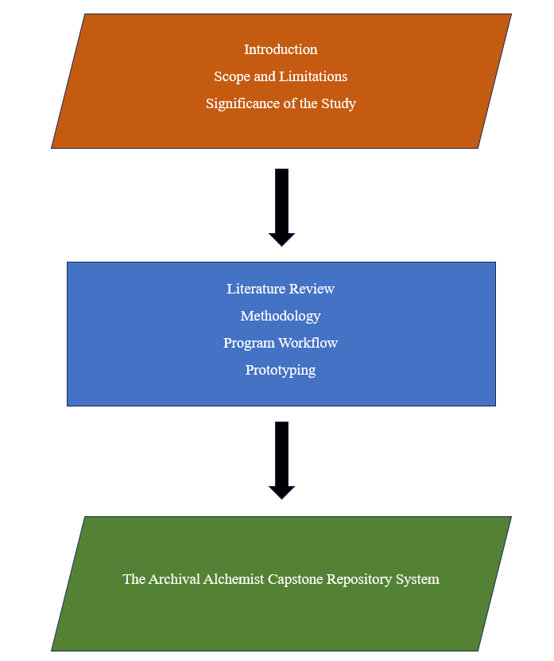

Figure 1: **Flow of the Study**

## Definition of Terms

To ensure a clear understanding, this section defines key terms in the context of this study:

**Archival Alchemist :** an alchemist is someone who has historically aimed to transform elements into gold. Here, the archive system acts like the alchemist, but instead of physical elements, it "transforms" capstone projects.

**Capstone Projects :** a culminating project undertaken by courses with a capstone program related to information technology, typically in their third year second semester of study, that demonstrates their knowledge and skills acquired throughout their program.

**Collaboration :** working together to achieve a common goal.

**Collaborate :** establish a centralized collaboration space, facilitating idea exchange and networking opportunities within the academic community.

**Complexity :** the difficulty students encounter in selecting a capstone project topic that fits their interests, skills, and available resources.

**Connect :** represents a centralized hub for seamless submission, review, sharing and unifying the academic contributions of students and eliminates fragmented projects.

**Discoverable Knowledge :** The capstones contain valuable knowledge and research. By archiving them effectively, the system makes this knowledge "discoverable" to future researchers, students, and anyone interested in the information.

**Faculty :** a faculty member who supervises and guides students during their capstone project development.

**Fragmented :** scattered or unconnected pieces of information.

**Institution admin :** they are the identified head of the university, responsible for managing departments, courses, institutional subscriptions and members.

**Repository :** a central location where information is stored, organized, and accessed.

**Simplify :** provide guided support for students in navigating complex topic selection processes, empowering them to make informed decisions aligned with their interests and resources.

**The Archival Alchemist: Transforming Capstone into Discoverable Knowledge** - It is a web-based system that serves as a central hub for students specifically for colleges in Cebu with courses related to computer and information technology where students and other researchers can share, explore, and preserve capstone projects.

**Web application :** a type of app that can be accessed through a web browser.

# 

# CHAPTER II

**REVIEW OF RELATED LITERATURE AND STUDIES**

The development and implementation of digital platforms to enhance academic endeavors, particularly within higher education institutions, have garnered significant attention in contemporary literature. This section reviews existing literature related to the utilization of technology in educational settings to connect students and other researchers, the management of capstone projects, and the creation of collaborative environments to facilitate knowledge exchange among students and other researchers.

**Related Literature**

Numerous studies have highlighted the transformative impact of technology on learning processes in higher education. The COVID-19 pandemic has spurred innovation and digital transformation in Philippine academic libraries (Ana Maria B. Fresnido and Sharon Maria S. Esposo-Betan 2022). Bughin et al (2018) and (A Haleem, 2022) underscore the importance of embracing technological advancements to meet the diverse needs of learners and to promote innovative pedagogical approaches. (A Haleem, 2022) particularly emphasizes the role of technology in facilitating knowledge dissemination and collaboration among students and educators, stating that “Technology allows us new ways of interacting, building knowledge, assessing students in real-time and preparing students for life in an increasingly digital world. " Existing research emphasizes the significance of digital skills in the contemporary economy, and projections indicate a growing importance in the foreseeable future. Scholars suggest that while the demand for physical and manual labor may decline, the need for technological skills is expected to surpass other competencies (Bughin et al., 2018)."

The management of capstone projects within academic institutions has been a subject of scholarly inquiry. Literature by Stouffs, et.al (2022), Jeffery, D. (2010), and Iwasokun, et.al (2021) explores various challenges associated with project management, including fragmented projects, limited collaboration opportunities, and complex topic selection procedures. These authors advocate for developing streamlined systems and collaborative platforms to enhance the efficiency and effectiveness of project management, thereby maximizing students' learning outcomes and academic achievements. Vast academic resources are scattered online which makes it a bit challenging for students to retrieve projects that would meet their academic requirements. According to Jeffery, D. (2010), “The web is not a centralized store of data, if we want to use online applications then the metaphor of a catch-all project folder is largely irrelevant because our content is fragmented based on which application it was created in”. However, this fragmentation poses challenges, especially in academic settings. Thus, there is a need to establish a repository tailored specifically for universities, a university-centric repository exclusive for capstone documents. Such a repository would enable students to reference projects from their predecessors easily. The university-centric approach ensures alignment with the academic institution, facilitating students in creating their project documents. “Colleges and universities need to design impactful student-centric solutions that respond to the lifelong employability requirements of a student and the demands of a changing educational landscape” Jeffery, D. (2010). According to Clifford Lynch1, "a university-based institutional repository is a set of services that a university offers to the members of its community for the management and dissemination of digital materials created by the institution and its community members. It is most essentially an organizational commitment to the stewardship of these digital materials, including long-term preservation where appropriate, as well as organization and access or distribution." According to the findings of Iwasokun, et.al (2021), “establishing an institutional repository will increase access to digital material, managed, organized, archived, and disseminated institutional data [13-17]. Most institutions in developing countries have established institutional repositories to enhance the visibility and impacts of research generated within the institution [18-20]. An institutional repository is an electronic system that captures, preserves, and provides digital work product access [21]. It collects, manages, and disseminates material produced at an institution [22] and maximizes the institutions' intellectual outputs [23].”

Creating collaborative environments to facilitate knowledge exchange and cooperative learning among students is a central theme in educational research. Authors such as Jianzhong Xu, et.al (2015), SASÍN, J. (2023) and Chapman, C., et.al (2005) emphasize the importance of collaborative learning in promoting deeper understanding, critical thinking, and knowledge construction among students. Nevgi, A., et.al (2006), Okon, R., et.al (2020) particularly advocate for the integration of technology to support collaborative learning processes. Additionally, according to the findings of Jianzhong Xu, et.al (2015), feedback, help-seeking, online group work interest, and affective attitude relate positively to group work management, Yi Jia (2005) even stated that “collaborative learning at Web-based environment may give as good results as classroom learning or even better”.

Web-based systems designed to streamline academic management processes have been increasingly adopted by educational institutions worldwide. Studies by Stouffs, et.al (2022), Hoorens, et al. (2024), Iwasokun, et.al (2021), and Nuestro (2023) explore the development and implementation of web-based platforms for various academic purposes. These authors highlight the potential of web-based systems to enhance administrative efficiency, improve communication channels, and provide students with seamless access to academic resources.

Research examining the impact of digital platforms on student engagement and learning outcomes has yielded valuable insights into the efficacy of technology-enhanced learning environments. Authors such as D'Angelo, C. (2018) and Sappaile, B. I. et al. (2023) investigate the relationship between technology use and student engagement, learning outcomes, and academic performance. Their findings suggest that well-designed digital platforms, when integrated effectively into educational practices, can positively influence student engagement, motivation, and learning outcomes.

## Related Studies

This section presents related studies identified through a comprehensive review of existing systems. This review considered both theoretical frameworks and practical applications, resulting in the selection of key studies presented here. These are the following studies:



Figure 2: **https://www.researchgate.net/**

**ResearchGate**

ResearchGate is a social networking platform founded in 2008 by a team of three; Ijad Madisch, Sören Hofmaye, and Horst Fickenscher. It was created to address the problems of how scientific research was created and shared. The developers of this platform wanted to offer a place where researchers can share their valuable research and access more than 250 million publication pages, connect with the scientific community around the globe where members can follow and directly message other researchers who collaborate on projects and ask technical questions, support others with answers, and discuss research. ResearchGate is an investor-funded startup that enables them to expand their network and has garnered over 20+ million users. Unlike any other platform, ResearchGate focuses on helping the researchers first above their profits so anyone who has a research interest can freely use the full features they offer. Being a free-of-charge platform, they developed marketing and recruitment services as a way to maintain a sustainable business while prioritizing the needs of the researchers (O’Brien K., 2019).

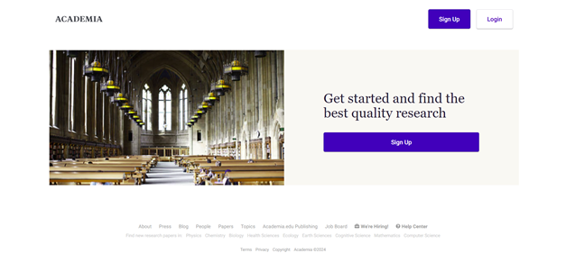

­Figure 3: **https://www.academia.edu/**

**Academia**

Academia is a social networking platform for academics created in 2008 with over 257+ million registered users. The founder of Academia.edu, Richard Price, had the idea of wanting to create a website where he could share his profile, the things he’s been working on, and share the research papers he created. This led him to the idea of creating a one-click way of creating a profile and sharing their papers without writing their own html code. Together with his fellow graduate students, Academia was founded. The main goal of their platform is to speed up research in every field. Academia also aims to ensure that every paper uploaded to the platform is accessible for free, to build the fastest and most relevant paper distribution, to provide signals regarding the trustworthiness of the research papers, and to enable the sharing of knowledge. Academia has a “Freemium” business model where everyone can access the platform freely and a paid version to subscribers so that they can access the full features of the platform. They garnered 260+ thousand premium subscribers.

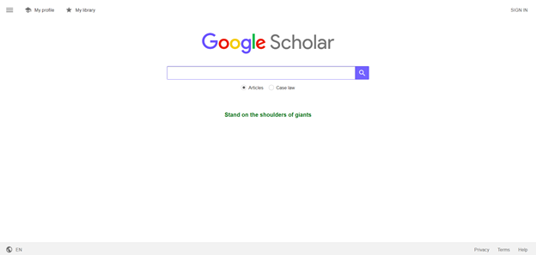

Figure 4: **https://scholar.google.com/**

**Google Scholar**

Google Scholar is a free-to-use search engine created in November 2004 by two Google engineers, namely Alex Verstak and Anurag Acharya. Through this platform, users can search for academic resources and literature such as thesis, journals, articles, books, etc. from various sources across the internet like academic publishers, professional societies, online repositories, universities, and other websites. Using Google Scholar, any user can search all scholarly literature from one convenient place, they can explore related works, citations, authors, and publications, easily locate the complete document, and it has an advanced search filter where you can organize the search based on the year, author, category etc. Although Google Scholar is free to use, not all resources in full text provided by the platform are available. Since Google Scholar provides all the resources based on the keywords, narrowing it down through filtering is limited.

## Comparative Matrix

A comparative matrix is a tool used to visualize and compare different features of the study and other existing related systems by calculating the percentage according to the number of features covered by competitors. It is often used in business and marketing to understand a company’s position within the market. The matrix helps to organize and classify the elements being compared, highlighting similarities and differences.

Table 1: **Comparative Matrix Specific Features**

|  | Features | Academia | Google Scholar | ResearchGate | Archival Alchemist |  |
| --- | --- | --- | --- | --- | --- | --- |
| 1 | Web Support | ✔ | ✔ | ✔ | ✔ | 100% |
| 2 | Online Registration | ✔ | ✔ | ✔ | ✔ | 100% |
| 3 | Comprehensive catalog |  |  |  | ✔ | 25% |
| 4 | Download capstone manuscripts | ✔ | ✔ | ✔ | ✔ | 100% |
| 5 | Public commenting |  |  | ✔ | ✔ | 50% |
| 6 | Capstone Title Suggestion |  |  |  | ✔ | 25% |
| 7 | Access manuscripts online | ✔ | ✔ | ✔ | ✔ | 100% |
| 8 | Private Messaging | ✔ |  | ✔ | ✔ | 75% |
| 9 | Forum |  |  | ✔ | ✔ | 50% |
| 10 | Subscription (Freemium) | ✔ |  |  | ✔ | 50% |
| 11 | Uploading capstone manuscripts | ✔ |  | ✔ | ✔ | 75% |
| 12 | Manuscript review and approval |  |  |  | ✔ | 25% |
| 13 | Search filter | ✔ | ✔ | ✔ | ✔ | 100% |
| 14 | Notification | ✔ |  | ✔ | ✔ | 75% |
| 15 | Rating capstone manuscripts |  |  |  | ✔ | 25% |
| 16 | Collaboration | ✔ |  | ✔ | ✔ | 75% |
|  |  | 63% | 31% | 69% | 100% |  |

## 

## Comparative Analysis

A comparative analysis is a side-by-side comparison that systematically compares two or more things to pinpoint their similarities and differences which is relevant to the development process. This evaluates the features, limitations, platform details and monetization scheme of various alternatives to inform decision-making and guide to the development of the system.

Table 2: **Comparative Analysis**

| Platforms | Academia | Google Scholar | ResearchGate | Archival Alchemist |
| --- | --- | --- | --- | --- |
| Features | - Connect with researchers  - Create academic profile and showcase researches  - Upload academic papers  - Analytics and Metrics | - Search academic literatures across the internet  - Track literature and citations | - Connect with researchers  - Showcase researches and expertise  - Upload academic papers  - Analytics and Metrics | - Connect and collaborate with other student and faculty  - Showcase capstone manuscript  - Upload capstone manuscript  - Comprehensive manuscript review process |
| Limitations | - Copyright Issues  - Needs to subscribe to unlock full features of the platform  - Depends on peer review for document quality control  - Broad range of academic papers | - Limited social features  - Limited full- text access  - Broad range of academic papers | -Copyright Issues  - Depends on peer review for document quality control  - Broad range of academic papers | - Needs to subscribe to unlock full features of the platform  - Platform is specifically for universities, faculty and students with capstone programs  - Available only within Cebu |
| Platform Details | An online web-based platform that is accessible in any web browser | An online web-based platform that is accessible in any web browser | An online web-based platform that is accessible in any web browser | An online web-based platform that is accessible in any web browser |
| Monetization Scheme | Freemium Model | Advertisements | Advertisements | Freemium Model |
| Platform Link | https://www.academia.edu/ | https://scholar.google.com/ | https://www.researchgate.net/ |  |
| Launched Year | 2008 | 2004 | 2008 |  |

# CHAPTER III

# RESEARCH METHODOLOGY

## Software Engineering Methodology

Software development methodology is a process or a way of managing a software development project. It is a methodology that helps structure, plan, and manage the software development process. The methodology typically breaks down into several steps and stages, such as requirements gathering, prototyping, design, coding, testing, deployment, and maintenance. Each step is designed to ensure the software works correctly and meets the end user’s needs. Some common software development methodologies include agile, waterfall, lean, and prototype model. In this chapter, the researchers must choose an appropriate software methodology to further help the development process of the system. The proposed system is a web-based capstone archiving system for collaboration and for preserving the completed capstone projects, showcasing the skills and talents of the students. Therefore, the researchers implement the Agile methodology.

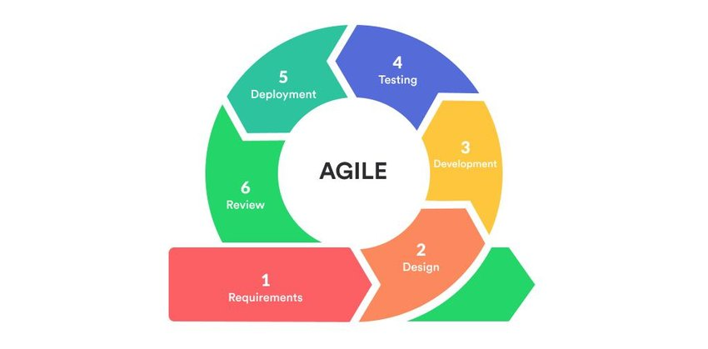

Figure 5: **Agile Development Methodology**

The agile development methodology is well-suited for the system because of its flexibility, iterative development approach, and customer feedback. Since agile methodology is an iterative development, the researchers will be able to gather feedback from students, faculty, and other users and then use the gathered data to improve the system. As user feedback and collaboration are often incorporated throughout the Agile development process, this will greatly help the researchers to gather opinions from the user and modify the features based on the needs of the users. The flexibility of Agile development will also allow the researchers to adapt to the adjustments of the functionalities in the system as the project progresses. Thus, improving the overall quality of the project.

## 

## 

## Planning Phase

## 

### Business Model Canvas

The Business Model Canvas serves as a valuable tool for businesses to gain a comprehensive overview of their operations in a single glance. This enables the business to pinpoint areas requiring improvements and formulate strategic actions for future growth.

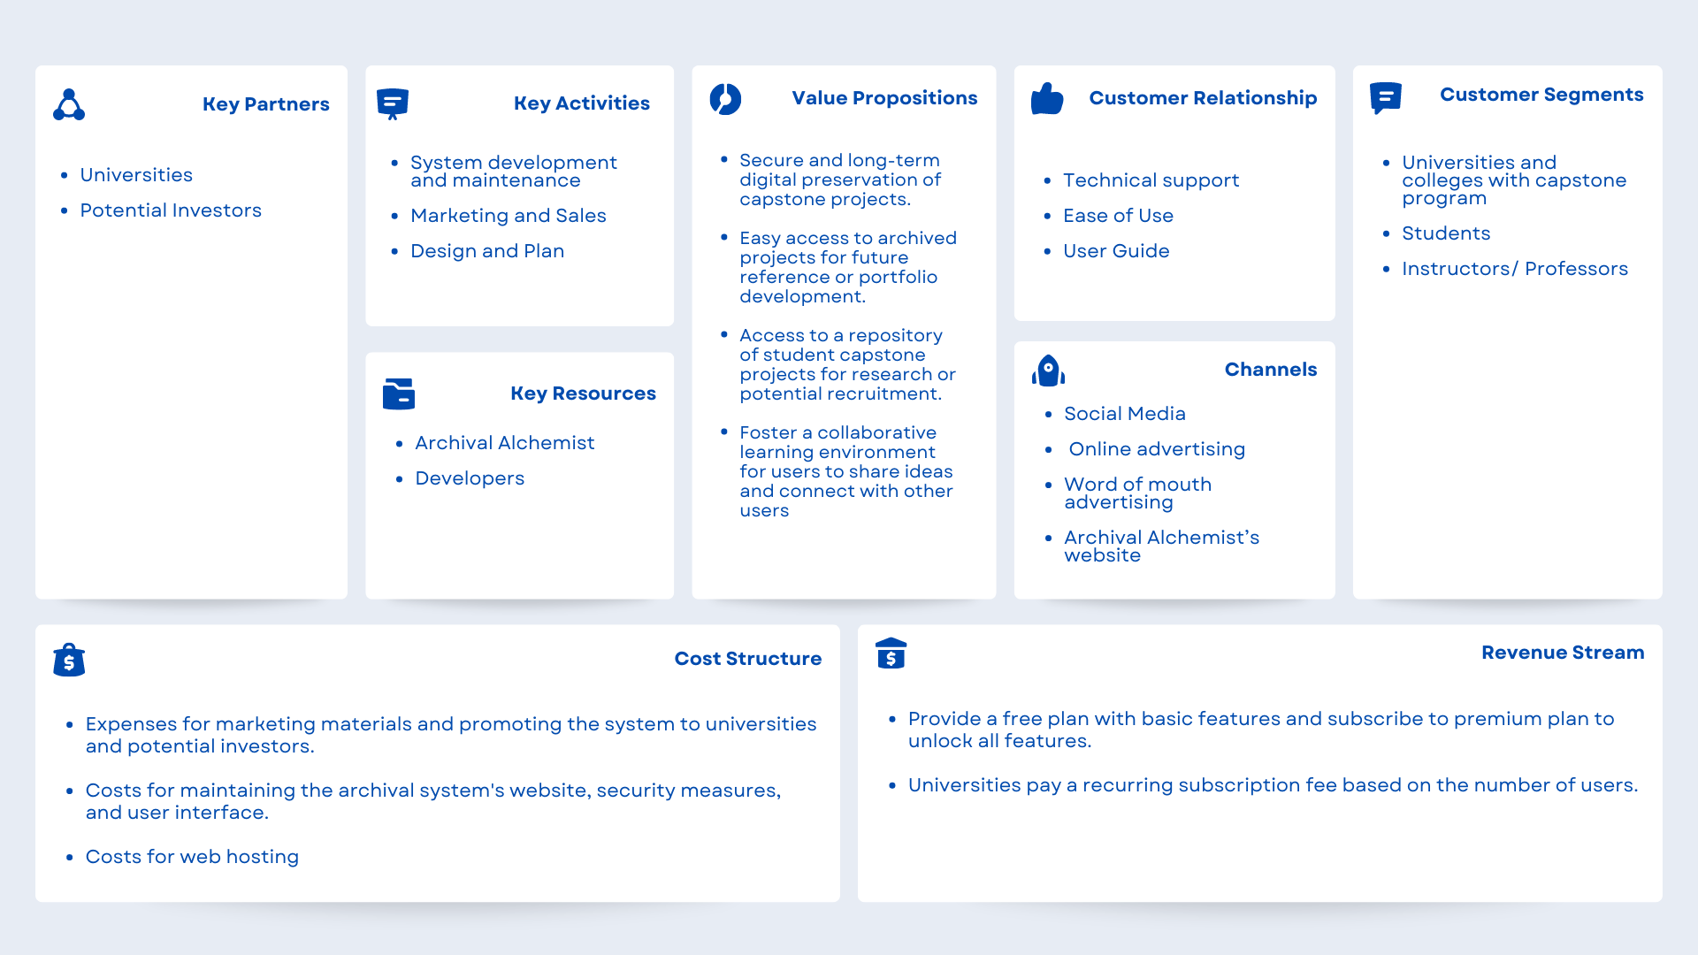

Figure 6: **Archival Alchemist Business Model Canvas**

## Program Workflow

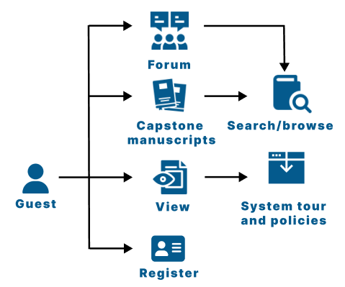

Figure 7: **Program Workflow for Guest**

Figure 7 illustrates the program workflow for guests. They only have limited access to the system, such as viewing menu pages, searching or browsing manuscripts, and registering an account.

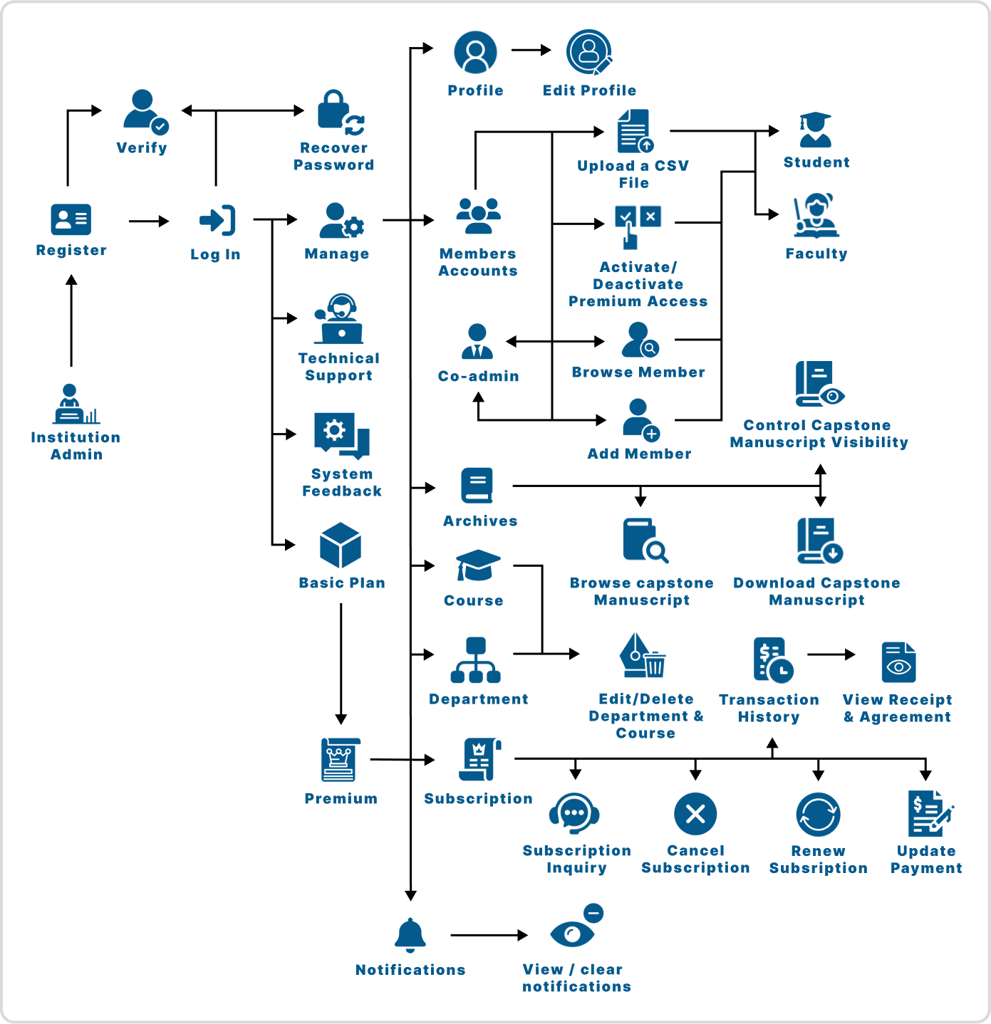

Figure 8: **Program Workflow for Institution Admin**

Figure 8 illustrates the program workflow for institution admins. Just like the super admins, they also manage user accounts but their role simply focuses on managing institution subscriptions.

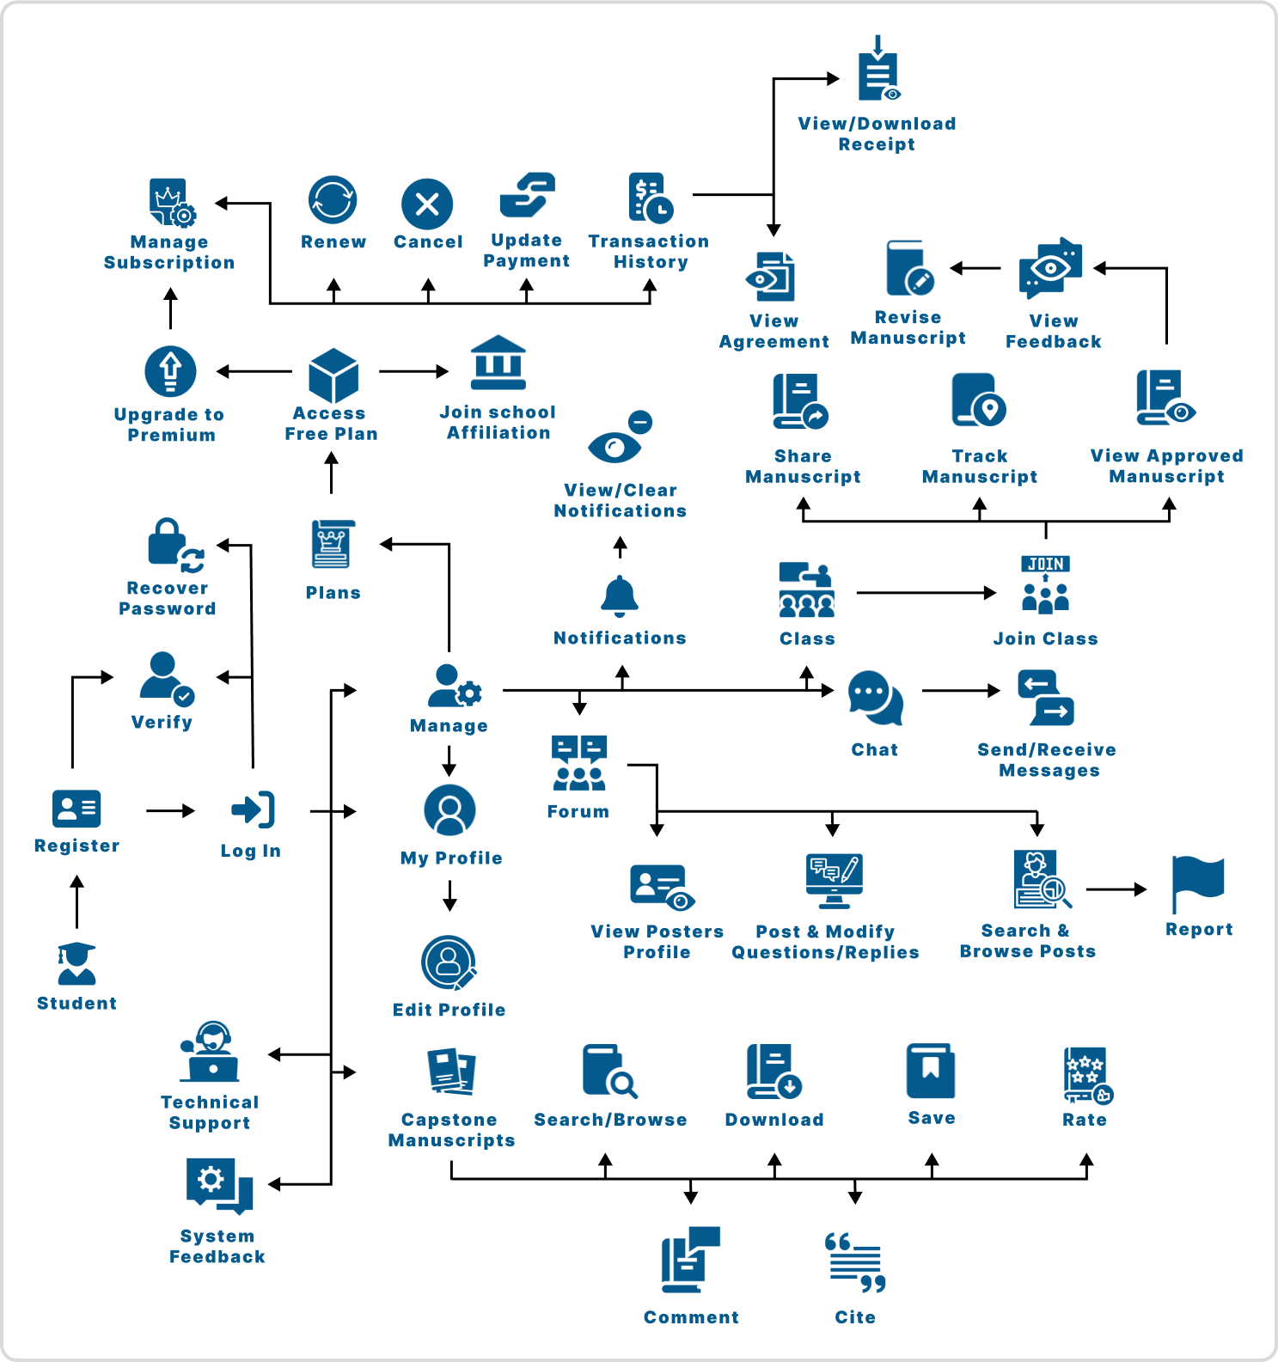

Figure 9: **Program Workflow for Student**

Figure 9 illustrates the program workflow for students. They can engage in various activities, including creating an account, managing their profile, handling capstone projects, bookmarking favorites, engaging in interactive activities like chat and rating, and participating in forums to connect with others.

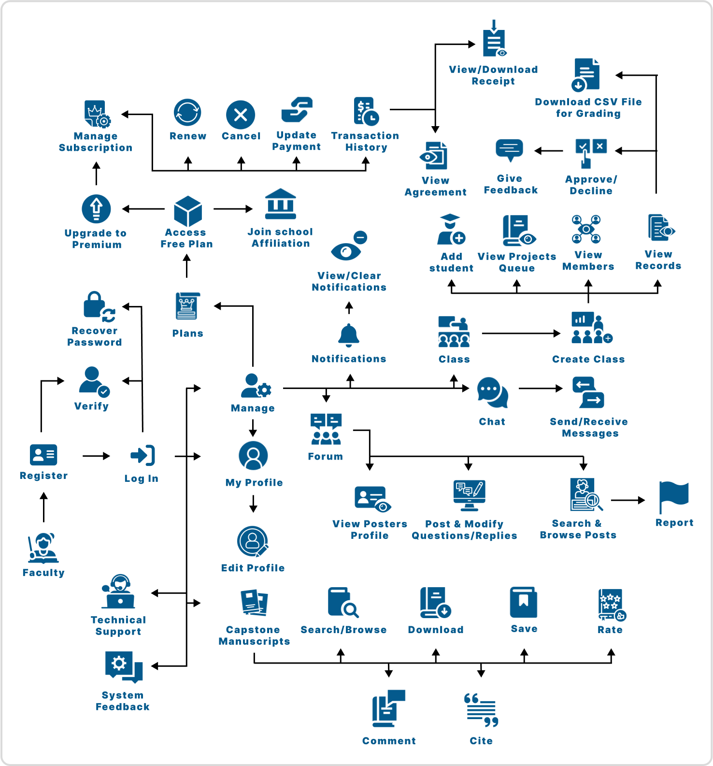

Figure 10: **Program Workflow for Faculty**

Figure 10 illustrates the program workflow for faculty. They oversee various tasks, such as managing their class, approving or declining capstone projects submitted by each student in a class, and providing feedback afterward. Additionally, faculty can engage in activities like save favorites, engage in interactive activities like chat and rating, and participate in forums to connect with others.

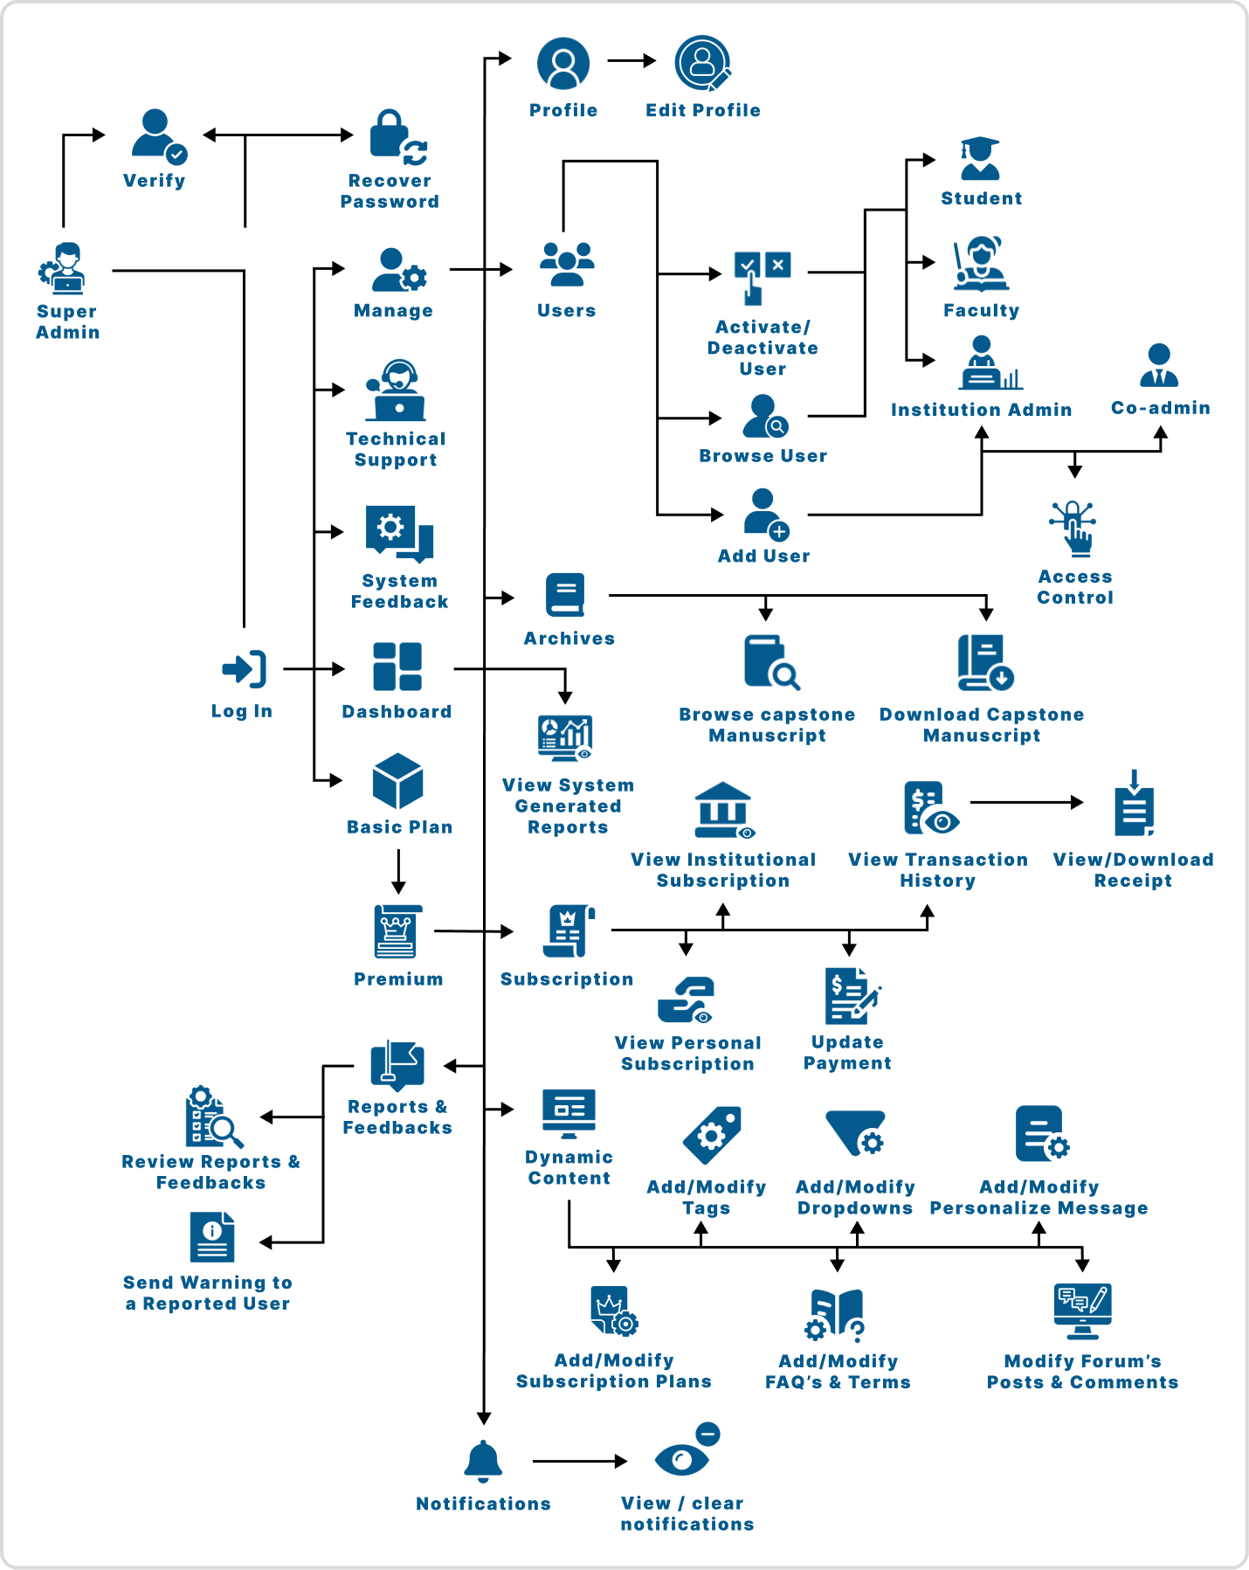

Figure 11: **Program Workflow for Super Admin**

Figure 11 illustrates the program workflow for super admins. They oversee various administrative tasks, including managing user accounts, monitoring platform functionality, addressing user inquiries, intervening when necessary, and customizing the user interface.

**Gantt Chart**





| **Capstone 1** | | | | | **March** | | | **April** | | | | | **May** | | |
| --- | --- | --- | --- | --- | --- | --- | --- | --- | --- | --- | --- | --- | --- | --- | --- |
| **Task**  **#** | **Task Name** | **Task**  **Leader** | **Start**  **Date** | **End**  **Date** |  |  |  |  |  |  |  |  |  |  |  |
| **Chapter 1** | | | | |  | | |  | | | | |  | | |
| 1 | Rationale of the Study | Hustler | March 12 | March 14 |  |  |  |  |  |  |  |  |  |  |  |
| 2 | Objectives of the Study | Hustler | March 12 | March 14 |  |  |  |  |  |  |  |  |  |  |  |
| 3 | Scope and Limitation | Hustler | March 12 | March 14 |  |  |  |  |  |  |  |  |  |  |  |
| 4 | Significance of the Study | Hipster | March 12 | March 14 |  |  |  |  |  |  |  |  |  |  |  |
| 5 | Flow of the Study | Hipster | March 12 | March 14 |  |  |  |  |  |  |  |  |  |  |  |
| 6 | Definition of Terms | Hacker | March 12 | March 14 |  |  |  |  |  |  |  |  |  |  |  |
| **Chapter 2** | | | | |  | | |  | | | | |  | | |
| 7 | Related Literature | Hustler | March 25 | April 5 |  |  |  |  |  |  |  |  |  |  |  |
| 8 | Comparative matrix | Hacker | March 25 | April 5 |  |  |  |  |  |  |  |  |  |  |  |

Table 3: **Gantt Chart Chapter I and II**

| **Chapter 3** | | | | |  | | |  | | | | |  | | |
| --- | --- | --- | --- | --- | --- | --- | --- | --- | --- | --- | --- | --- | --- | --- | --- |
| 9 | Software Engineering Methodology | Hacker | April 8 | April 12 |  |  |  |  |  |  |  |  |  |  |  |
| 10 | Business Model Canvas | Hacker | April 8 | April 12 |  |  |  |  |  |  |  |  |  |  |  |
| 11 | Program Workflow | Hipster | April 25 | May 16 |  |  |  |  |  |  |  |  |  |  |  |
| 12 | Gantt Chart | Hipster | April 25 | May 17 |  |  |  |  |  |  |  |  |  |  |  |
| 13 | FDD | Hipster | April 25 | May 16 |  |  |  |  |  |  |  |  |  |  |  |
| 14 | Use Case Diagram | Hustler | April 22 | May 16 |  |  |  |  |  |  |  |  |  |  |  |
| 15 | Storyboard | Hustler | March 25 | May  17 |  |  |  |  |  |  |  |  |  |  |  |
| 16 | Database Design | Hipster | April 17 | May 16 |  |  |  |  |  |  |  |  |  |  |  |
| 17 | Data Dictionary | Hacker | April 25 | May 16 |  |  |  |  |  |  |  |  |  |  |  |
| 18 | Network Model | Hipster | April 25 | May 7 |  |  |  |  |  |  |  |  |  |  |  |
| 19 | Network Topology | Hipster | April 25 | May 7 |  |  |  |  |  |  |  |  |  |  |  |
| 20 | Technology Stack Diagram | Hipster | April 25 | April 30 |  |  |  |  |  |  |  |  |  |  |  |
| 21 | Software Specification | Hacker | April 24 | April 24 |  |  |  |  |  |  |  |  |  |  |  |
| 22 | Hardware Specification | Hacker | April 23 | April 23 |  |  |  |  |  |  |  |  |  |  |  |
| 23 | Program Specification | Hustler | April 25 | April 30 |  |  |  |  |  |  |  |  |  |  |  |
| 24 | References | Hustler | April 25 | April 26 |  |  |  |  |  |  |  |  |  |  |  |
| 25 | Curriculum Vitae | Hustler | May  17 | May 17 |  |  |  |  |  |  |  |  |  |  |  |
| 26 | Appendices | Hustler | May  17 | May 17 |  |  |  |  |  |  |  |  |  |  |  |

Table 4: **Gantt Chart Chapter III**

| Capstone 2 | | | | | | | | | | | | | | | | | | | | | | | | | | | | | | | | |
| --- | --- | --- | --- | --- | --- | --- | --- | --- | --- | --- | --- | --- | --- | --- | --- | --- | --- | --- | --- | --- | --- | --- | --- | --- | --- | --- | --- | --- | --- | --- | --- | --- |
| **Task Name** | | | | | June | | | | July | | | | August | | | | September | | | | October | | | | November | | | | December | | | |
| 1 | 2 | 3 | 4 | 1 | 2 | 3 | 4 | 1 | 2 | 3 | 4 | 1 | 2 | 3 | 4 | 1 | 2 | 3 | 4 | 1 | 2 | 3 | 4 | 1 | 2 | 3 | 4 |
| Preparation and  Planning | | | | |  |  |  |  |  |  |  |  |  |  |  |  |  |  |  |  |  |  |  |  |  |  |  |  |  |  |  |  |
|  |  |  |  |  |  |  |  |  |  |  |  |  |  |  |  |  |  |  |  |  |  |  |  |  |  |  |  |
| Implementation of Database | | | | |  |  |  |  |  |  |  |  |  |  |  |  |  |  |  |  |  |  |  |  |  |  |  |  |  |  |  |  |
|  |  |  |  |  |  |  |  |  |  |  |  |  |  |  |  |  |  |  |  |  |  |  |  |  |  |  |  |
| Designing the Interface | | | | |  |  |  |  |  |  |  |  |  |  |  |  |  |  |  |  |  |  |  |  |  |  |  |  |  |  |  |  |
|  |  |  |  |  |  |  |  |  |  |  |  |  |  |  |  |  |  |  |  |  |  |  |  |  |  |  |  |
| Programming | | | | |  |  |  |  |  |  |  |  |  |  |  |  |  |  |  |  |  |  |  |  |  |  |  |  |  |  |  |  |
|  |  |  |  |  |  |  |  |  |  |  |  |  |  |  |  |  |  |  |  |  |  |  |  |  |  |  |  |
| Beta Testing | | | | |  |  |  |  |  |  |  |  |  |  |  |  |  |  |  |  |  |  |  |  |  |  |  |  |  |  |  |  |
|  |  |  |  |  |  |  |  |  |  |  |  |  |  |  |  |  |  |  |  |  |  |  |  |  |  |  |  |
| Finalizing Programs | | | | |  |  |  |  |  |  |  |  |  |  |  |  |  |  |  |  |  |  |  |  |  |  |  |  |  |  |  |  |
|  |  |  |  |  |  |  |  |  |  |  |  |  |  |  |  |  |  |  |  |  |  |  |  |  |  |  |  |
| Revising Chapters | | | | |  |  |  |  |  |  |  |  |  |  |  |  |  |  |  |  |  |  |  |  |  |  |  |  |  |  |  |  |
|  |  |  |  |  |  |  |  |  |  |  |  |  |  |  |  |  |  |  |  |  |  |  |  |  |  |  |  |

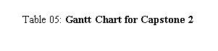

## Functional Decomposition Diagram

**Web**

Figure 13 illustrates the functional decomposition diagram of the proposed system within the application. It displays the various tasks users can perform within the application. For example, the sky blue color indicates what the administrator could do, from managing user accounts to overseeing operations.

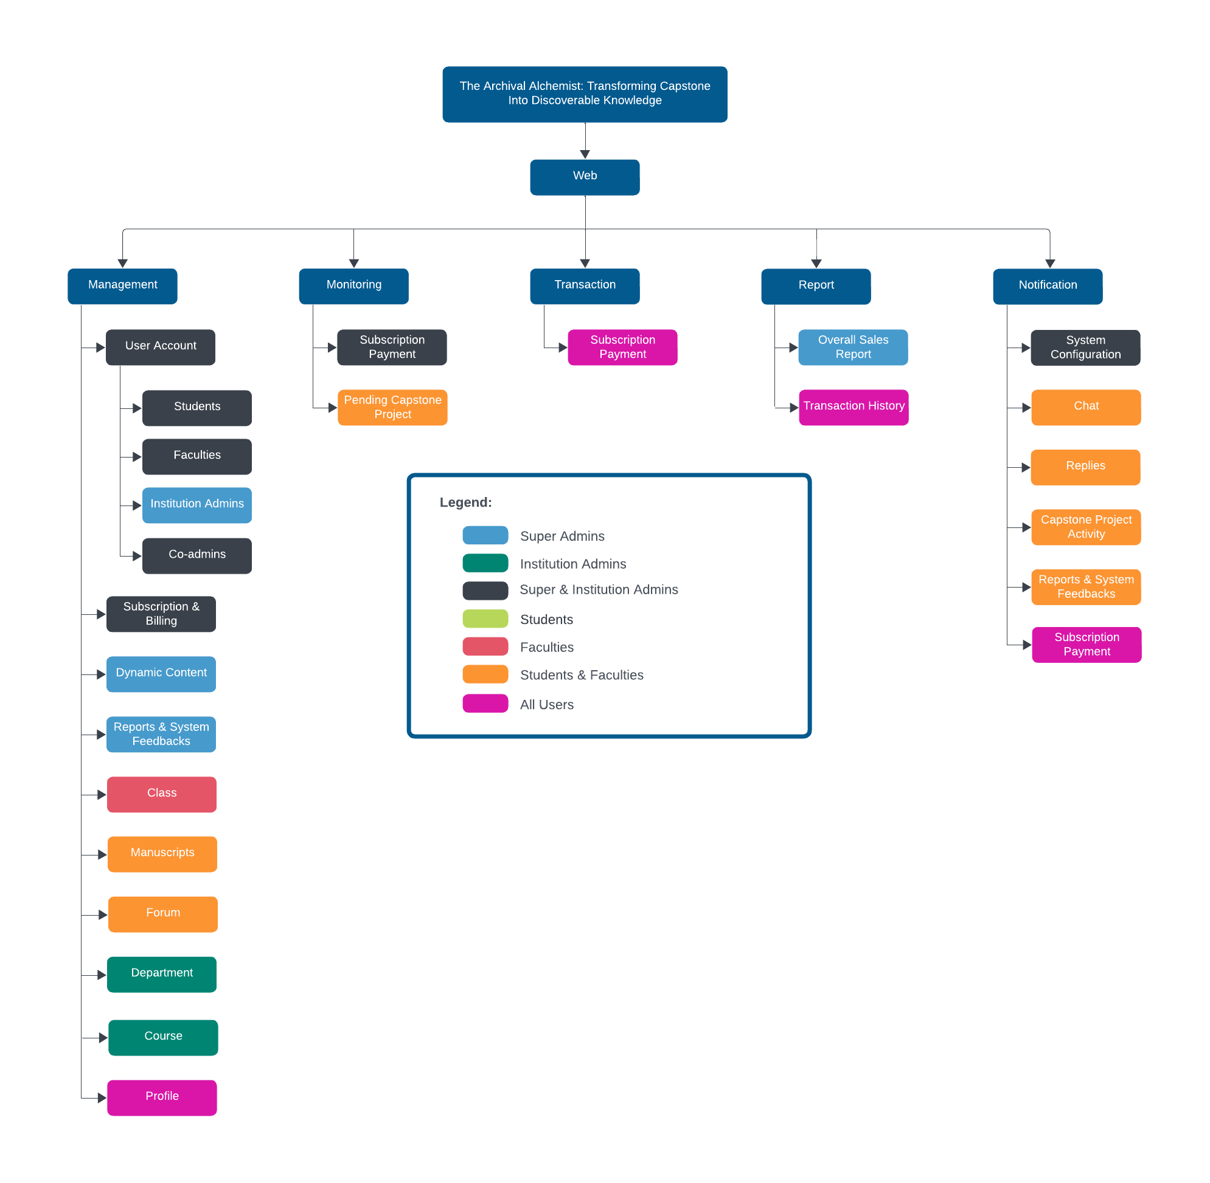

Figure 12: **FDD for Web Application**

## Analysis Phase

### Use-Case Diagram

**The Archival Alchemist**

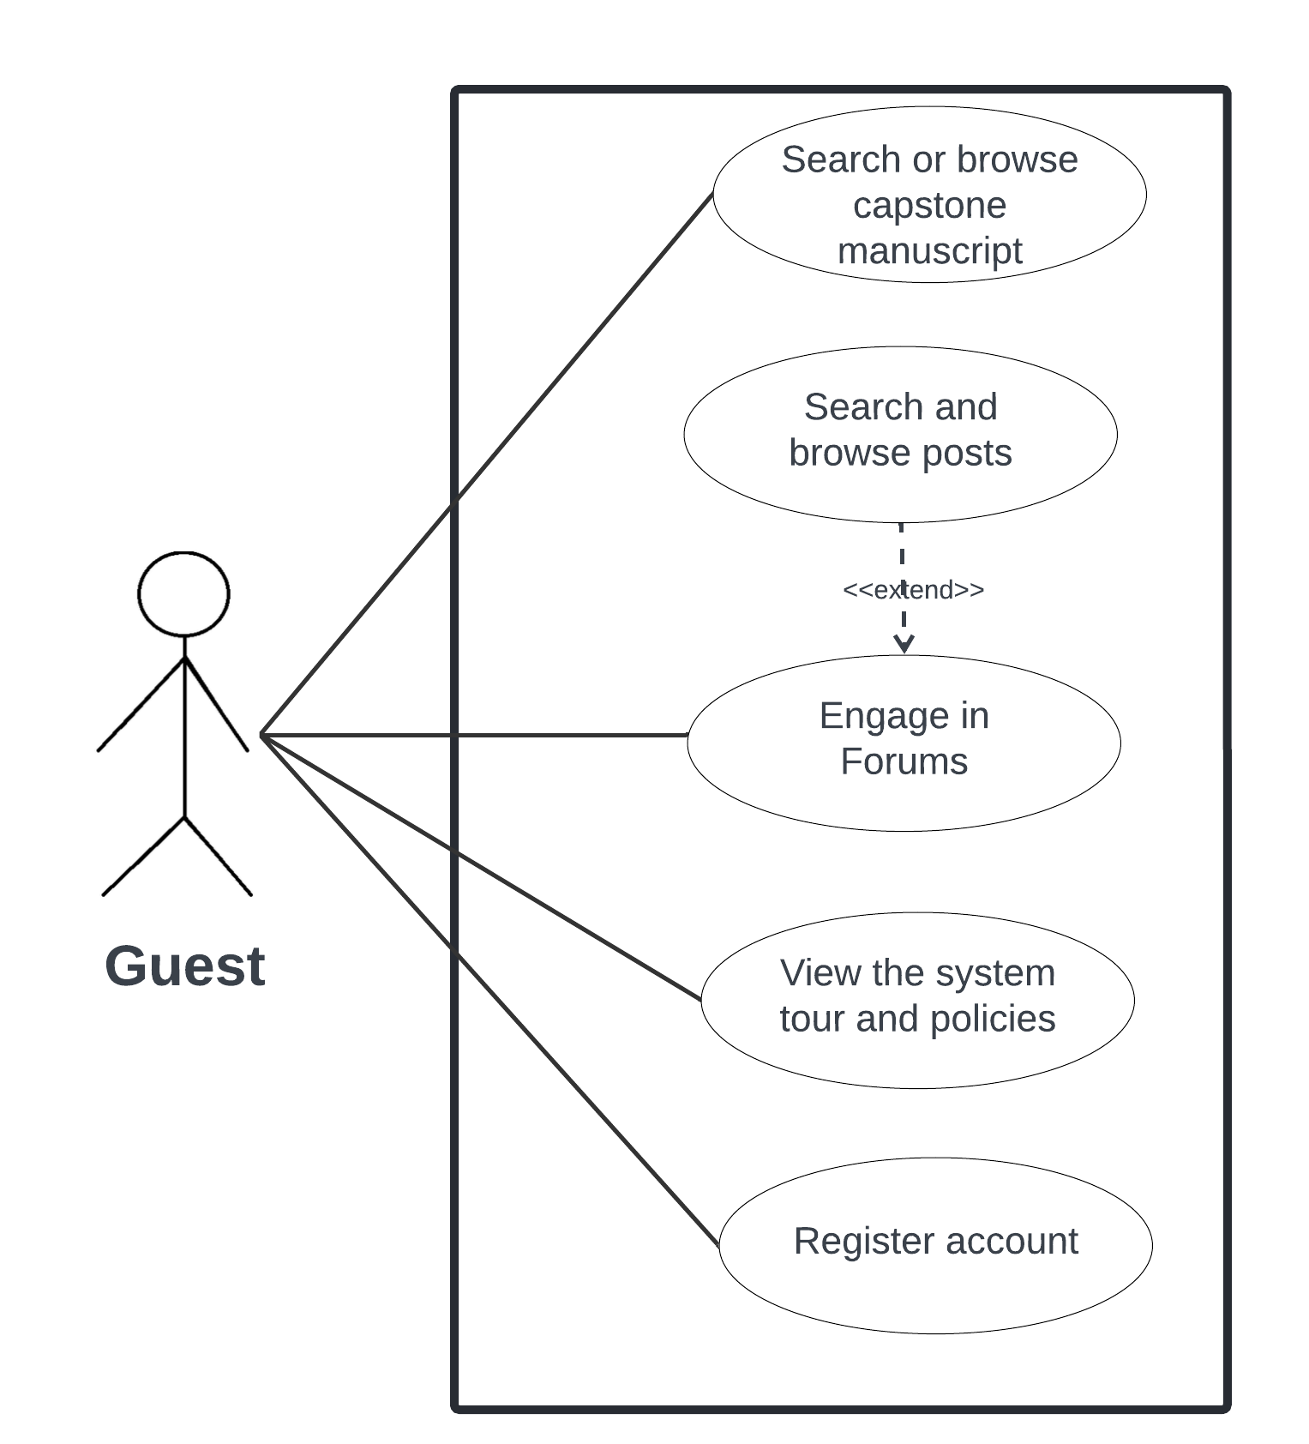Figure 13: **UCD for Guest**

In the use case diagram for guests, they can search and browse capstone manuscripts and posts in forums, view system tours and policies and register an account.

**The Archival Alchemist**

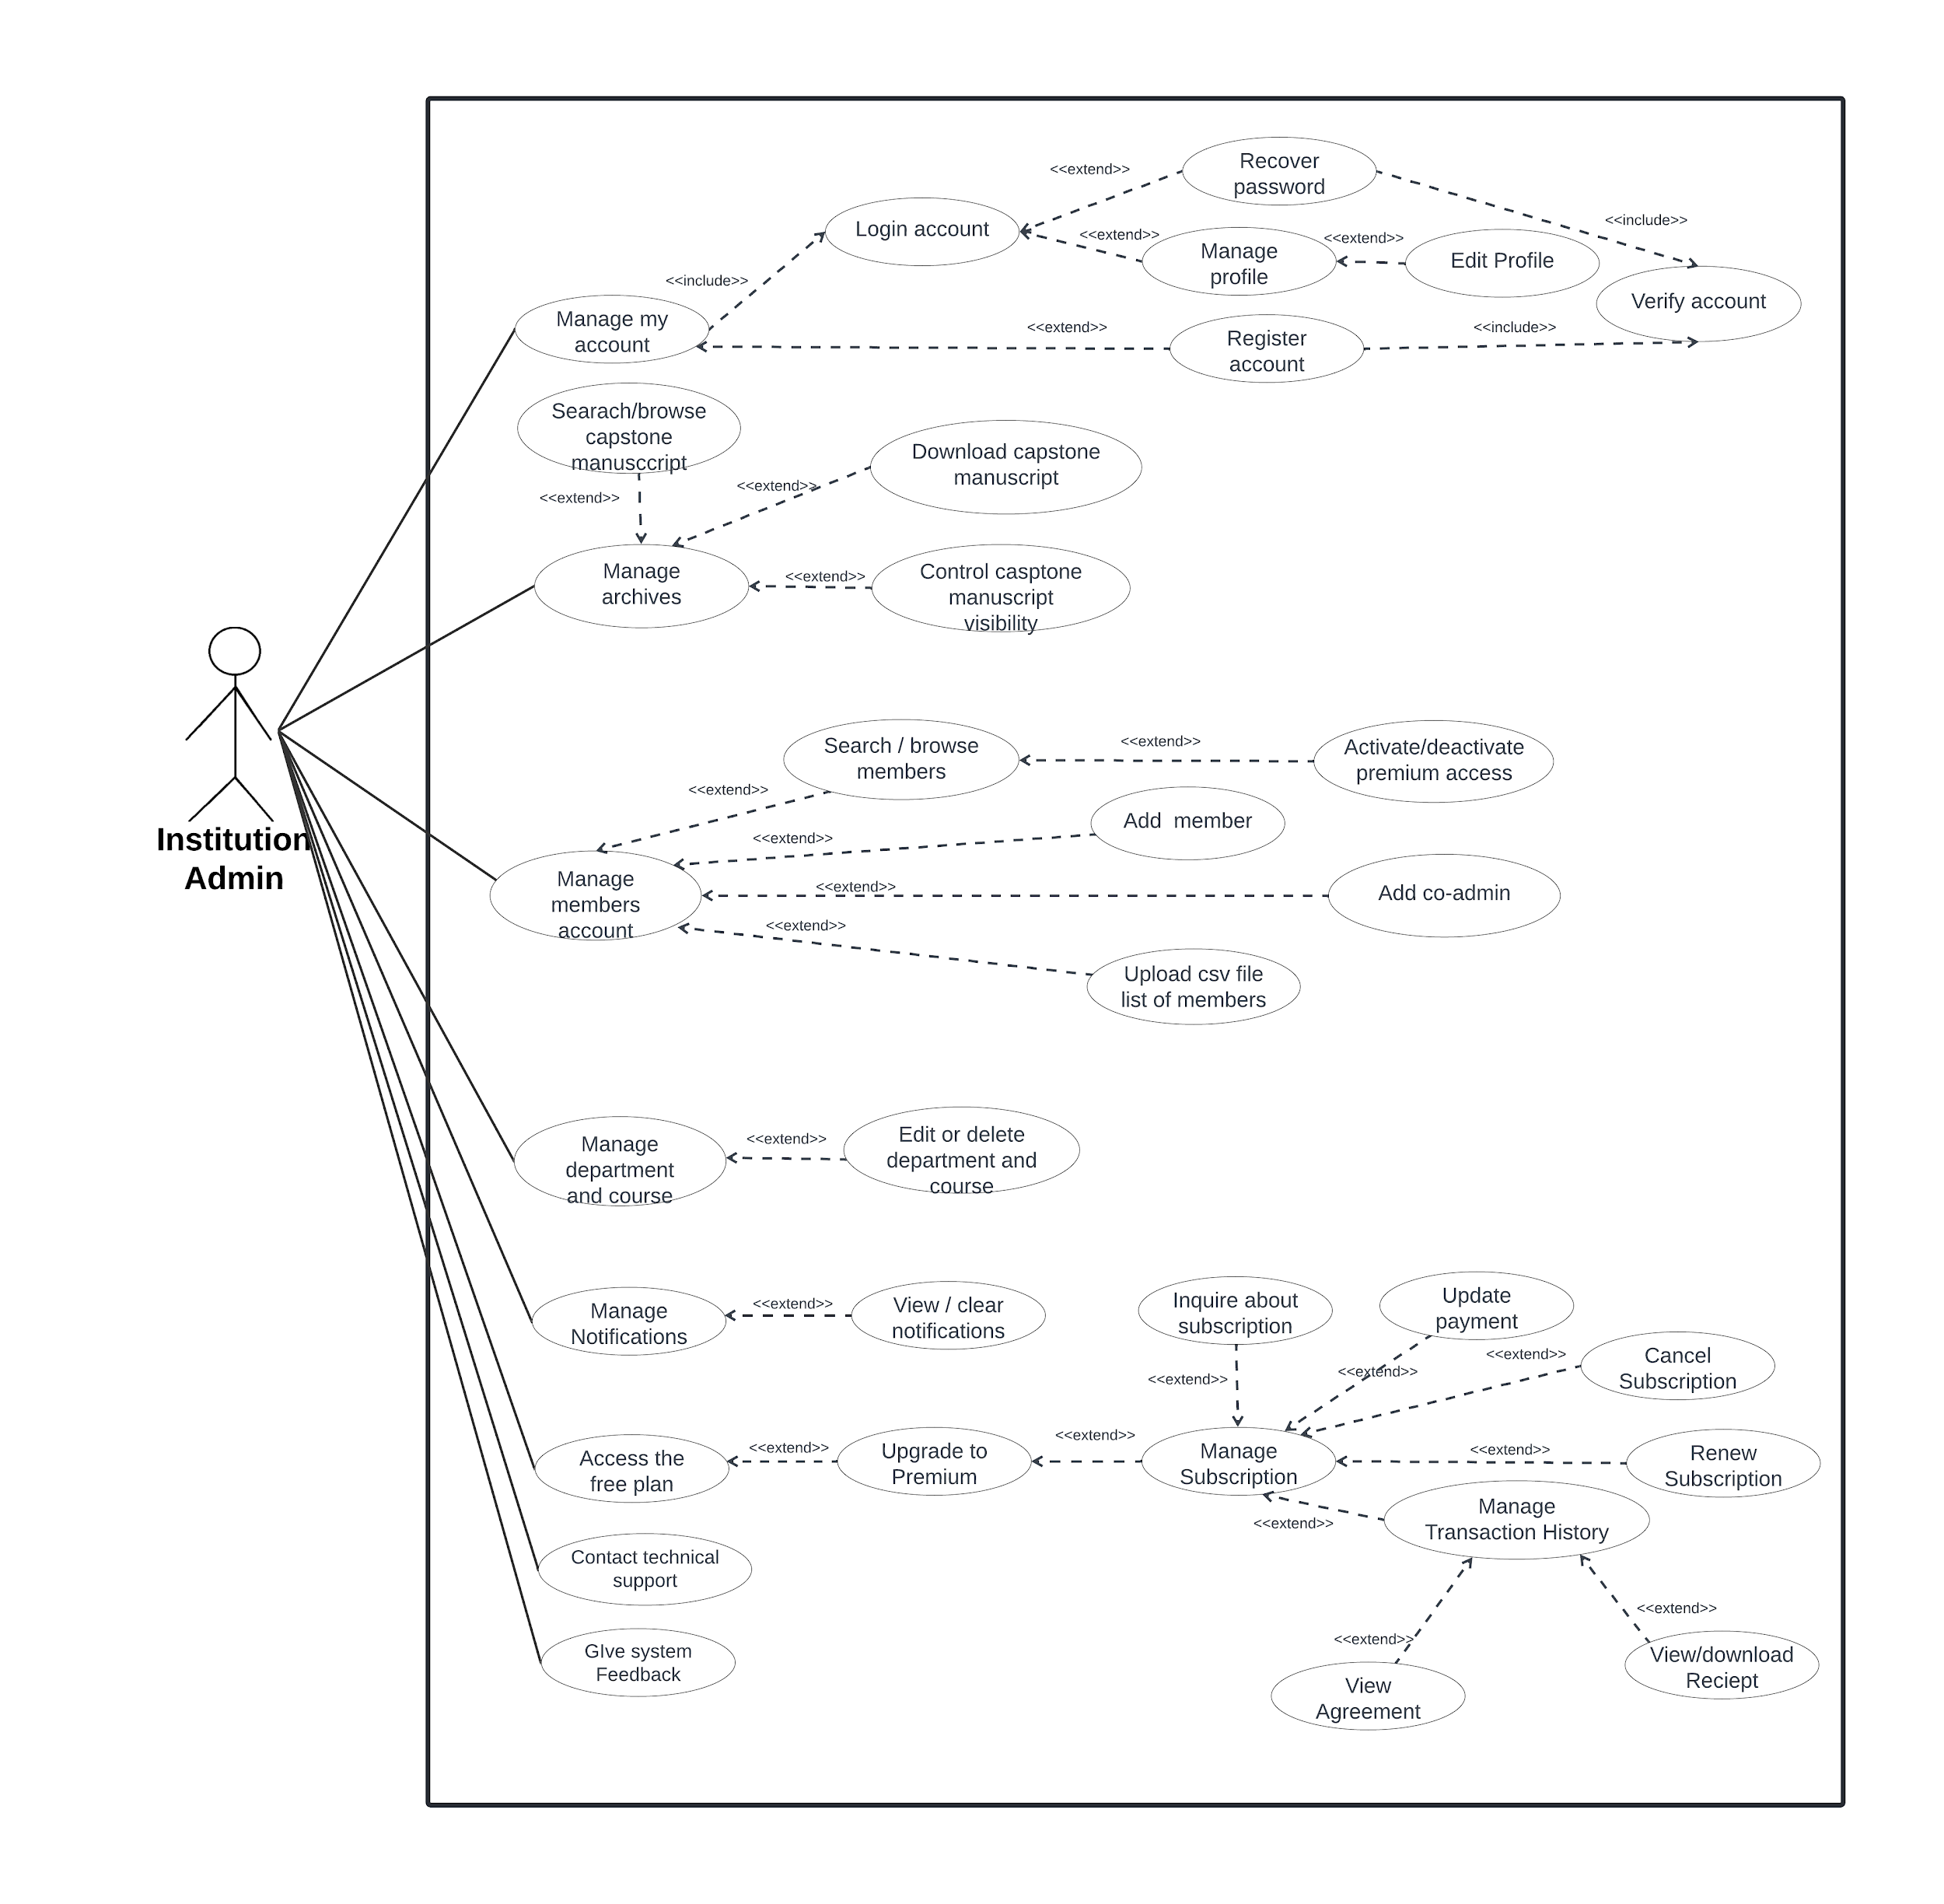

Figure 14: **UCD for Institution admin**

In the use case diagram for institution admin, their options mostly revolve around management of the institution. Institution admins possess fewer functionalities than super admins that cater to their unique roles. Specifically, they can manage users under their institution, manage institutional subscriptions, manage departments and courses, manage users' premium access within their institution, manage capstone manuscript, and notifications.

**The Archival Alchemist**

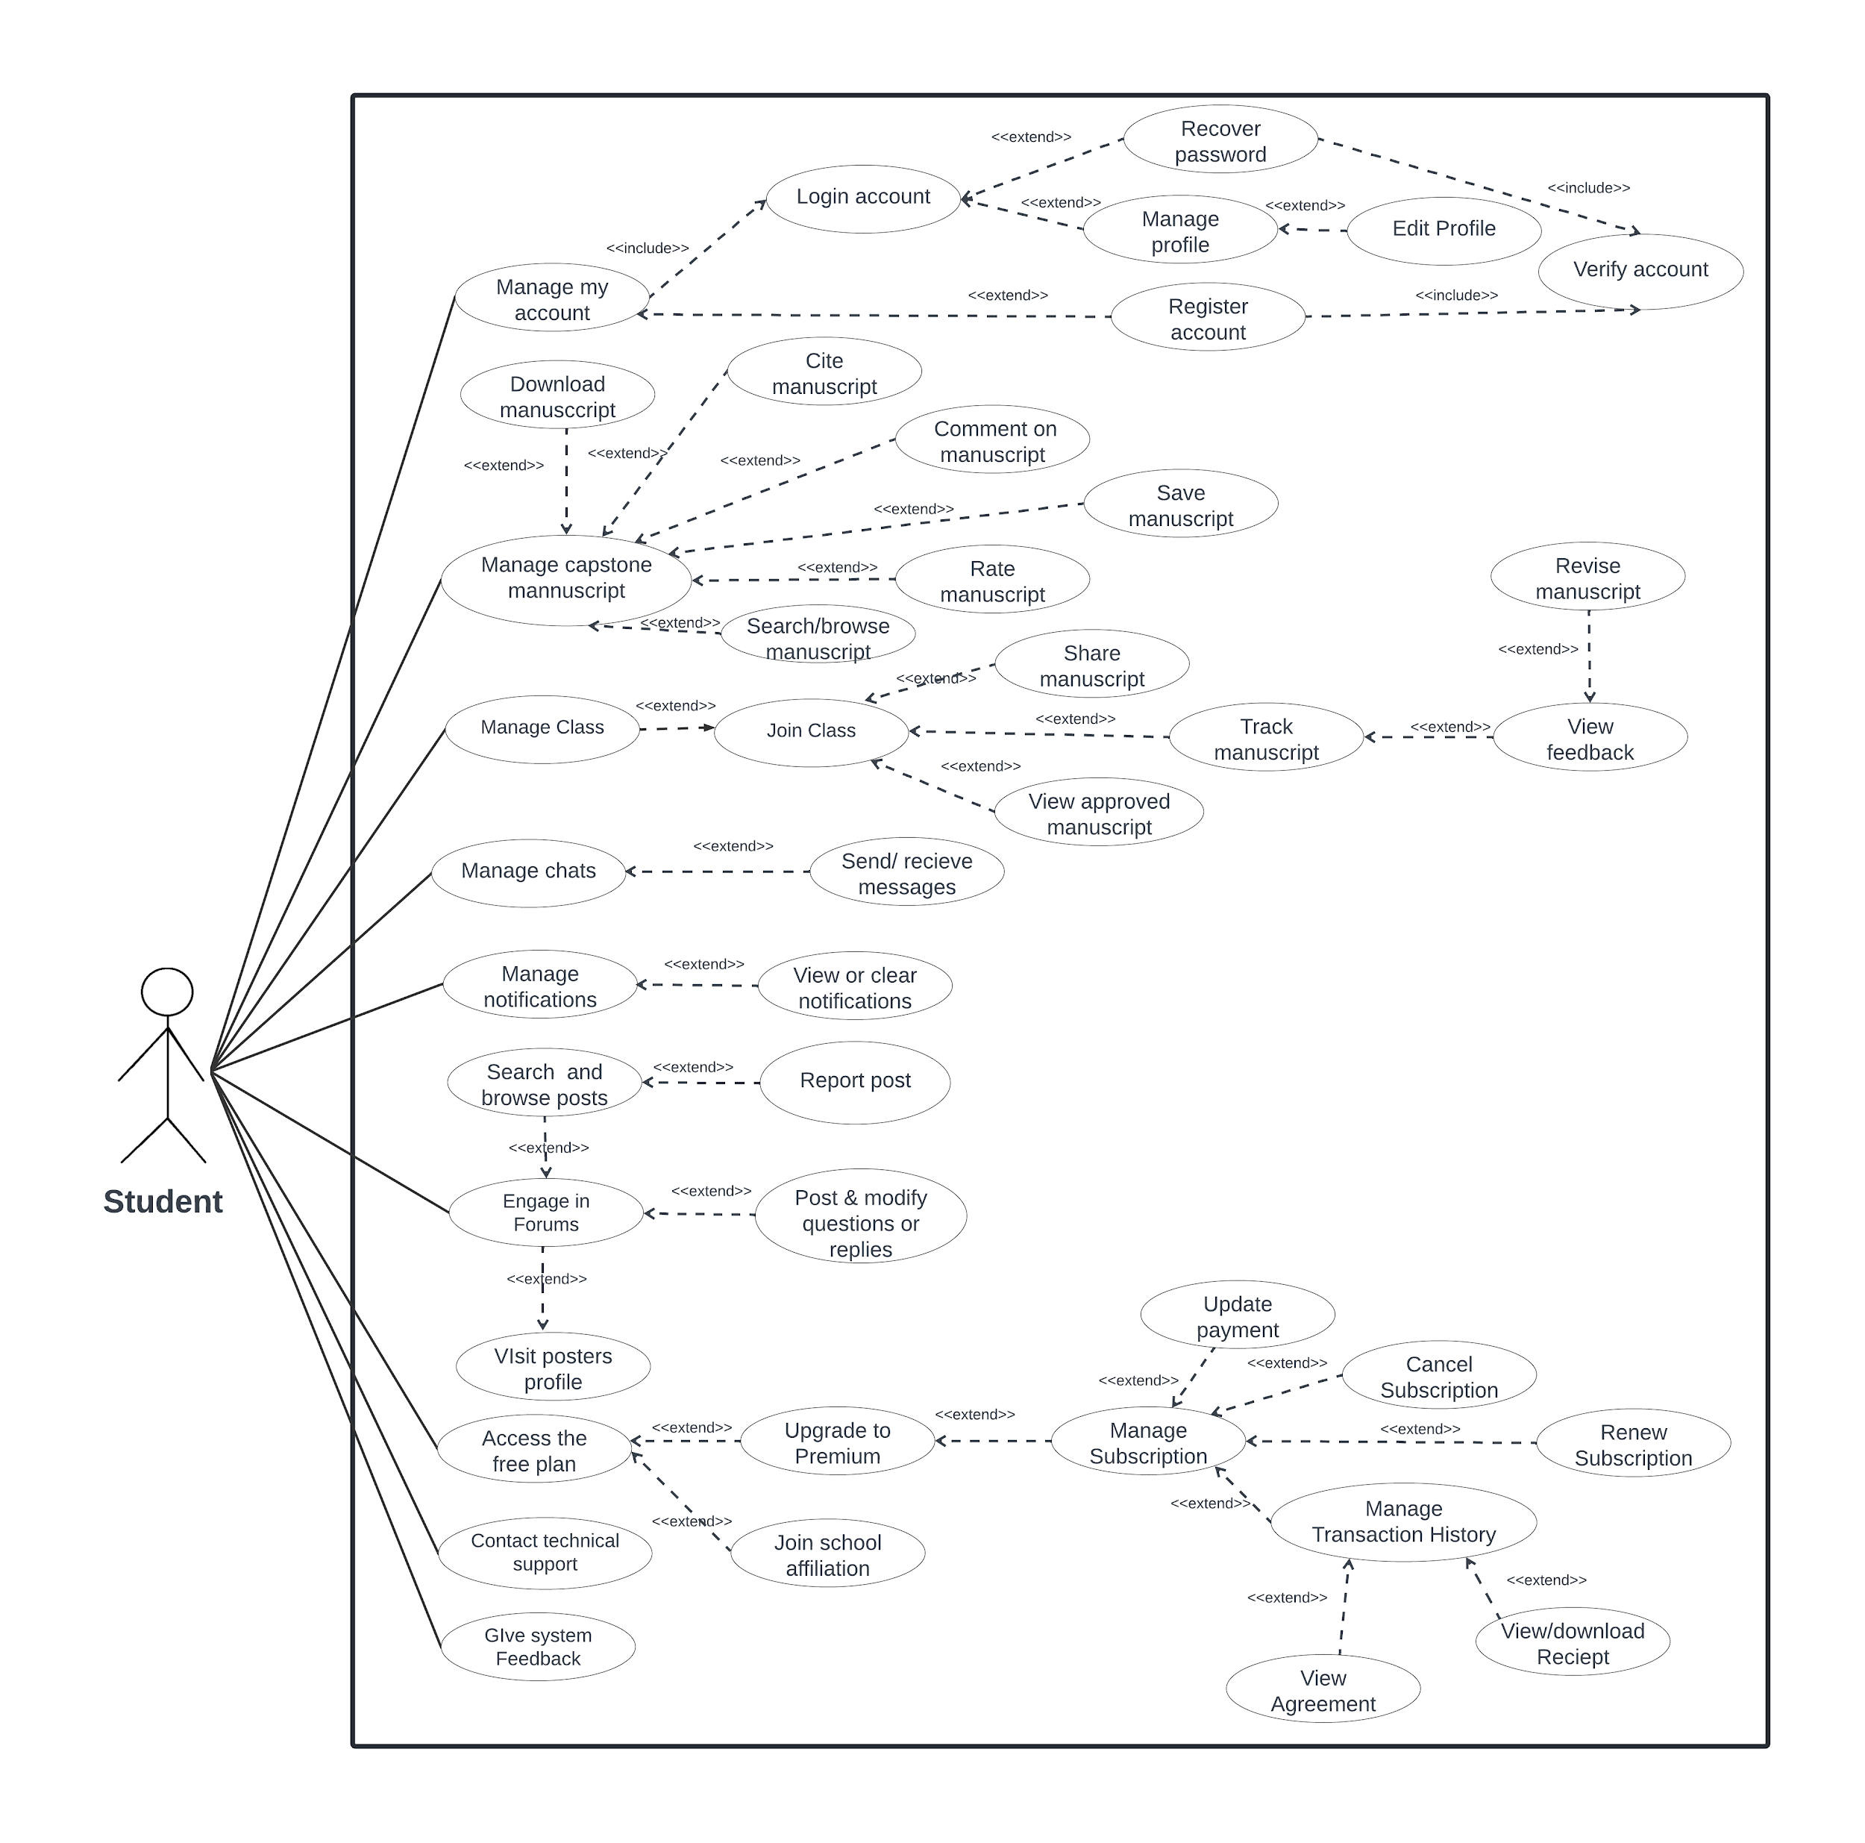

Figure 15: **UCD for Student**

In the student use case diagram, students have a variety of functionalities available to them as shown in Figure 15. They can communicate with other users by sending messages. Additionally, students can access and explore capstone manuscript, with options to download, cite, or save their favorite projects. Engaging in forum discussions is another key feature, enabling students to post questions, comment, delete their posts, and respond to threads initiated by others. They can view all forum posts from other users. Furthermore, students can navigate through user profiles. Beyond social interaction, students can subscribe, cancel and renew their subscriptions. Finally, sharing projects is facilitated, with submissions undergoing review and approval.

**The Archival Alchemist**

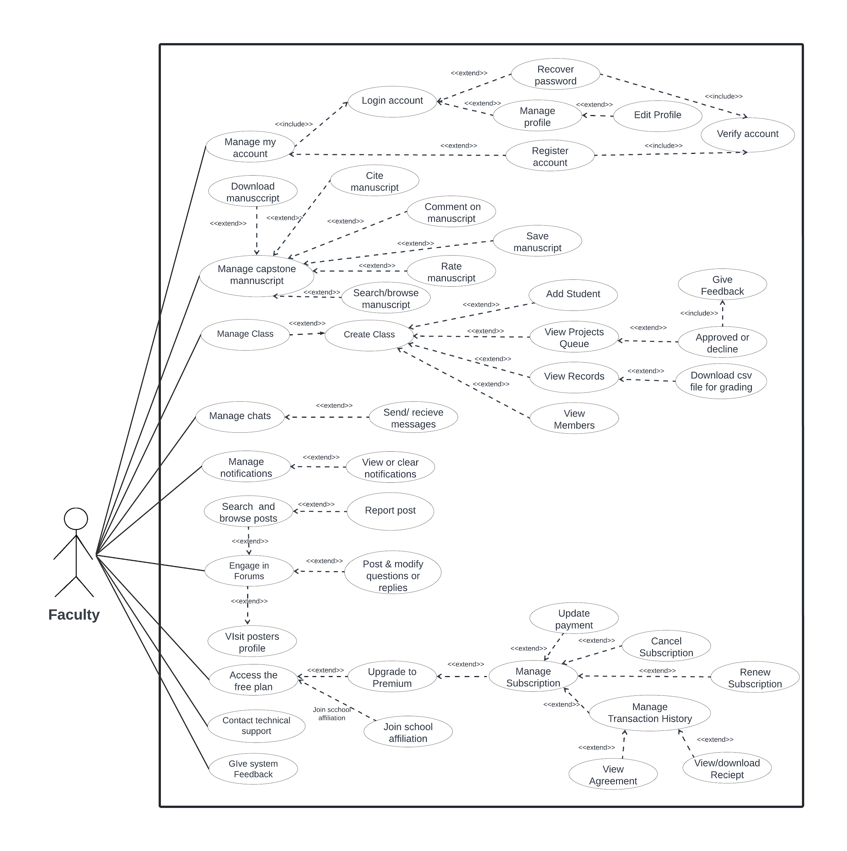

Figure 16: **UCD for Faculty**

In the use case diagram for faculty, their options are mostly similar to what students have. Faculty can communicate with other users through messaging, access and explore projects, participate in forum discussions, and subscribe just like students. However, faculty also possess additional functionalities that cater to their unique roles. Specifically, faculty have the authority to create classes and add students in the class. Furthermore, faculty are responsible for reviewing and providing feedback on student projects and downloading a csv file for grading purposes.

**The Archival Alchemist**

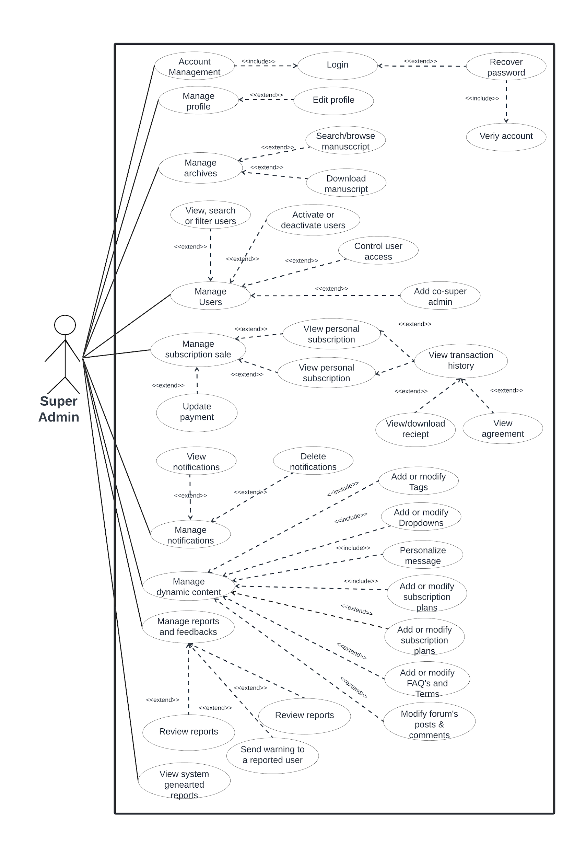

Figure 17: **UCD for Super admin**

The admin use case diagram is depicted in Figure 17. Most of what is shown in the use case diagram is related to management implying that each would have a crud functionality. They have to take over the system customizations which allow for the dynamic modification of various web system contents, such as messages, tags, dropdowns, subscription plan, FAQ’s, terms and conditions. They can view archives and subscribers' transaction billing history and agreement. On top of that, they can view the system generated sales report.

## Storyboard

## Users

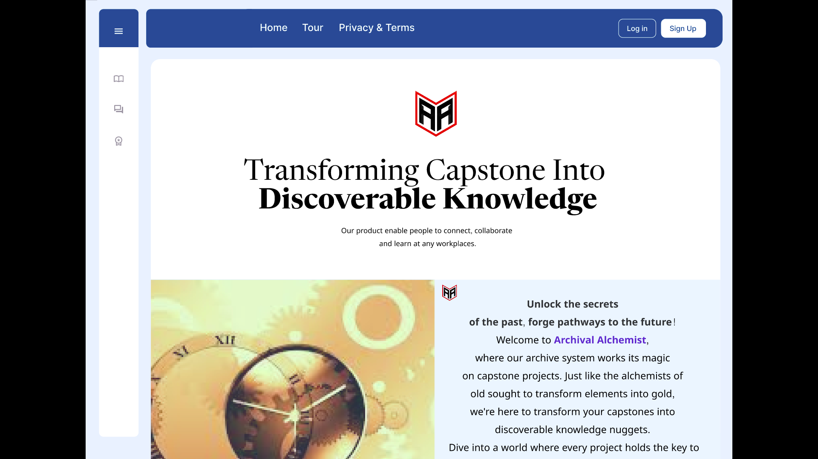

Figure 18**: Landing Page**

**Figure 18:** The figure above shows the landing page of the platform. This is the first page the users will view upon visiting the site.

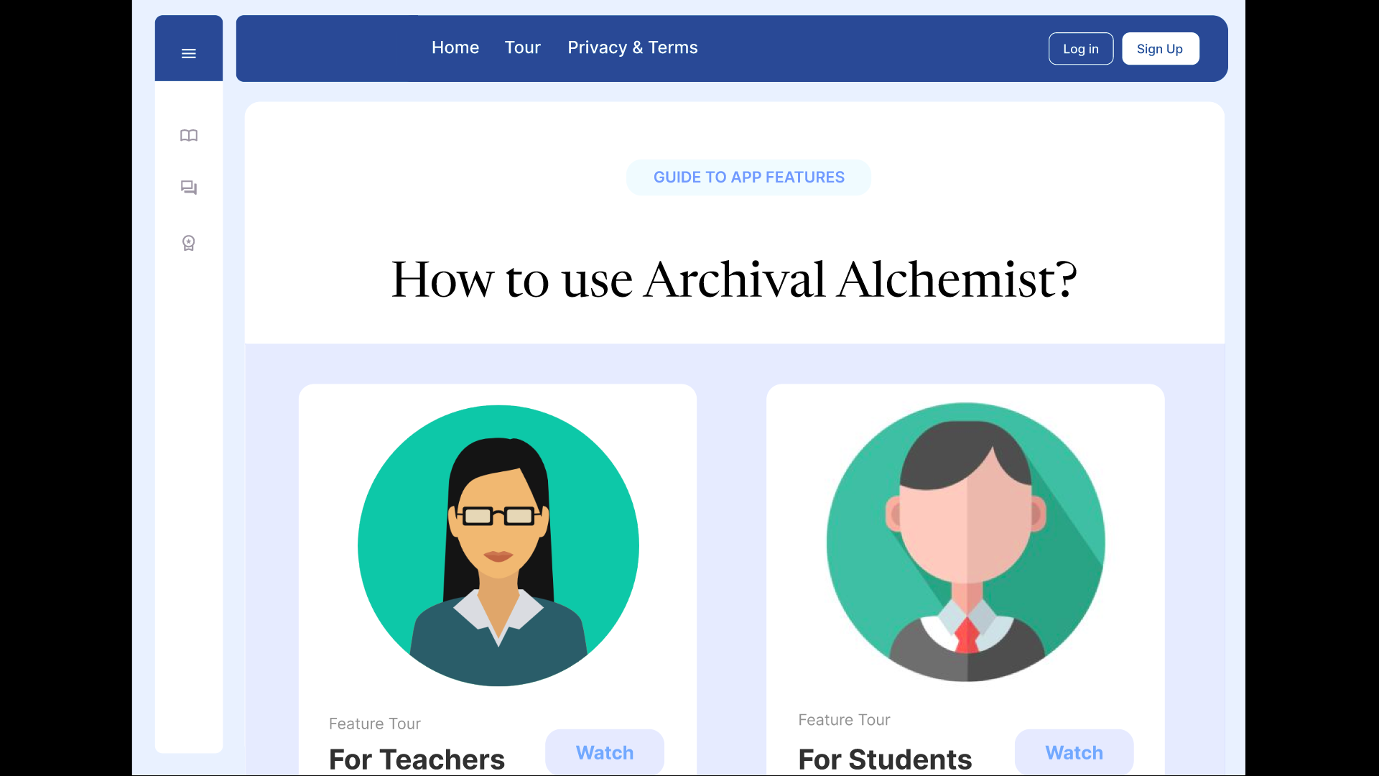

Figure 19: **User Guide Page**

**Figure 19:** The figure above shows the page where users can view the guide in using or navigating the platform. It includes subscription pricing and the frequently asked questions (FAQS).

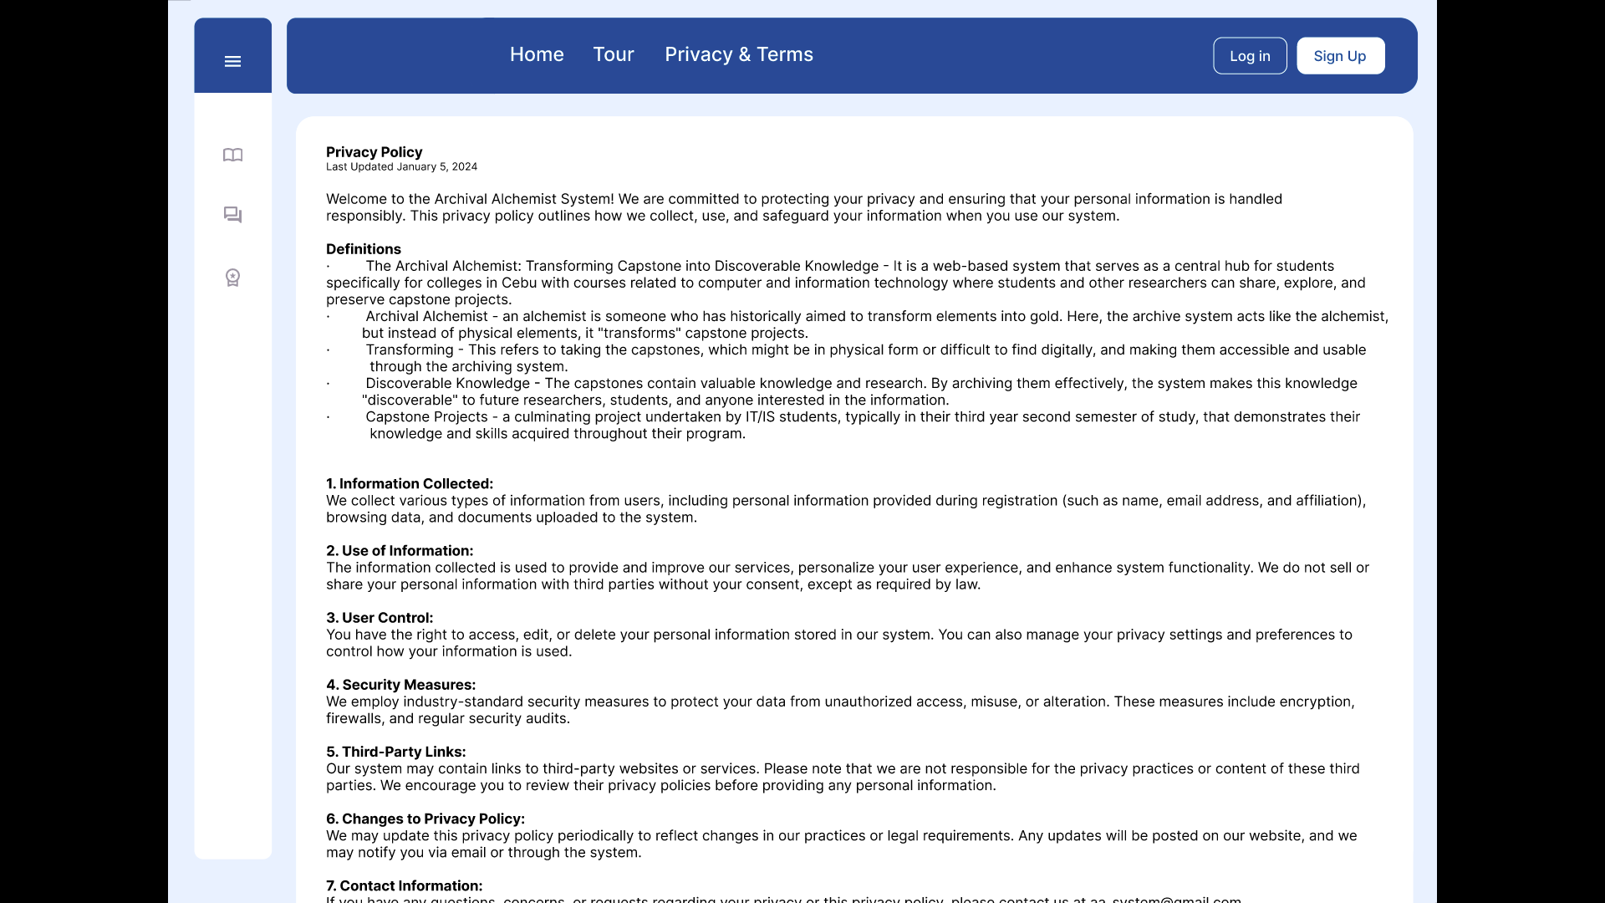

Figure 20: **Privacy and Terms Page**

**Figure 20:** The figure above shows the page where users can read and check the privacy and terms of the platform.

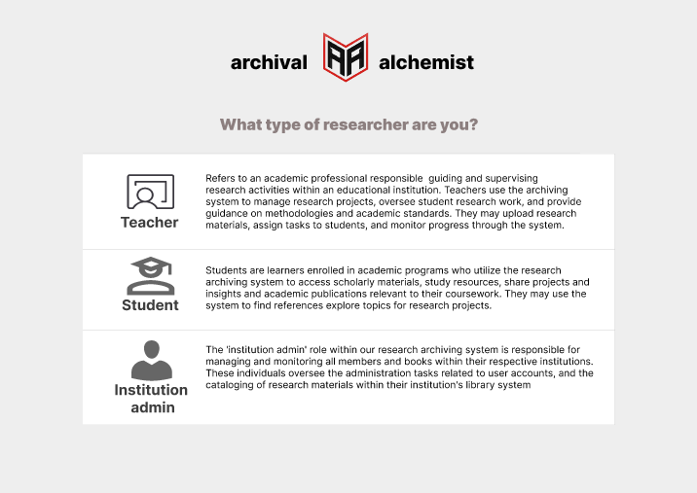

Figure 21: **First Step of Sign Up**

**Figure 21:** The figure above shows the first step of the sign up or the registration page. In this page, users are asked what type of users they are; faculty, students or institution admin.

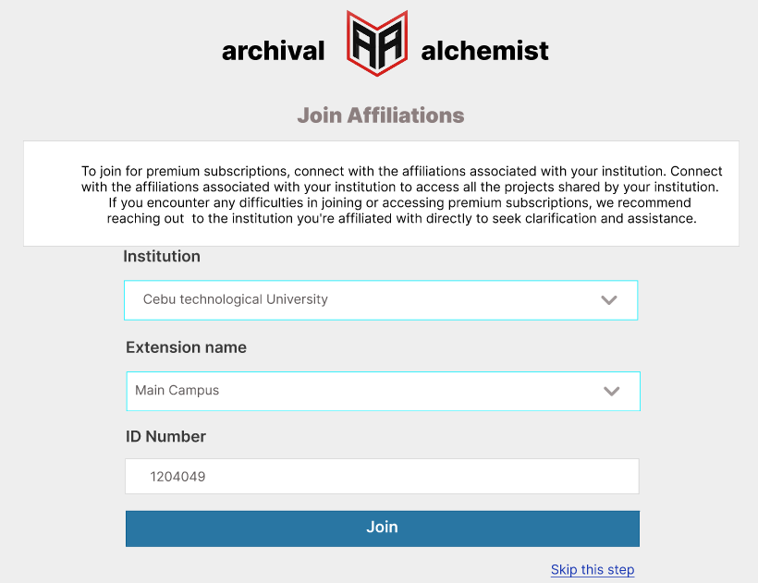

Figure 22: **Second Step of Sign Up**

**Figure 22:** The figure above shows the second step of the sign up or the registration page. In this page, the platform will ask for the user’s affiliated university however users will have the option to skip this page.

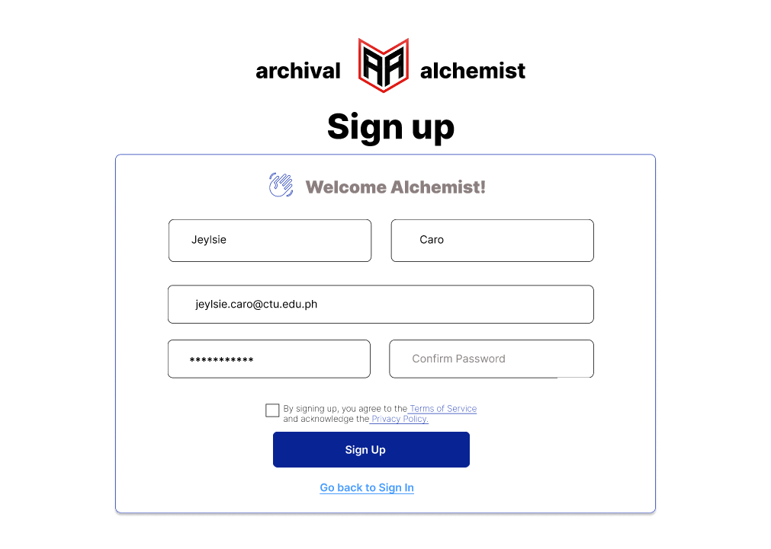

Figure 23: **Third Step of Sign Up**

**Figure 23:** The figure above shows the third step of the sign up or the registration page. In this page, the users input their personal information such as name, email and passwords.

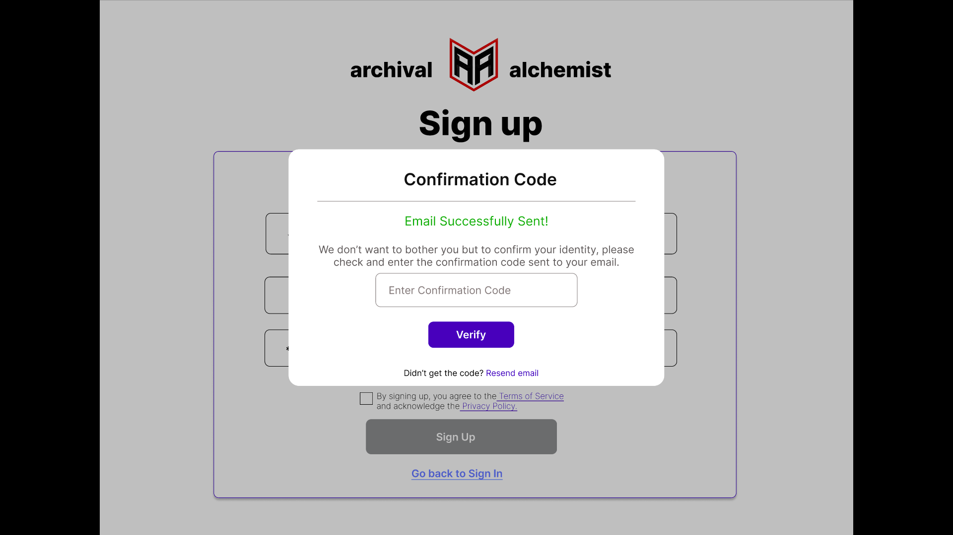

Figure 24: **Verification of Registered Account**

**Figure 24:** The figure above shows the verification of the newly registered account. In this page, the users input the confirmation code sent to their email to verify the account.

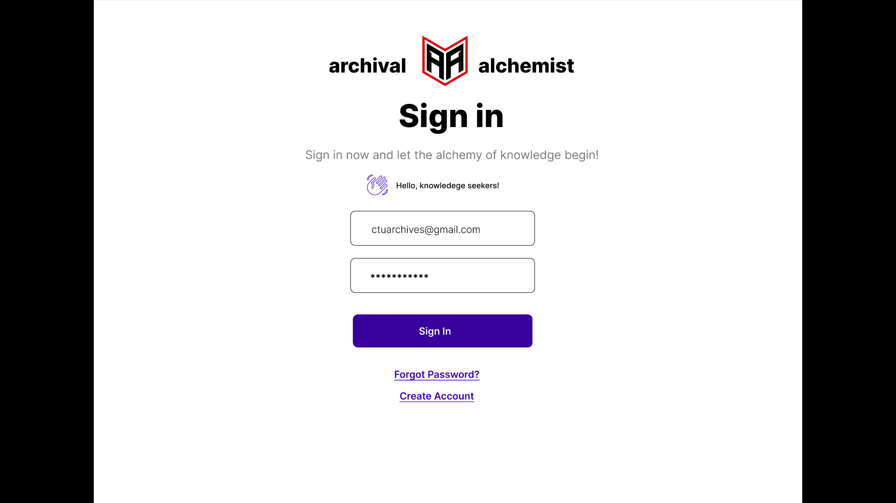

Figure 25: **Sign in Page**

**Figure 25:** The figure above shows the third step of the sign up or the registration page. In this page, users must input their login credentials.

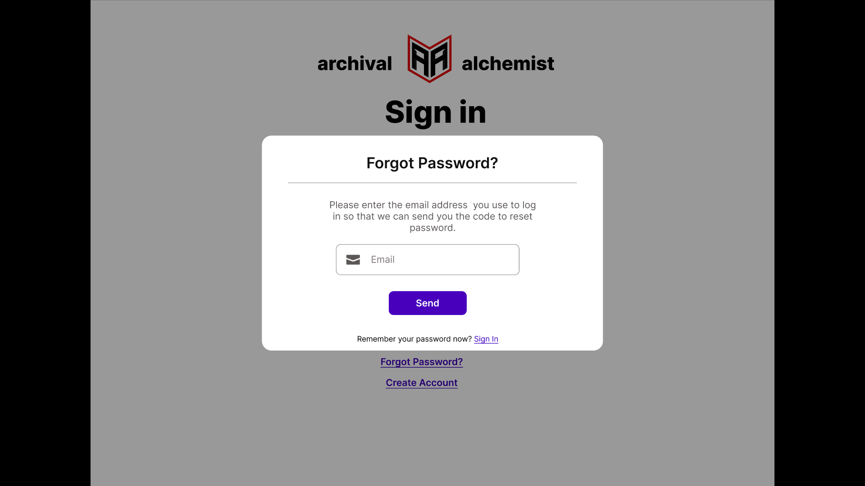

Figure 26: **Forgot Password (Send Email)**

**Figure 26:** The figure above shows the forgot password page where users input their email in order to get the code to change their password.

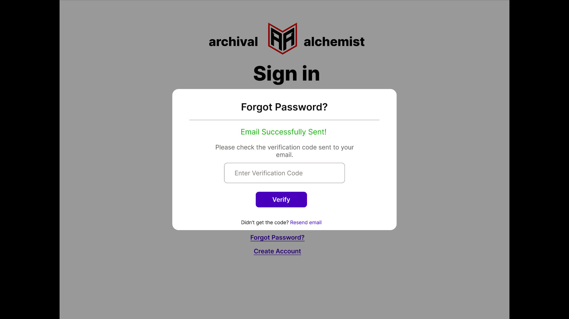

Figure 27: **Forgot Password (Enter Verification Code)**

**Figure 27:** The figure above shows the forgot password page where users must enter the verification code that was sent to their email.

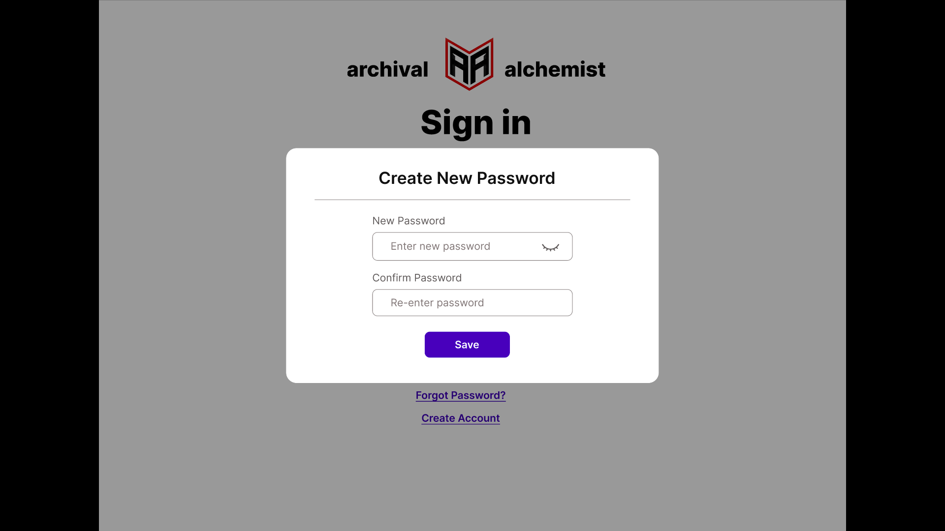

Figure 28**: Forgot Password (Enter New Password)**

**Figure 28:** The figure above shows the page where users can create a new password.

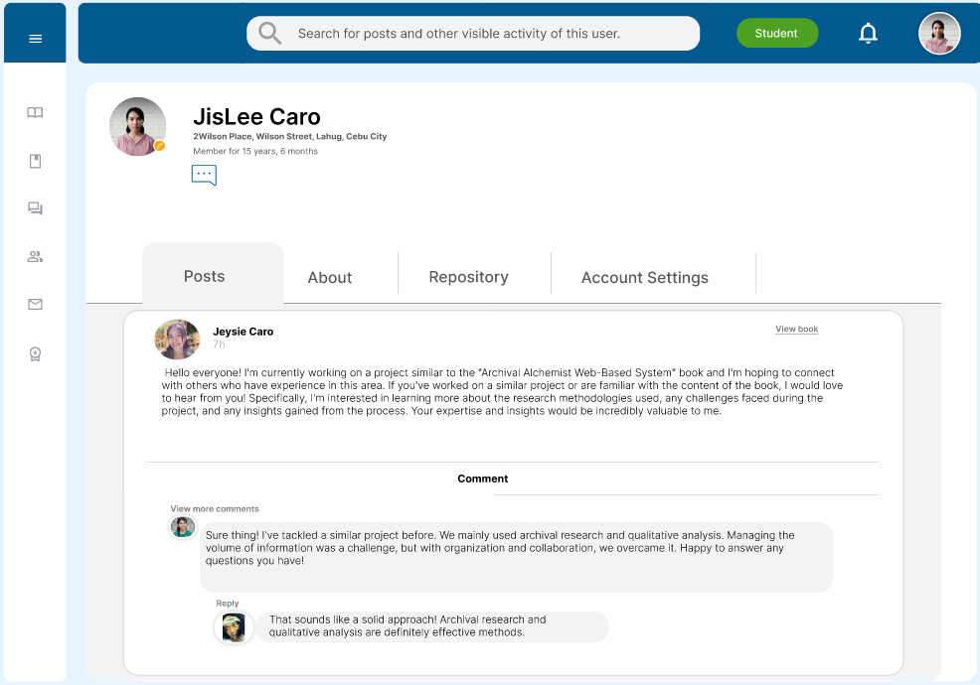

Figure 29: **User Profile**

**Figure 29:** The figure above shows the profile page of the user. Other users can visit their profile page and message them.

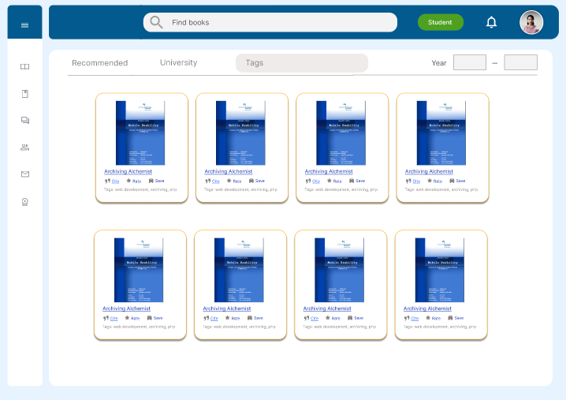

Figure 30: **Browse Project Documents**

**Figure 30:** The figure above shows the catalog for the approved capstone project documents. Users can filter out documents through title, tags, university, and year.

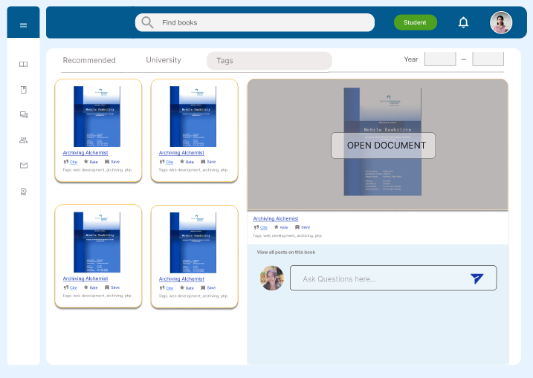

Figure 31: **View a Project Document**

**Figure 31:** The figure above shows the project document when the user clicks a certain page. In this part, users can cite or save/add to favorites the project document.



Figure 32: **Open a Project Document**

**Figure 32:** The figure above shows the opened project documents. Users will be able to view the contents of the document.

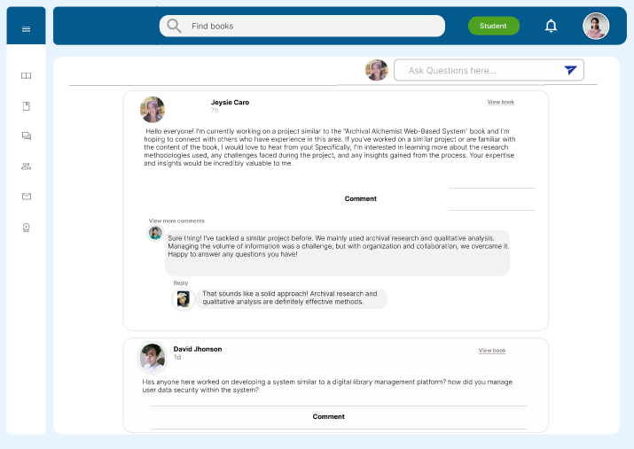

Figure 33: **Commenting a Specific Documents**

**Figure 33:** The figure above shows the comment section of a specific document. Users can ask questions related to the document.

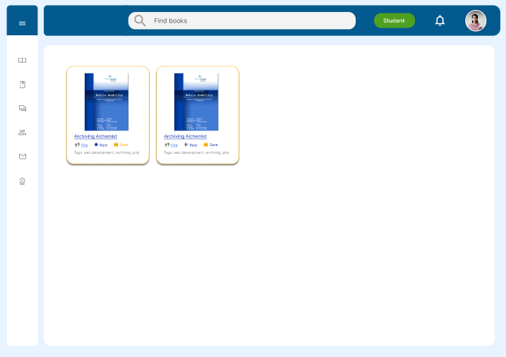

Figure 34: **View Save Project Documents**

**Figure 34**: The figure above shows the list of the save project documents. Users will be able to access and view the document without searching the document again.

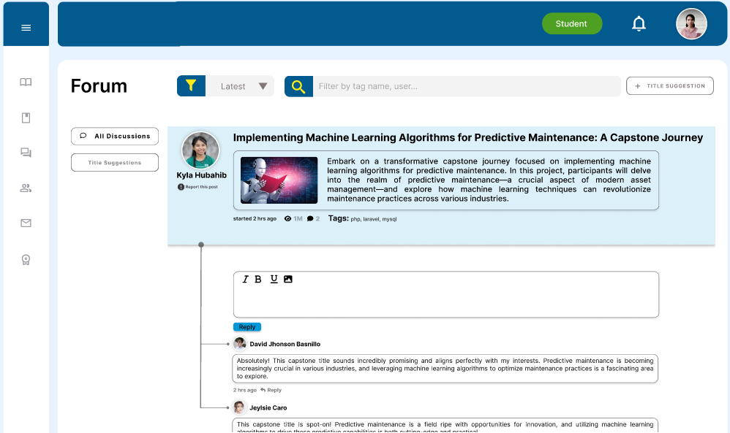

Figure 35: **Forum**

**Figure 35:** The figure above shows the forum section where users can interact with other fellow users such as asking questions or providing new ideas. They can report inappropriate posts that would directly affect the record of the specific user..

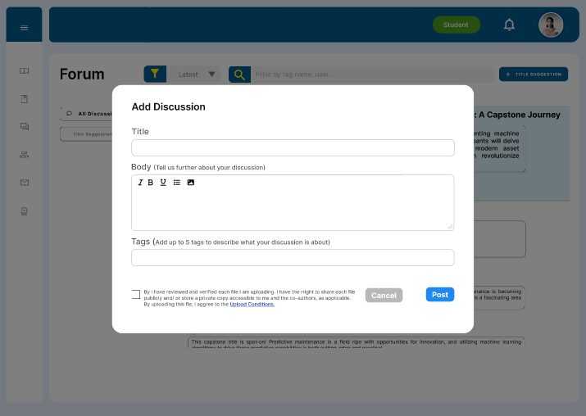

Figure 36: **Forum (Start a discussion)**

**Figure 36:** The figure above shows the add discussion where users add a title, context of the discussion, and tags to further specify the topic. Users can also attach files or pictures to further visualize the topic of the discussion.

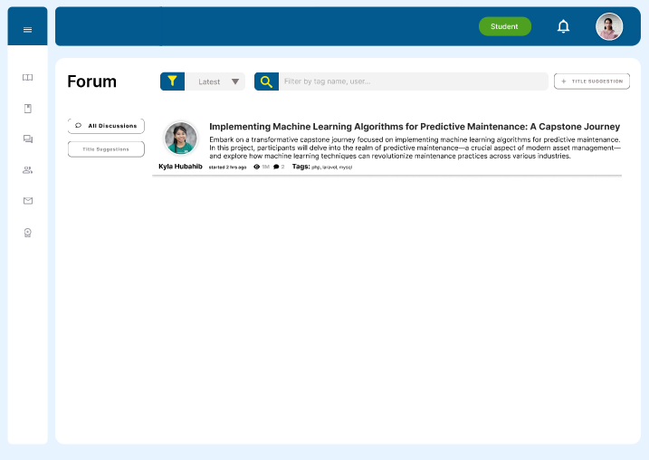

Figure 37: **Forum (Title Suggestion)**

**Figure 37:** The figure above shows the featured feature of the forum section where users can post an idea or title suggestion so that students who just started their capstone can gain insights.

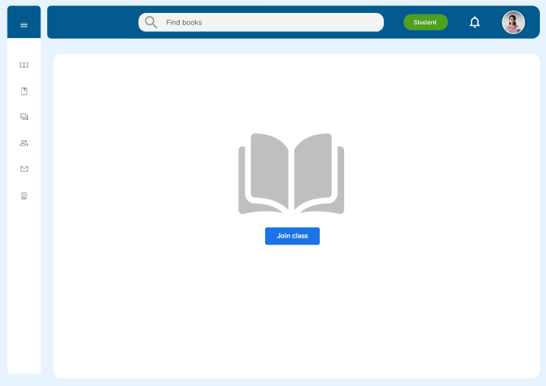

Figure 38: **Class (Student)**

**Figure 38:** The figure above shows the class page where users such as students can enter a class. In this page, students are handled by an instructor.

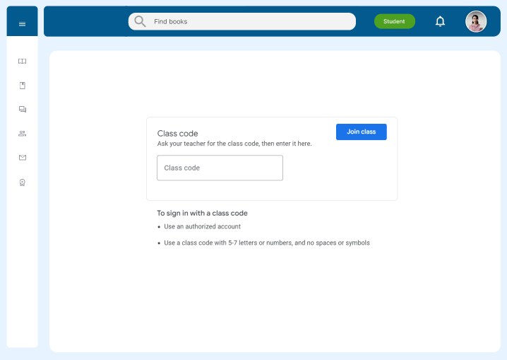

Figure 39**: Join Class (Student)**

**Figure 39:** The figure above shows the page where students can join a class. They can join by entering the class code given by the instructor or the instructor could also add them manually in order for them to join the class.

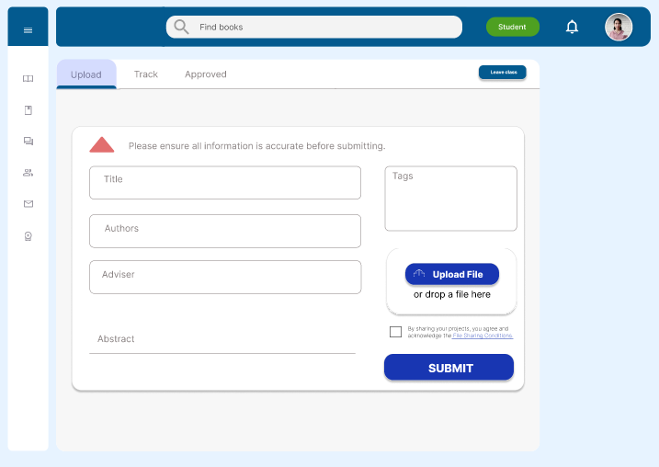

Figure 40: **Upload a Capstone Project Document**

**Figure 40:** The figure above shows the uploading of the capstone project document. Students can upload their project documents which will then be approved or rejected by the instructor.

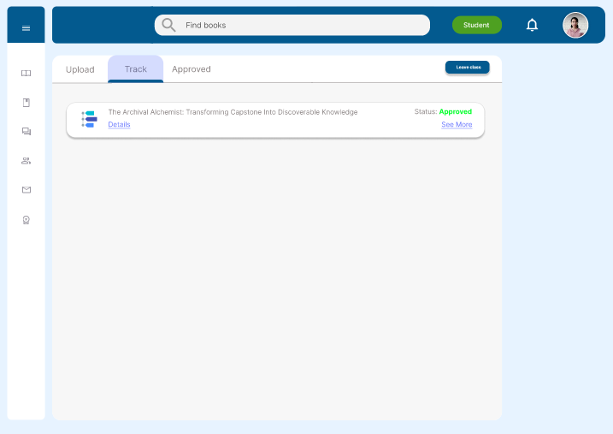

Figure 41: **Track Approval Status of Capstone Project Document**

**Figure 41:** The figure above shows the tracking of the approval status of the capstone project documents.

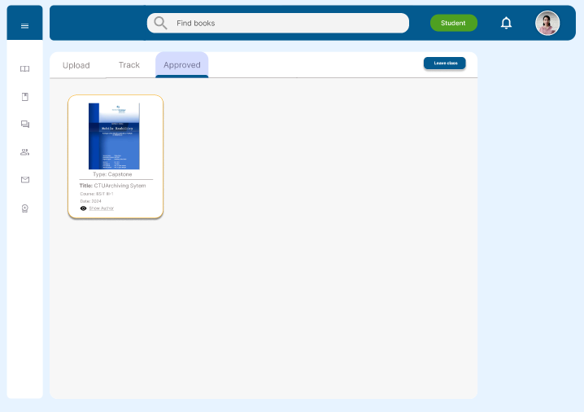

Figure 42: **View Approved Capstone Project Document**

**Figure 42:** The figure above shows the catalog or list for the approved capstone project documents.

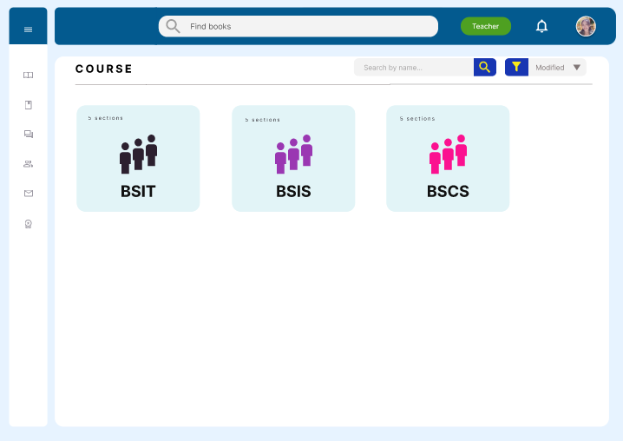

Figure 43: **Class (Faculty)**

**Figure 43:** The figure above shows the class page of the faculty where the faculty can view the classes they handled.

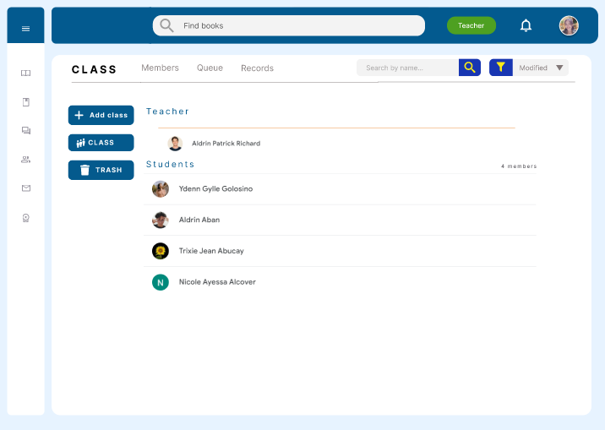

Figure 44: **Class Members**

**Figure 44:** The figure above shows the list of the students enrolled in this class.

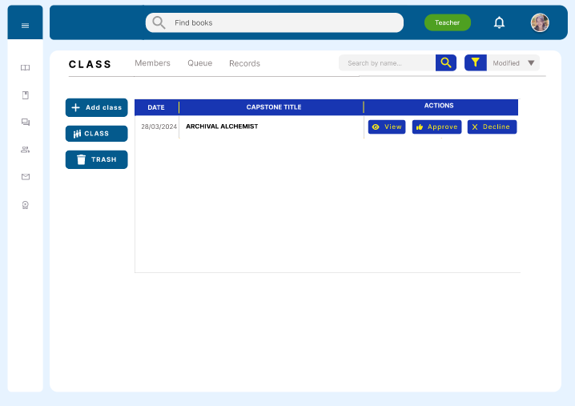

Figure 45: **Class Queue**

**Figure 45:** The figure above shows the queue of the capstone project documents. On this page, instructors can view, approve or reject the capstone project.

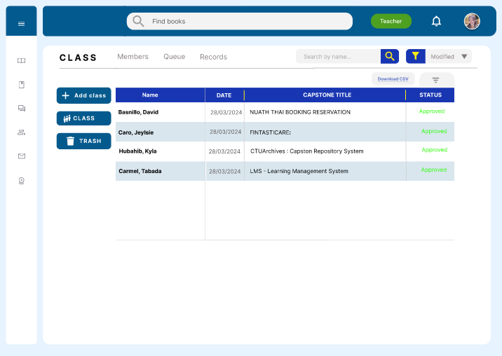

Figure 46: **Class Records**

**Figure 46:** The figure above shows the record of the project document in the class. On this page, instructors can view the capstone project documents that were approved and rejected.

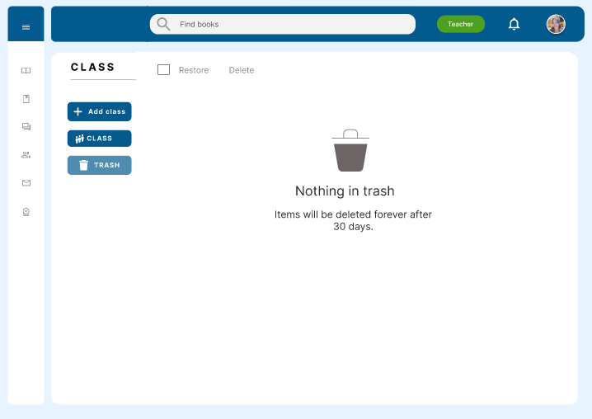

Figure 47: **Trash**

**Figure 47:** The figure above shows the trash section of the class. The items in the trash will be permanently deleted after 30 days.

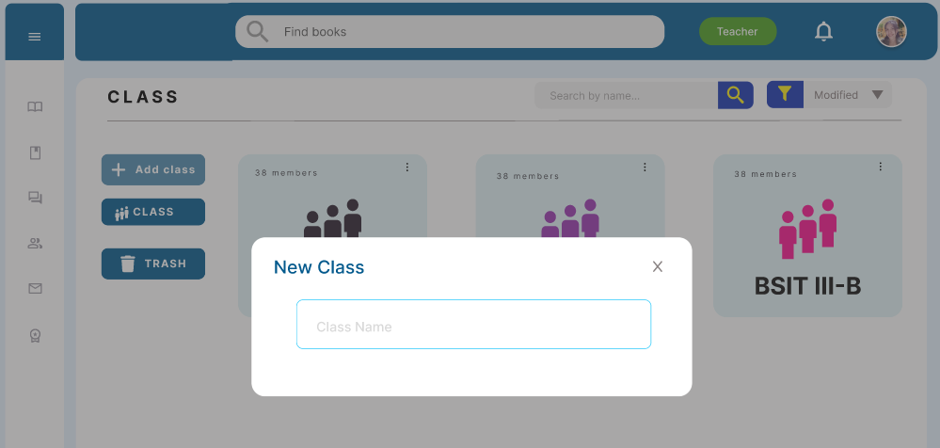

Figure 48: **Add New Class (Faculty)**

**Figure 48:** The figure above shows the page where the faculty can create a new class.

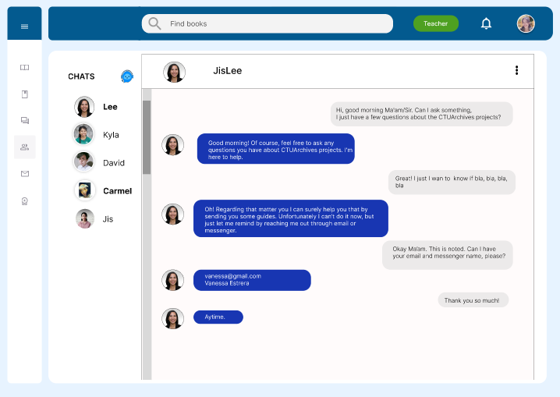

Figure 49: **Chat**

**Figure 49:** The figure above shows the chat page where users can message or communicate with other users privately.

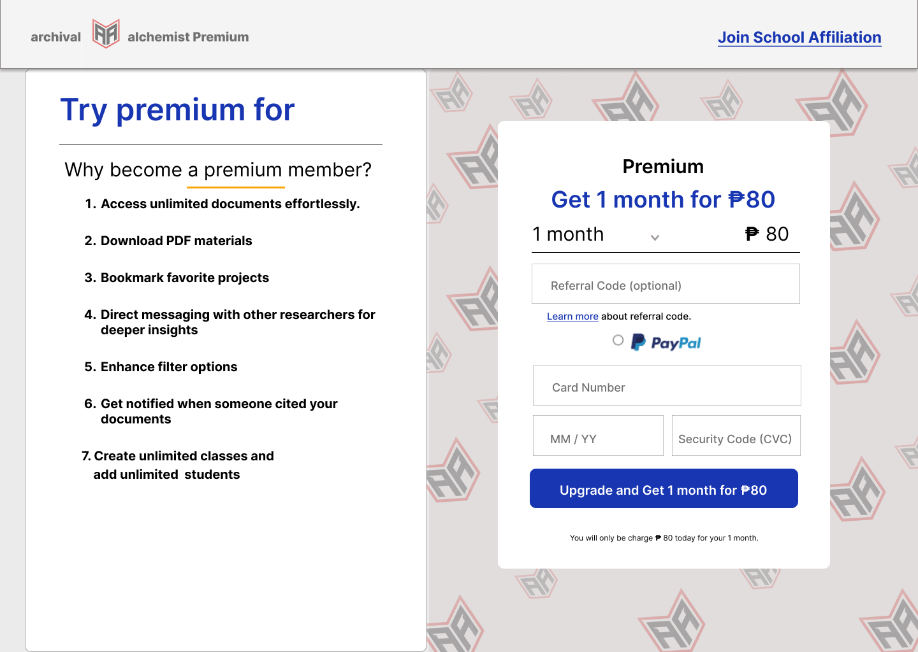

Figure 50: **Premium Subscription (Student)**

**Figure 50:** The figure above shows the premium subscription specifically for personal use for students. Users can enter a referral code given by subscribing faculty to access discounts.

## 

Figure 51: **Premium Subscription (Faculty)**

**Figure 51:** The illustration above displays the premium subscription tailored for individual use by faculty. Users have the ability to generate a referral code, which they can then share with students. Users stand to gain benefits when students utilize the referral code.

**Super Admin**

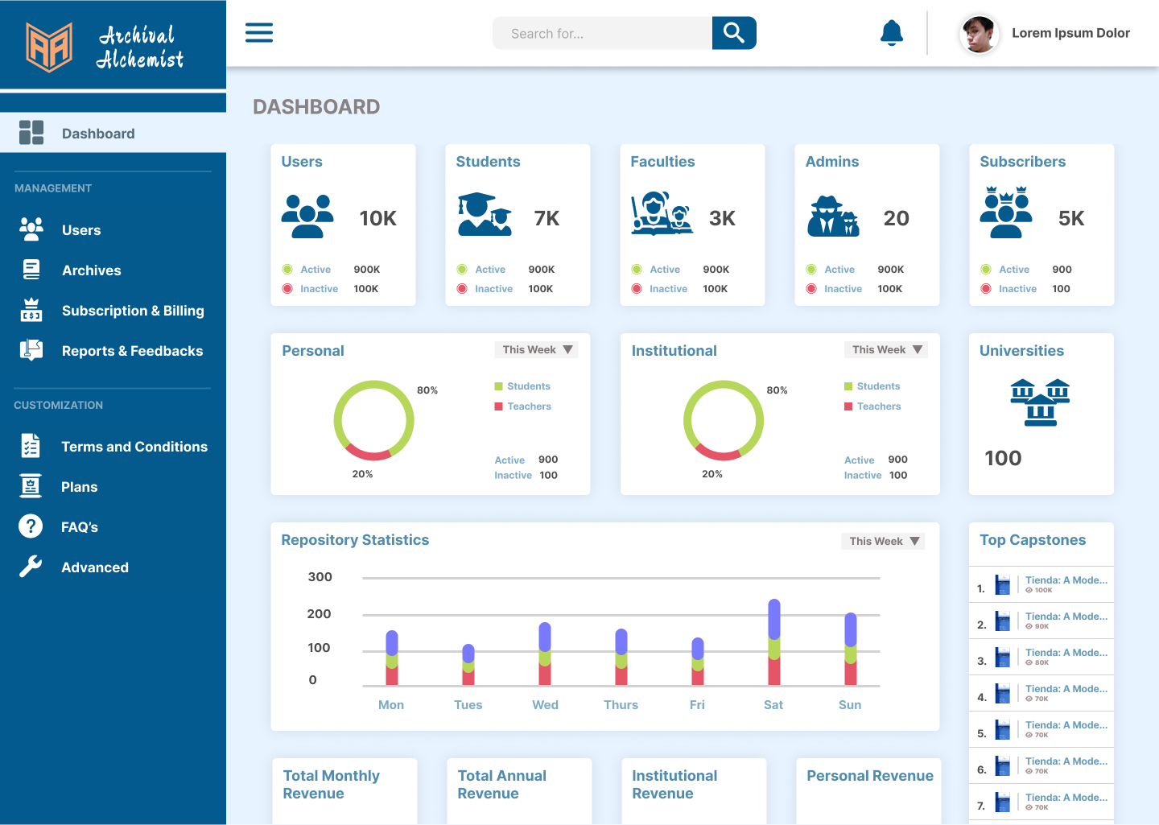

Figure 52: **Dashboard**

**Figure 52:**  The figure above shows The Archival Alchemist dashboard/landing page for the super admin after logging in from the client login interface. It also displays statistics for users, subscribers, sales reports and more.

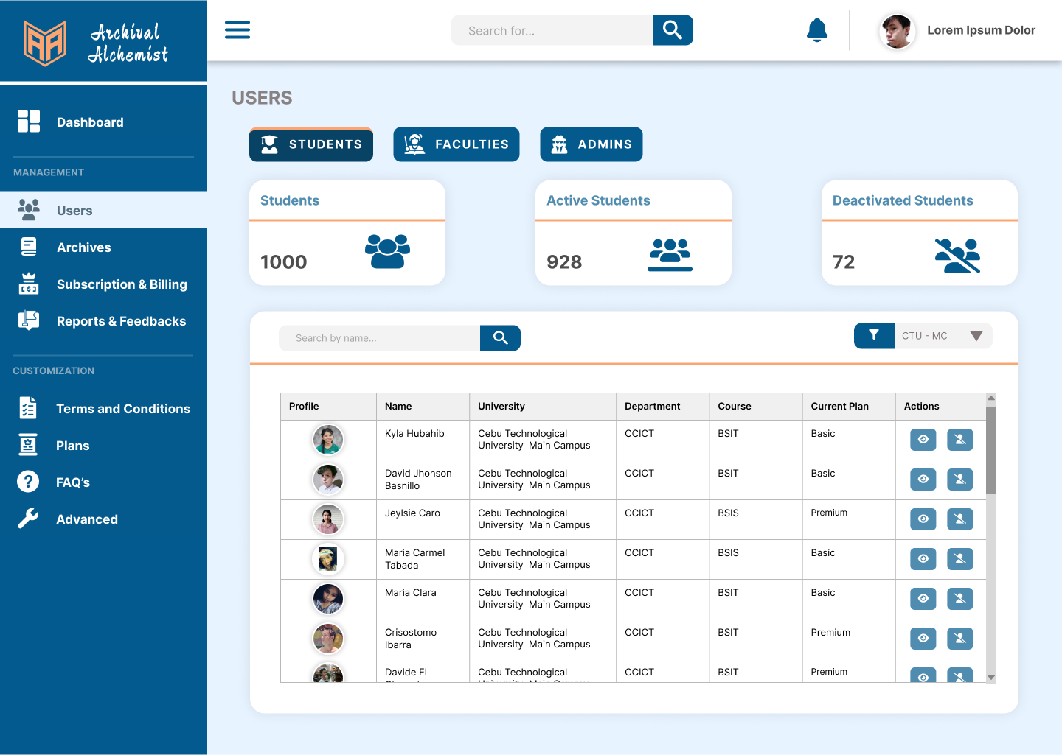

Figure 53: **Users**

**Figure 53:**  The figure above shows the users page where the super admin manages user accounts, including students, instructors, and admins, which include co-admins and institution admins.

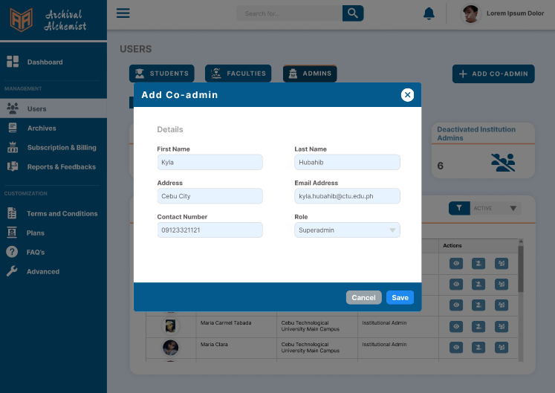

Figure 54: **Users (Add Co-admin)**

**Figure 54:**  The figure above shows that the super admin can add a co-admin through a modal.

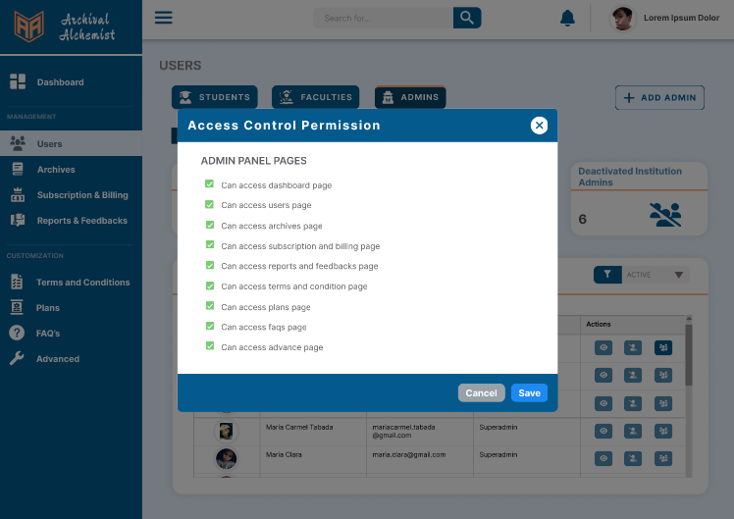

Figure 55: **Users (Admin Access Control Permission)**

**Figure 55:**  The figure above shows the page where super admins can manage access control permissions. Only the highest super admin can manage the access control permissions.

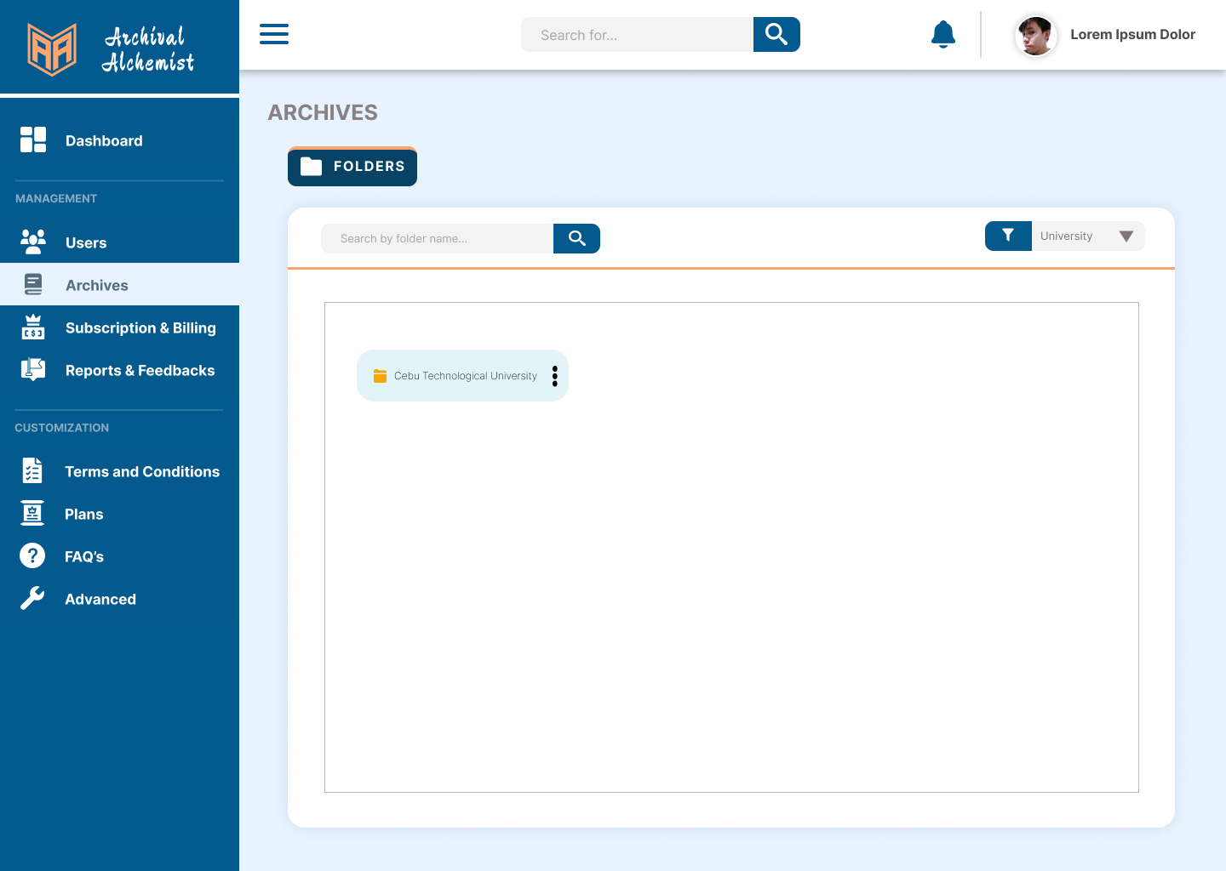

Figure 56: **Archives**

**Figure 56:**  The figure above shows the archives page where the administrators manage folders containing capstone projects.

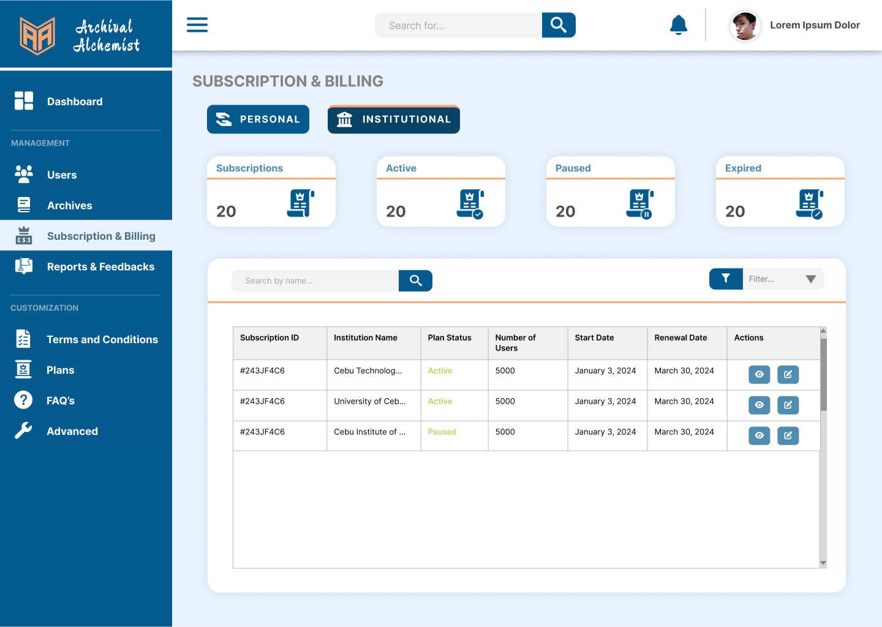

Figure 57: **Subscription & Billing**

**Figure 57:**  The figure above shows the subscription and billing page where the administrators manage the users' subscriptions, which include both personal and institutional subscriptions.

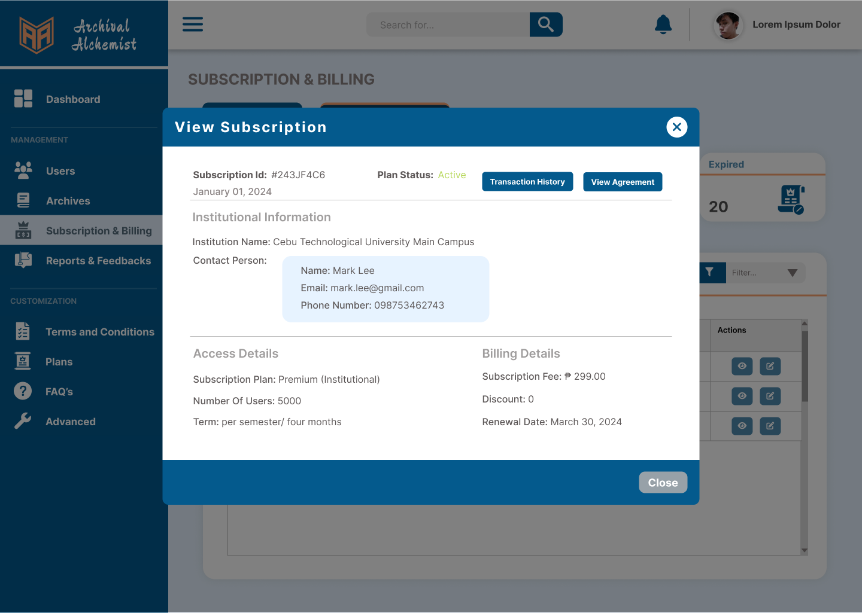

Figure 58: **View User’s Subscription**

**Figure 58:**  The figure above provides a comprehensive overview of the subscription details tailored specifically to an individual user. It encompasses a detailed breakdown of their subscription, including billing history, payment dates, due dates, and the specific subscription plan they subscribe to.

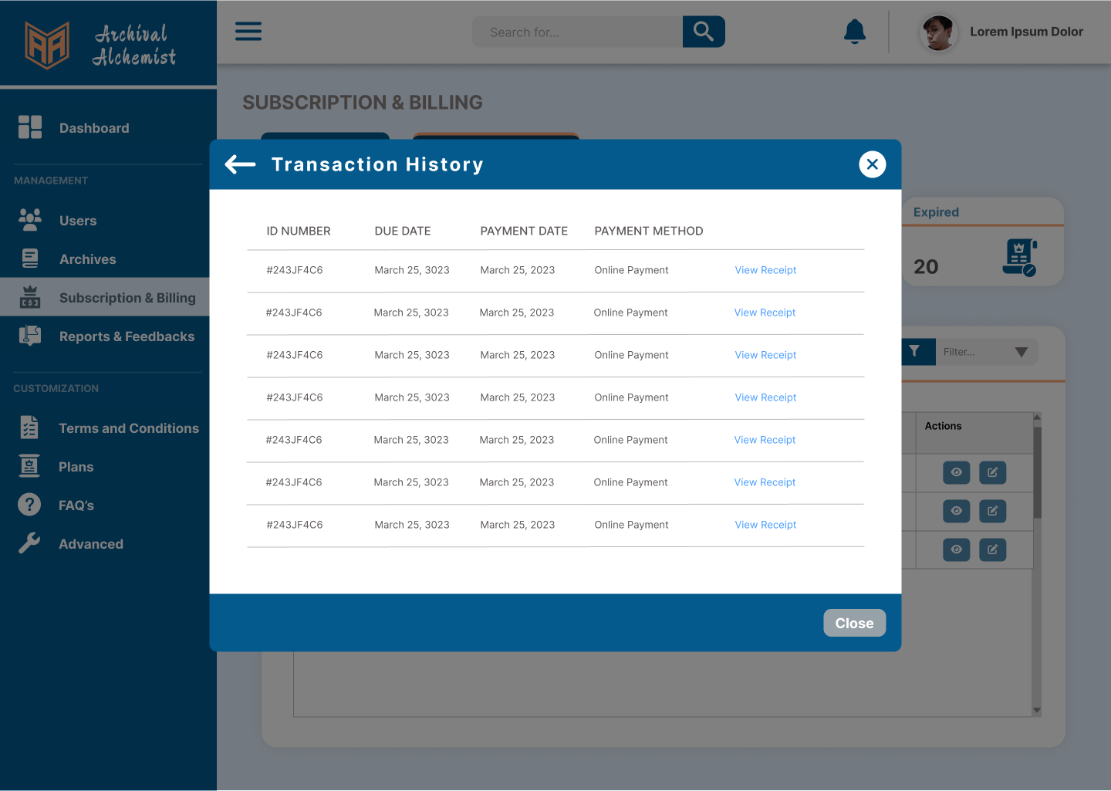

Figure 59: **View User’s Transaction History**

**Figure 59:**  The figure above shows the user's transaction history, detailing recent billings, payment dates, due dates, and the payment methods used.

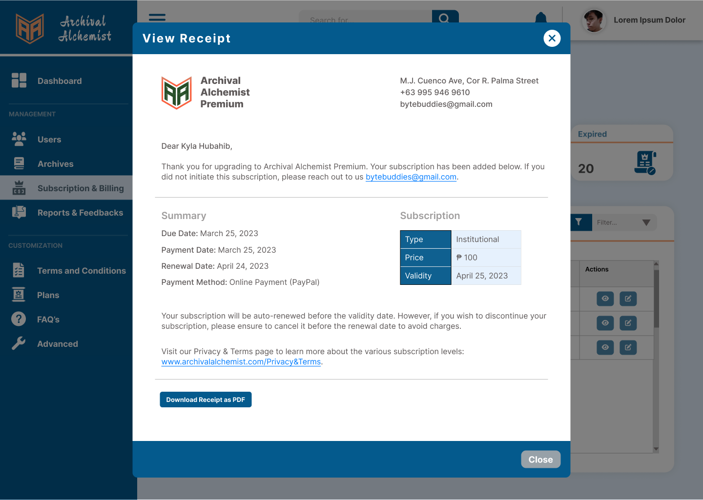

Figure 60: **View User’s Subscription Receipt**

**Figure 60:**  The figure above shows the user’s subscription receipt, which includes full details such as due dates, renewal date, and the subscription plan that the user is subscribing to.

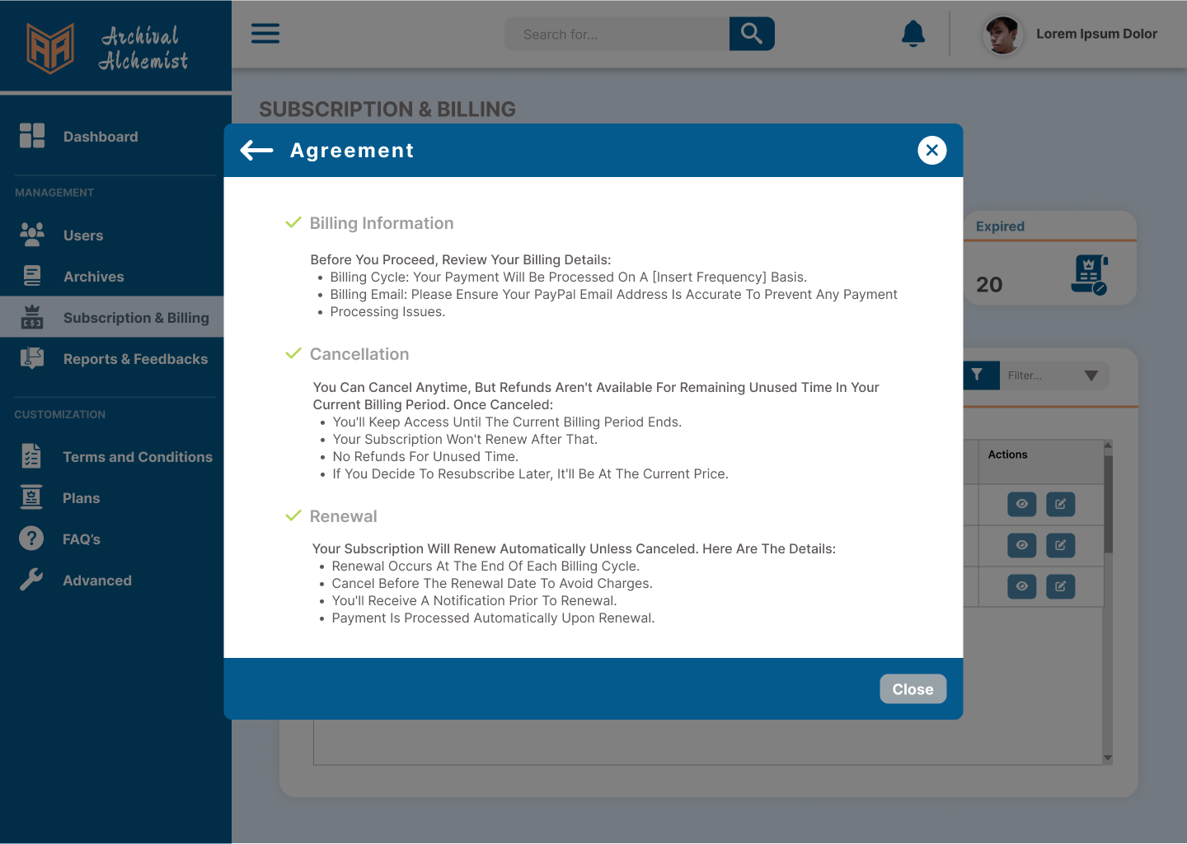

Figure 61: **View User’s Billing Agreement**

**Figure 61:**  The figure above shows the user accepting the subscription plan agreement, which includes billing information, cancellation, and renewal.

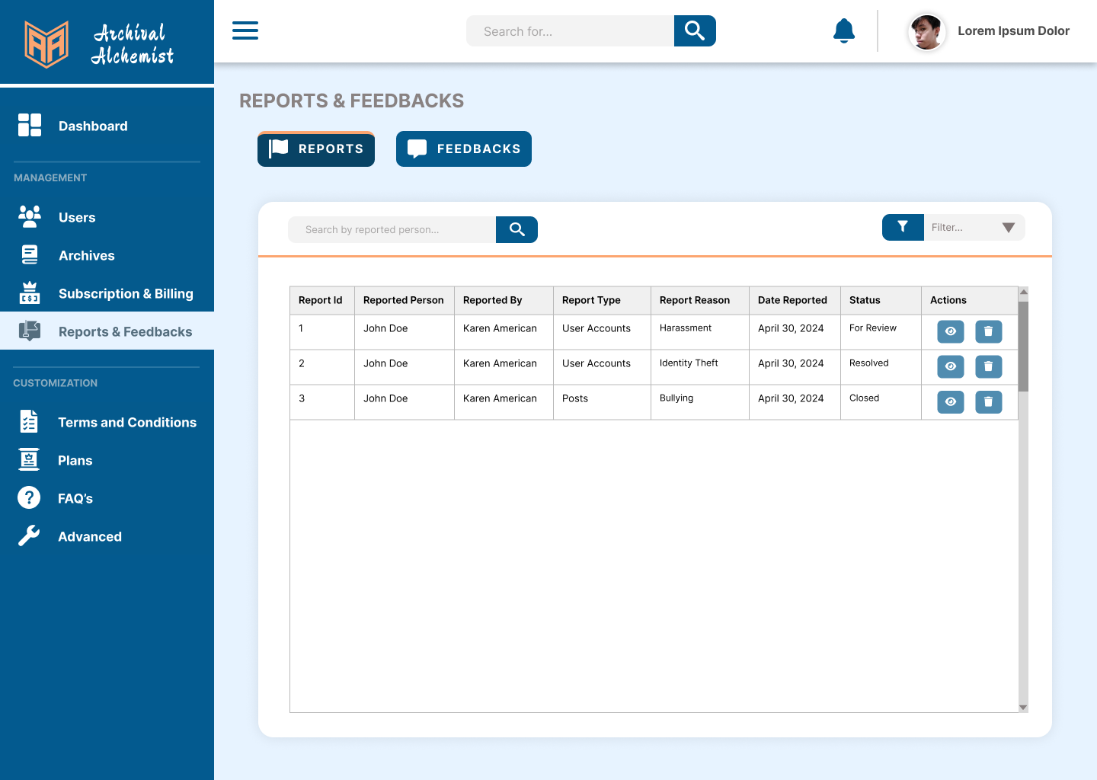

Figure 62: **Reports & Feedbacks**

**Figure 62:**  The figure above illustrates the reports where administrators can manage reported users and content. In addition, administrators can also keep track on user’s feedback to further improve the system.

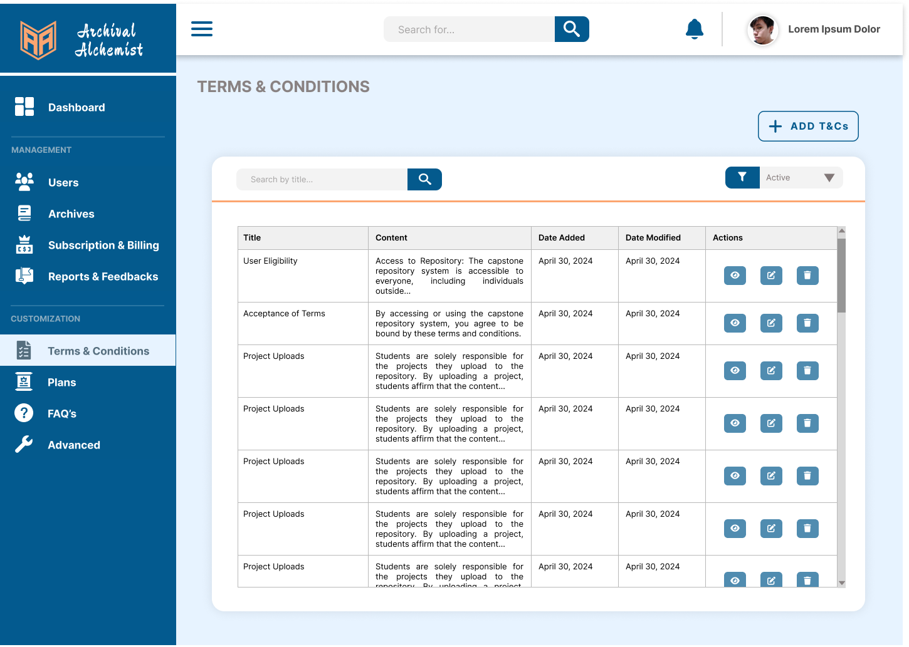

Figure 63: **Terms & Conditions**

**Figure 63:**  The figure above shows the terms and conditions page, where the admin customizes the content specifically for the client side to be displayed on the terms and conditions page.

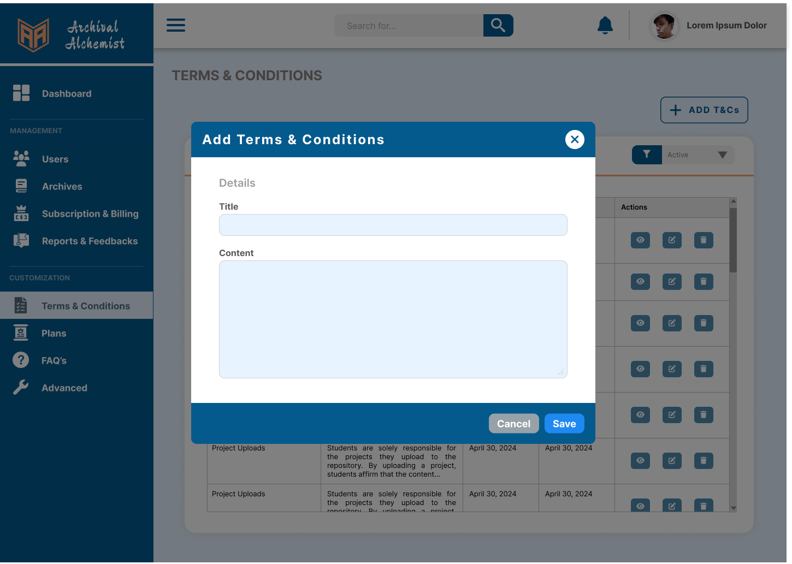

Figure 64: **Add Terms & Conditions**

**Figure 64:**  The figure above shows that administrators can perform CRUD operations to customize the terms and conditions page on the client side, such as adding terms and conditions.

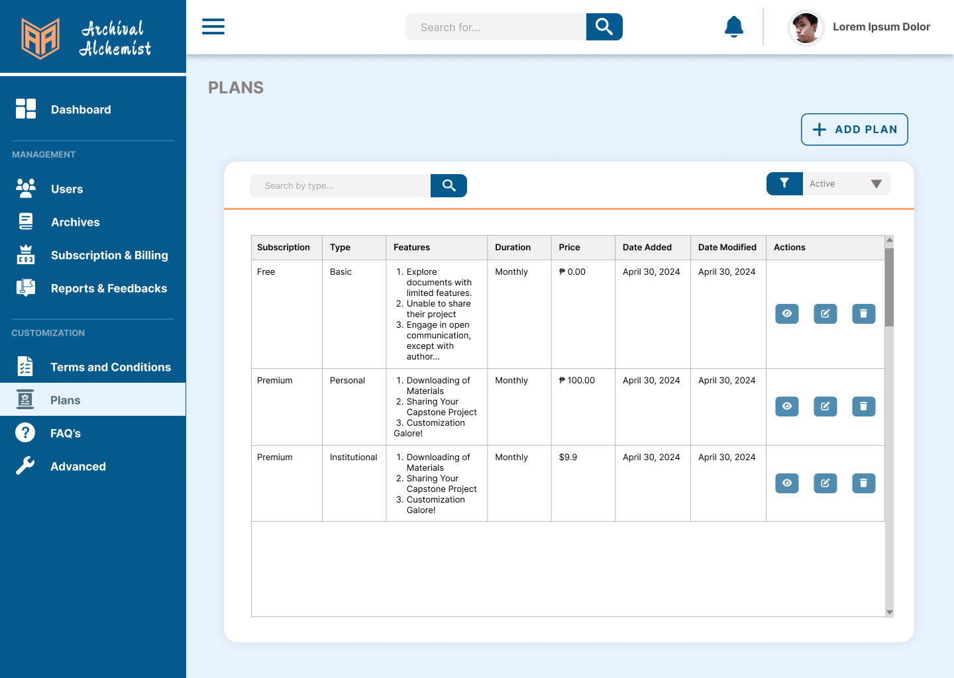

Figure 65: **Subscription Plans**

**Figure 65:** The figure above shows the subscription plans page, where the admin customizes the content specifically for the client side to be displayed on the subscription plans page.

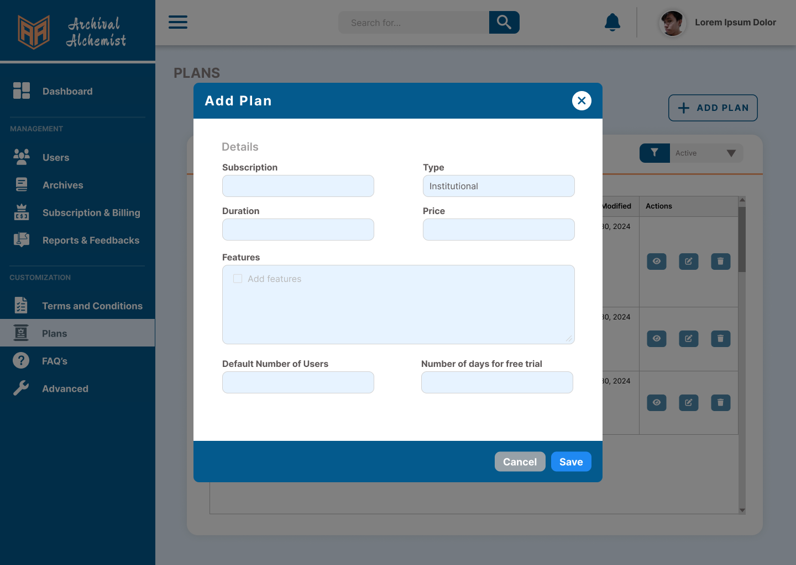

Figure 66: **Add Subscription Plans**

**Figure 66:**  The figure above demonstrates that administrators can add a new subscription plan. If the administrator chooses the ‘Institution’ for the plan type, two new inputs will be displayed in the modal.

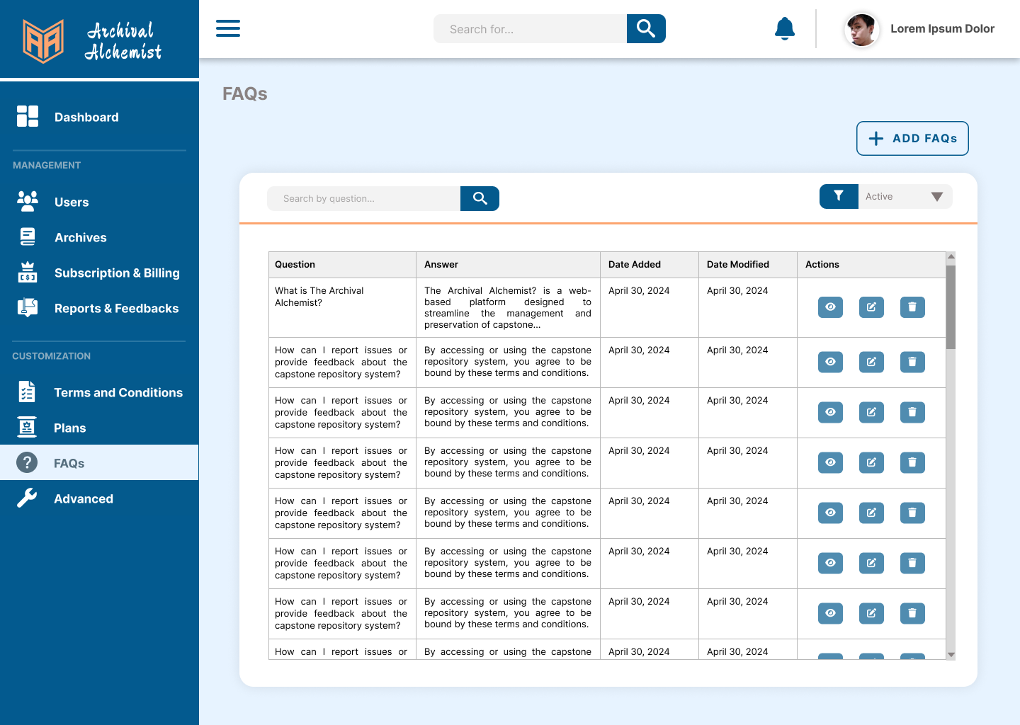

Figure 67: **Frequently Asked Questions**

**Figure 67:** The figure above shows the frequently asked questions page, where the admin customizes the content to be shown on the client side.

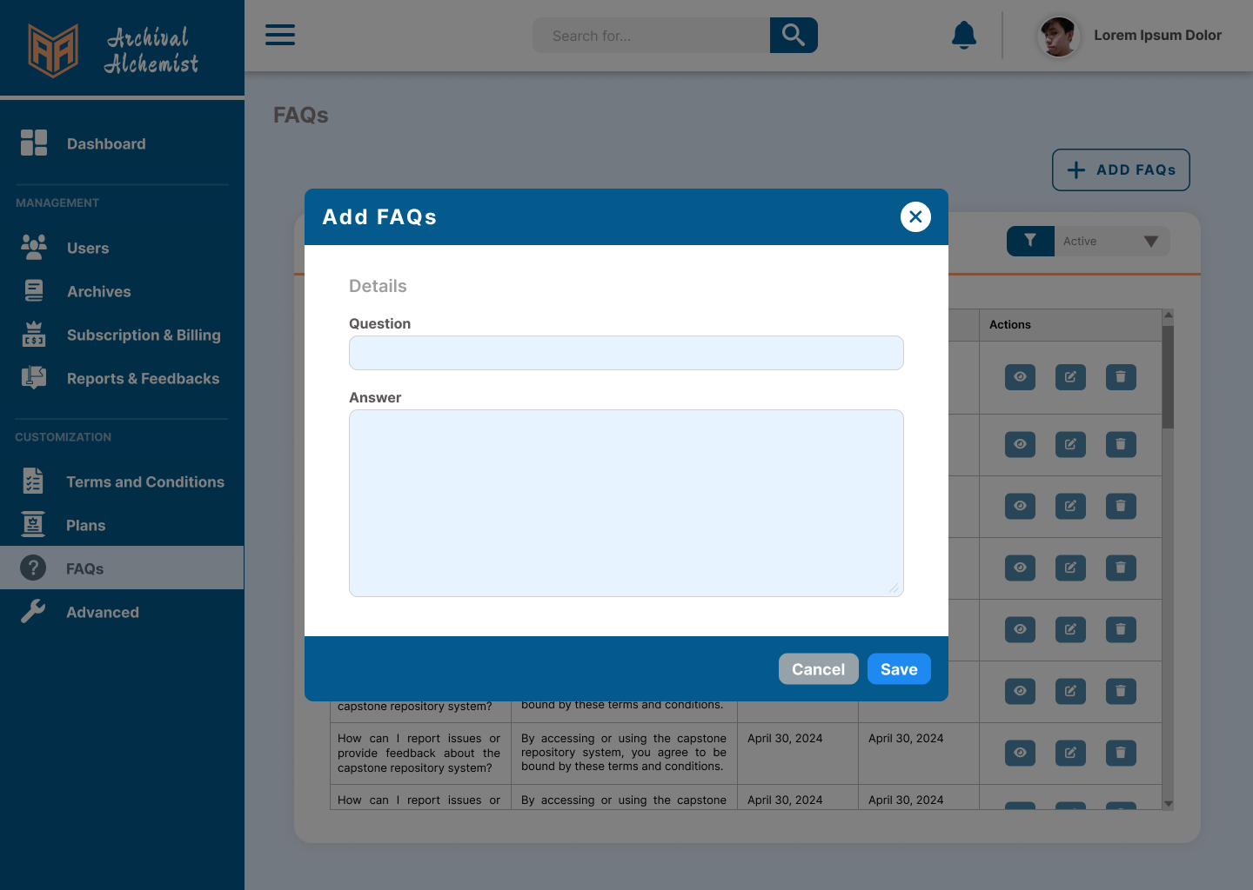

Figure 68: **Add Frequently Asked Questions**

**Figure 68:**  The figure above demonstrates that super admin can perform CRUD operations to customize the frequently asked questions page on the client side, including adding new frequently asked questions.

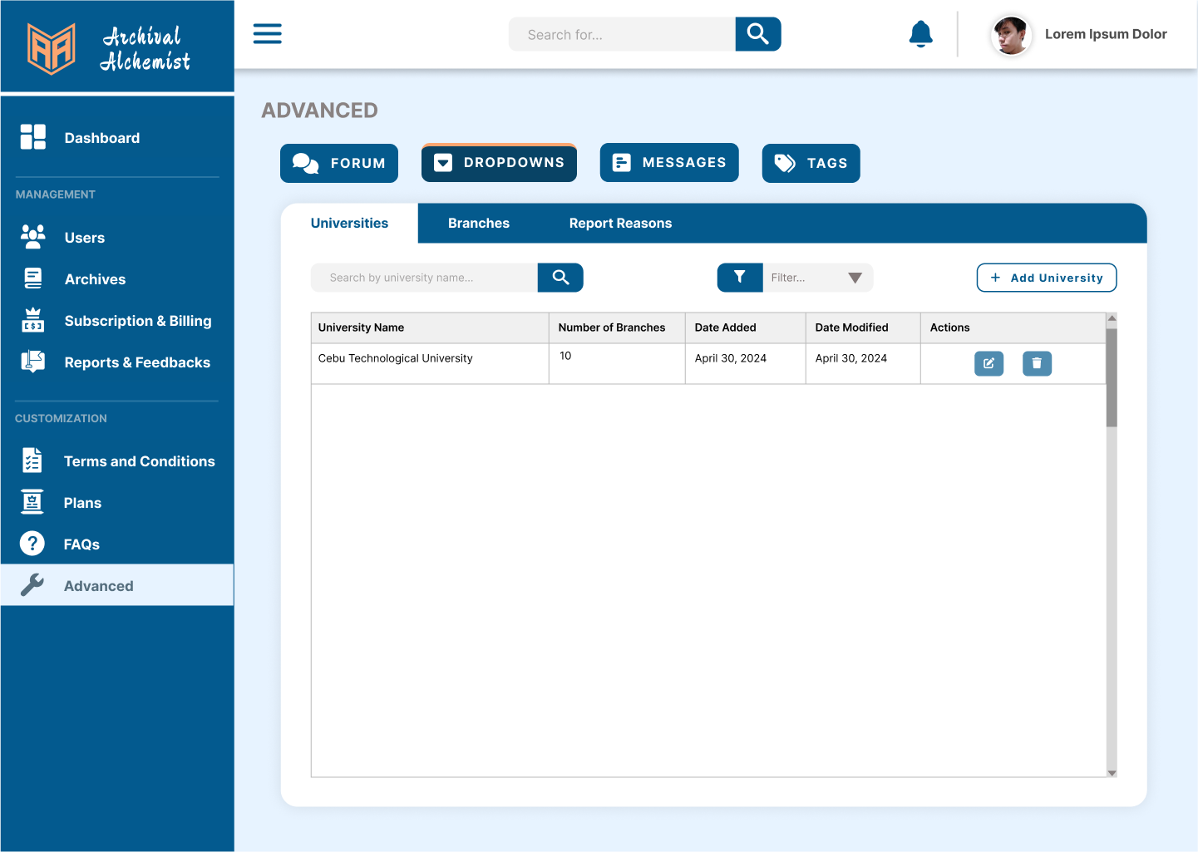

Figure 69: **Advanced**

**Figure 69:** The figure above shows the advanced page where the administrator customizes the user interface including pages, dropdowns, and tags on the client side.

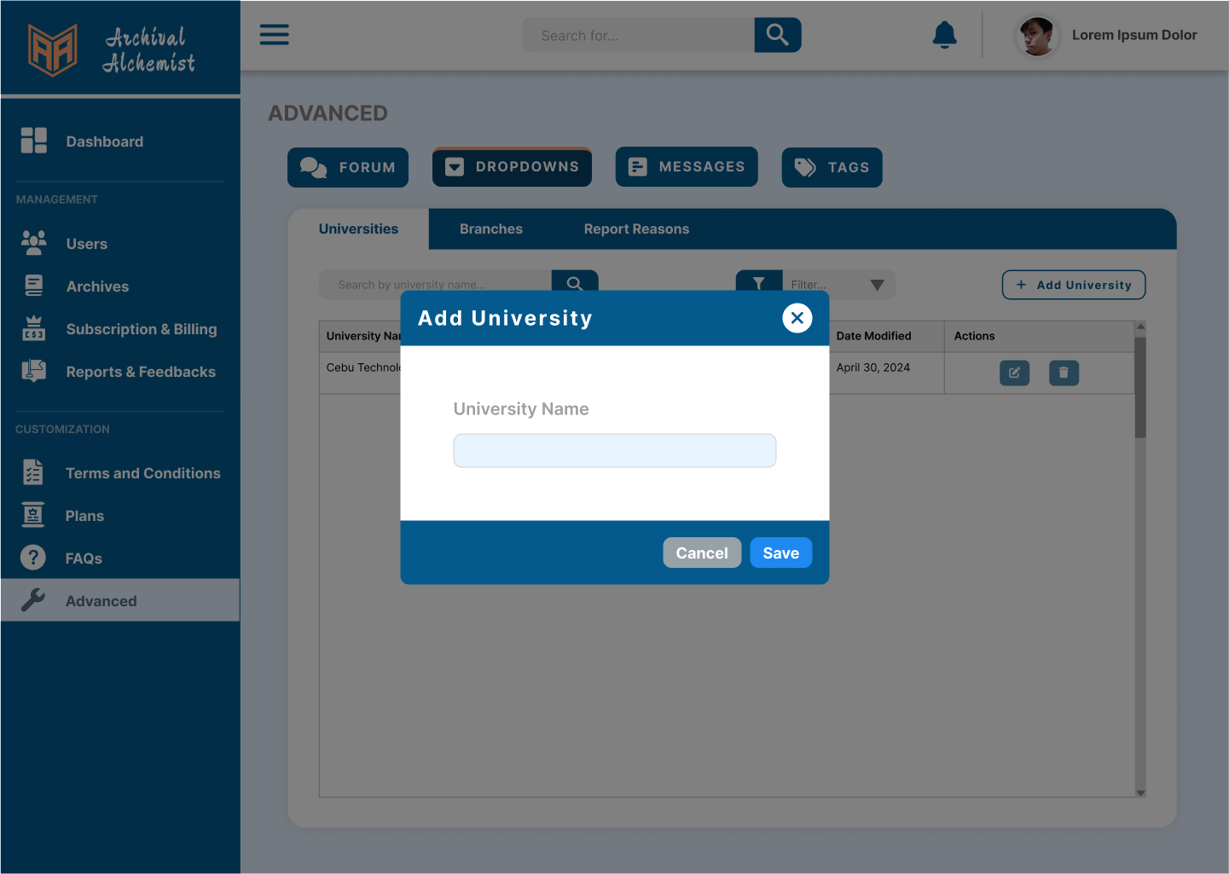

Figure 70: **Advanced(Add University)**

**Figure 70:**  The figure above demonstrates that administrators can perform CRUD operations to customize menu items for university dropdowns on the client side, including adding universities.

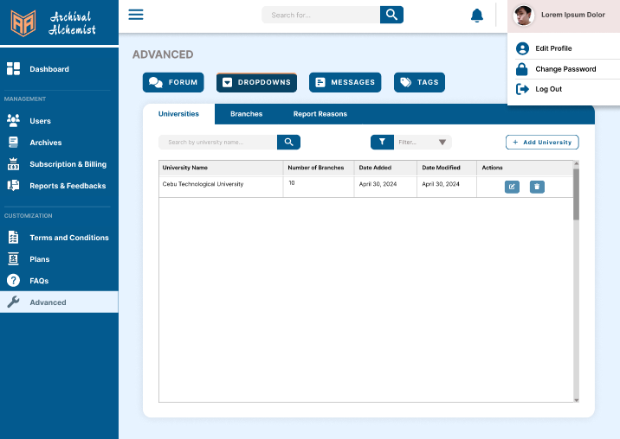

Figure 71: **Profile Settings**

**Figure 71:** The figure above demonstrates the profile settings for super admins, which include the edit profile and change password options.

**Institution Admin**

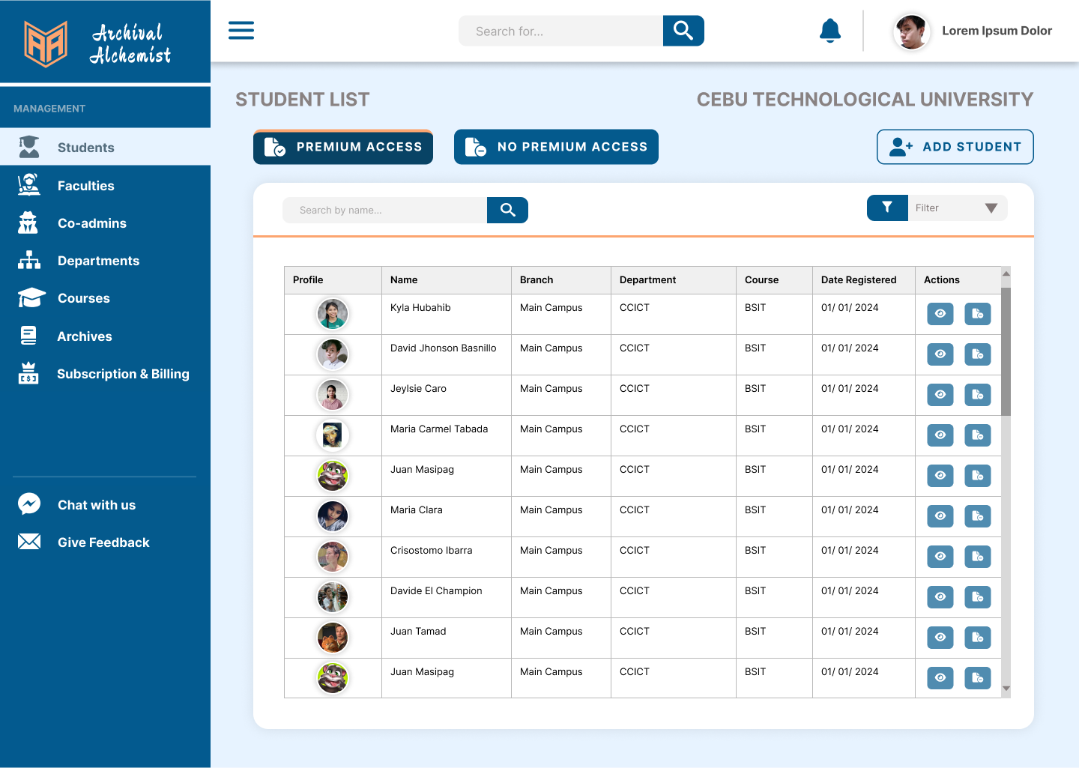

Figure 72: **Student**

**Figure 72:**  The figure above displays the list of students within the institution. Viewing students with granted or revoked premium access in the institution. Institution admin may add students to access the premium subscription.

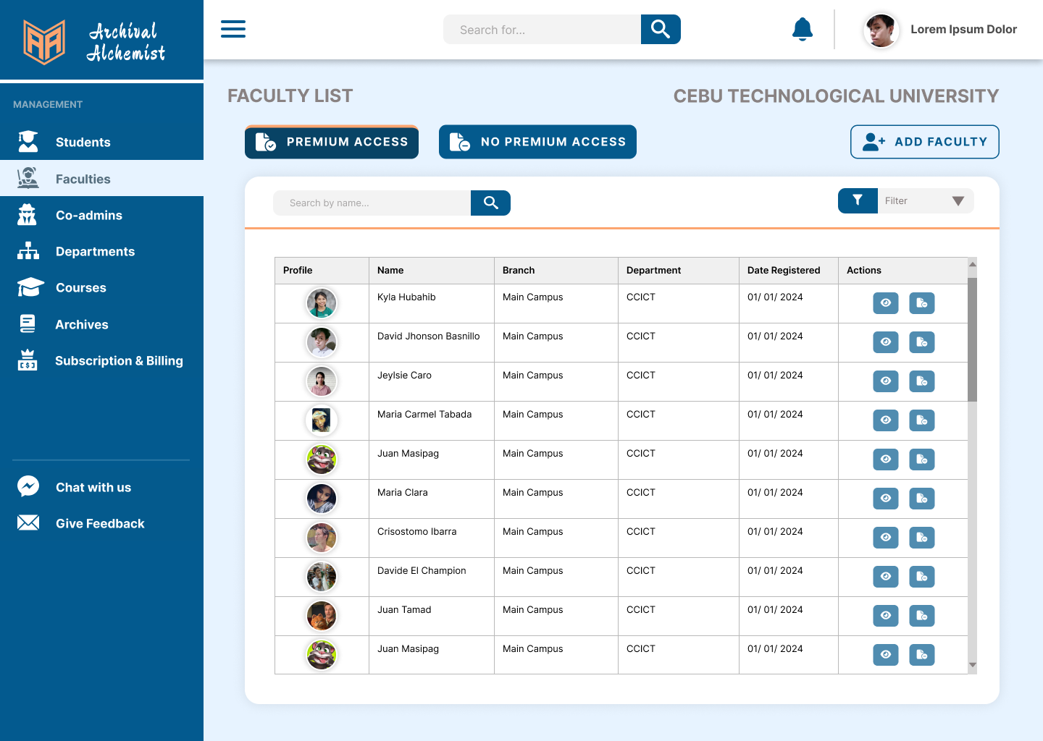

Figure 73: **Faculty**

**Figure 73:**  The figure above displays the list of faculty within the institution. Viewing faculty with granted or revoked premium access in the institution. Institution admin may add faculty to access the premium subscription.

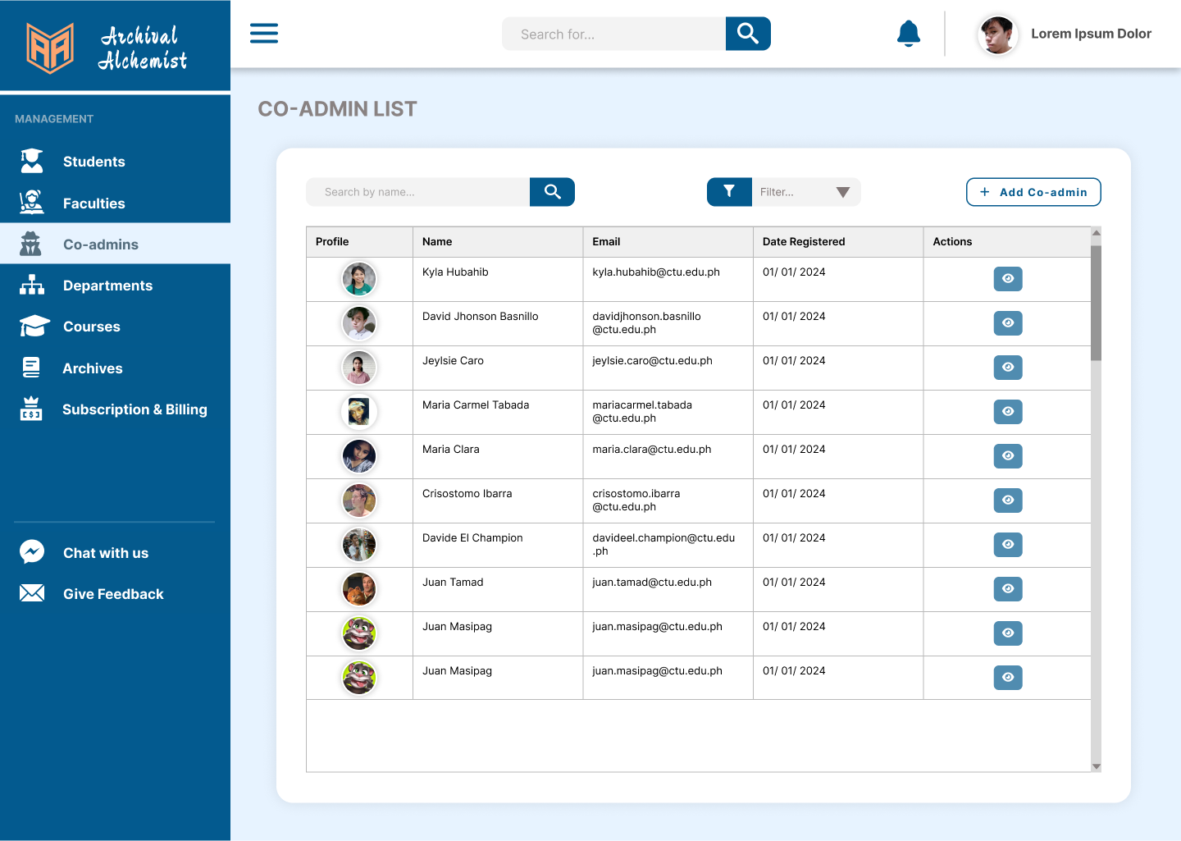

Figure 74: **Co-admins**

**Figure 74:**  The figure above displays the list of co-admins. Institution admin may add co-admin.

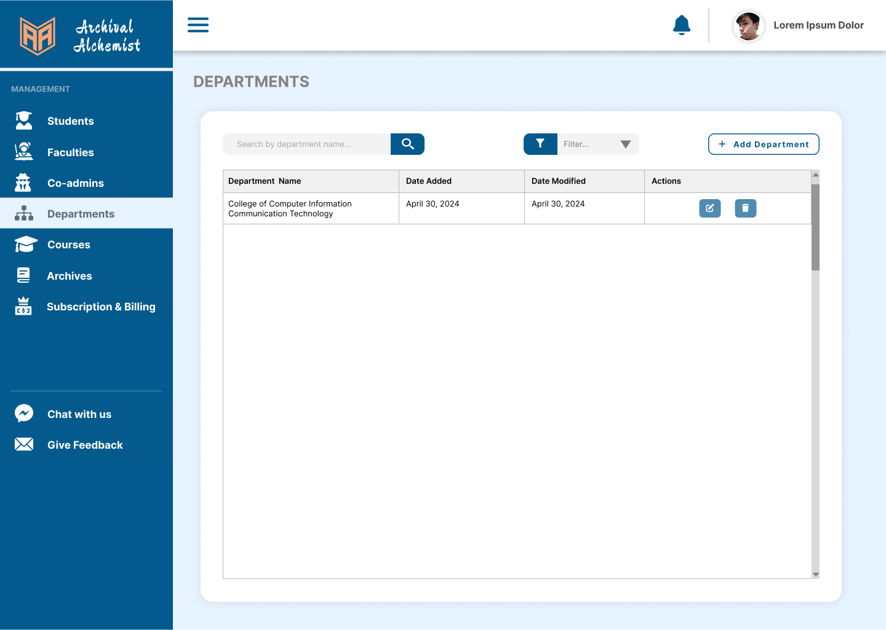

Figure 75: **Departments**

**Figure 75:**  The figure above displays the department where the institution admin can add, edit, or delete departments.

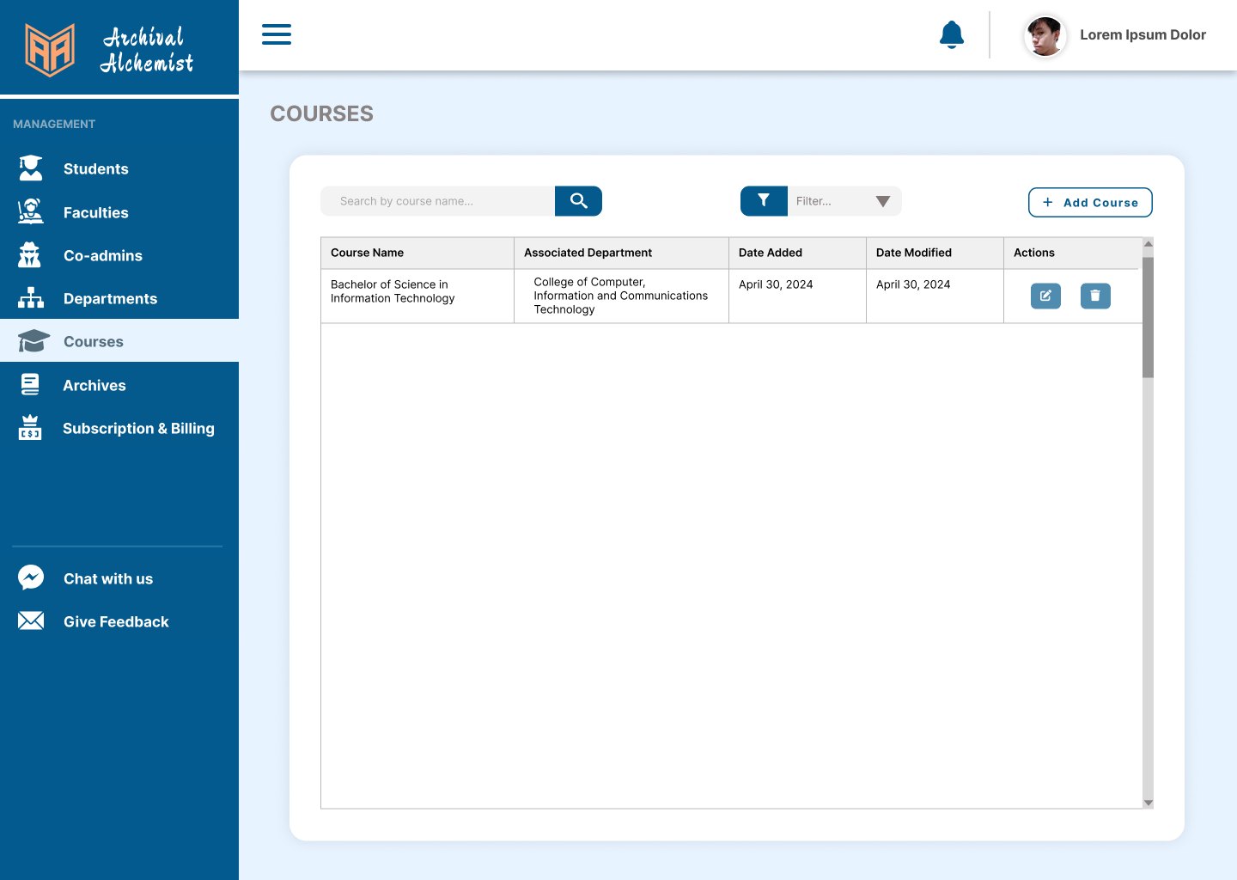

Figure 76: **Courses**

**Figure 76:**  The figure above displays the course where the institution admin can add, edit, or delete courses.

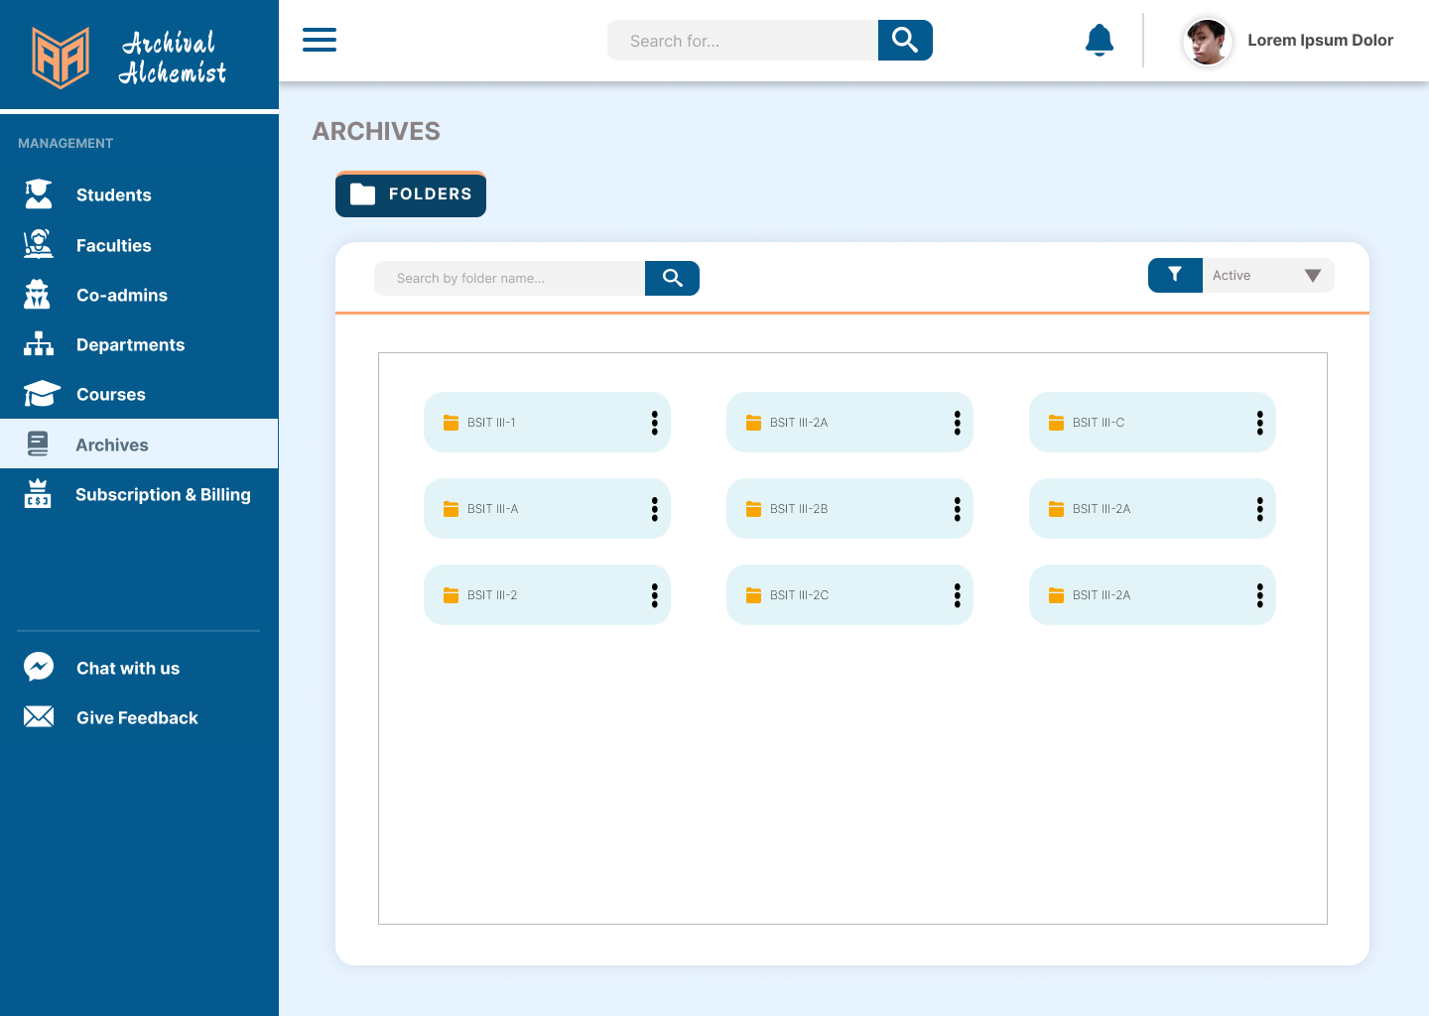

Figure 77: **Archives**

**Figure 77:**  The figure above displays the books contributed by the students in the institution with search and filter options.

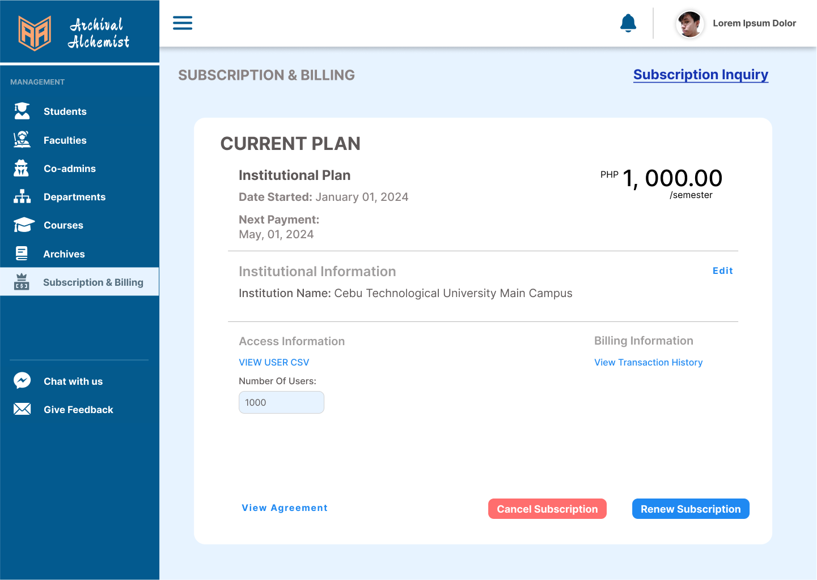

Figure 78: **Subscription and Billings**

**Figure 78:**  The above displays the subscription and billing figures. View the current plan and agreement and an upgrade subscription button opt to avail institutional subscription.

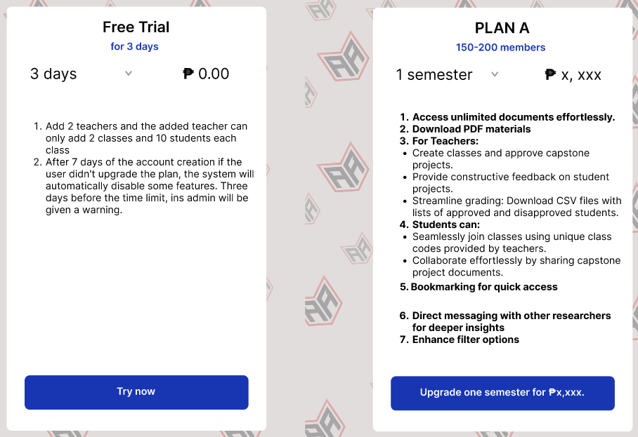

Figure 79: **Institutional Subscription Plan**

**Figure 79:**  The figure above displays the institutional subscription plan. They have subscription plan options.

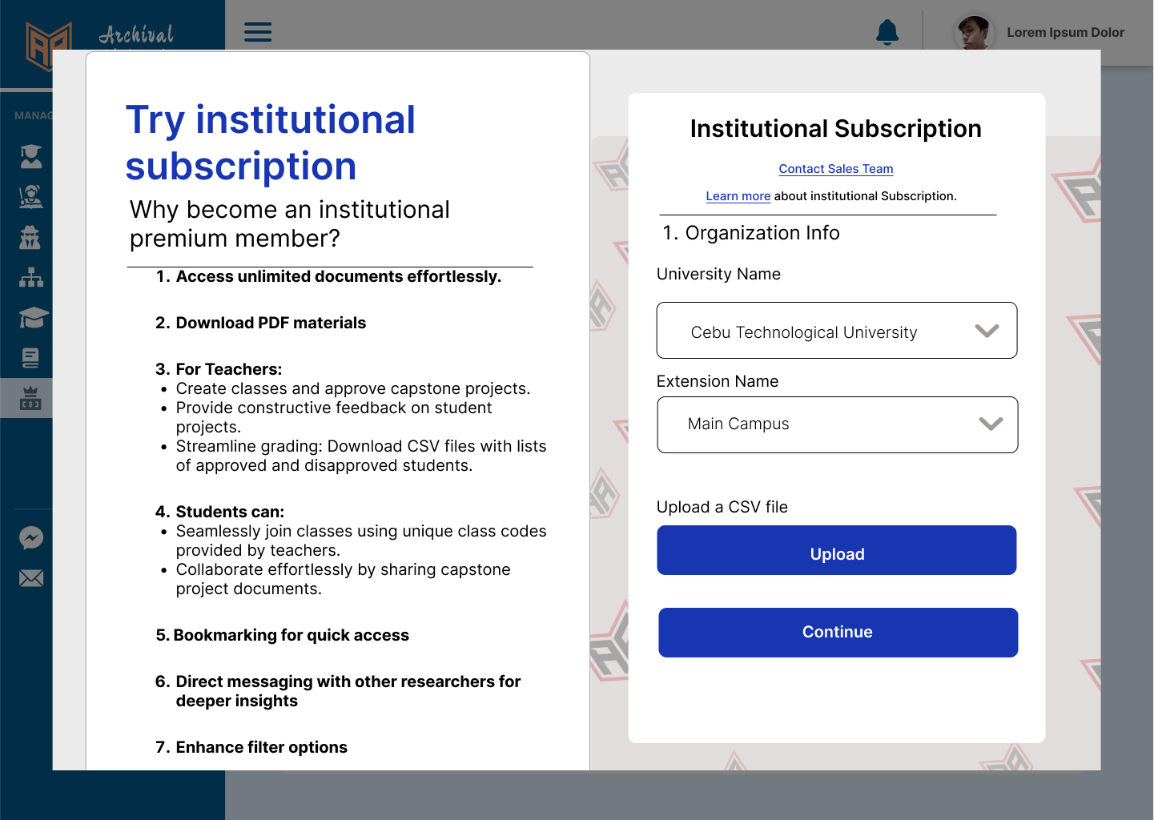

Figure 80: **Institutional Subscription**

**Figure 80:**  The figure above displays the institutional subscription that requires organization info, and uploading a csv file containing the list of members to be included in the institutional premium subscription.

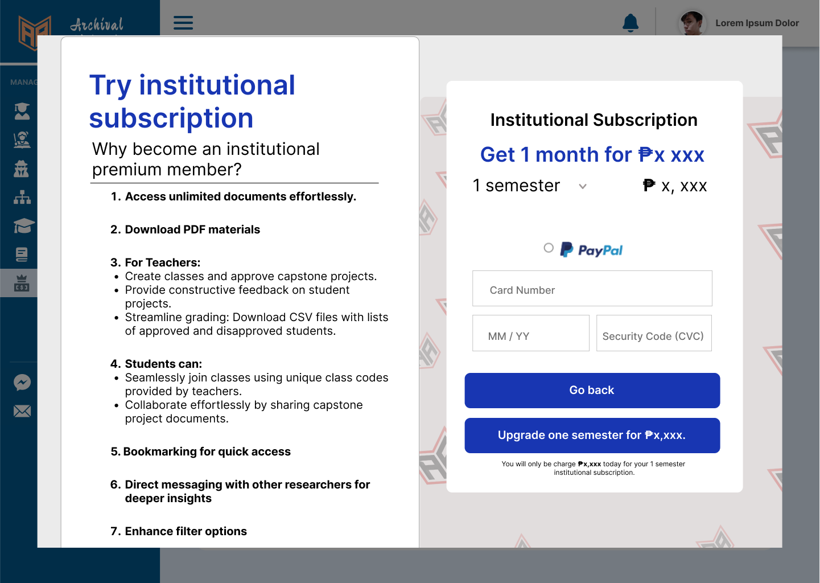

Figure 81: **Subscription Payment (Institutional)**

**Figure 81:**  The figure above displays the institutional subscription that opts to upgrade their 3-day free trial into a premium.

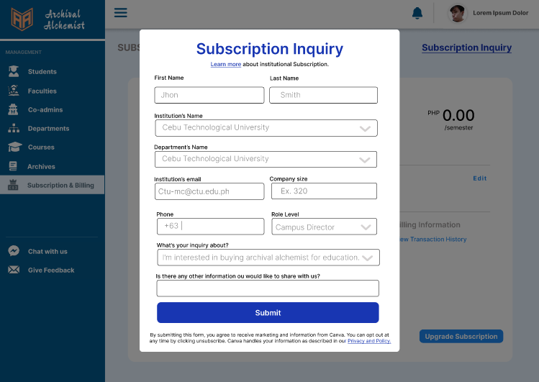

Figure 82: **Subscription Inquiry**

**Figure 82:**  The figure above displays the subscription inquiry modal where users can address additional concerns regarding the institutional subscription.

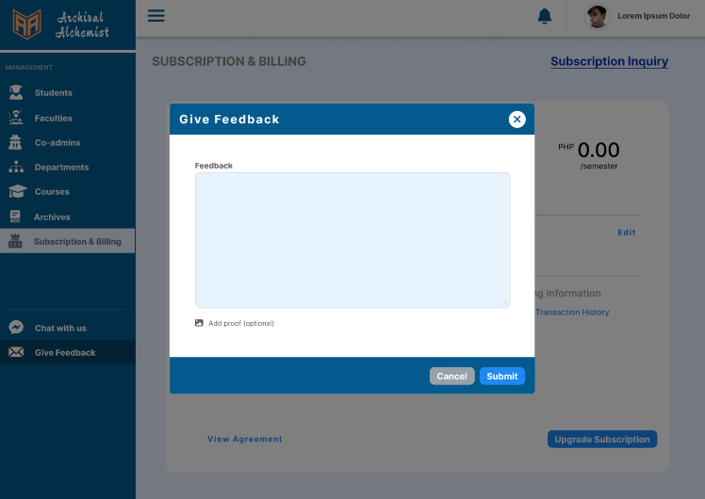

Figure 83: **Give Feedback**

**Figure 83:**  The figure above displays the feedback modal where the institution admin can give feedback to the system.

## Database Design

### 

Figure 84: **Entity Relationship Diagram**

## Data Dictionary

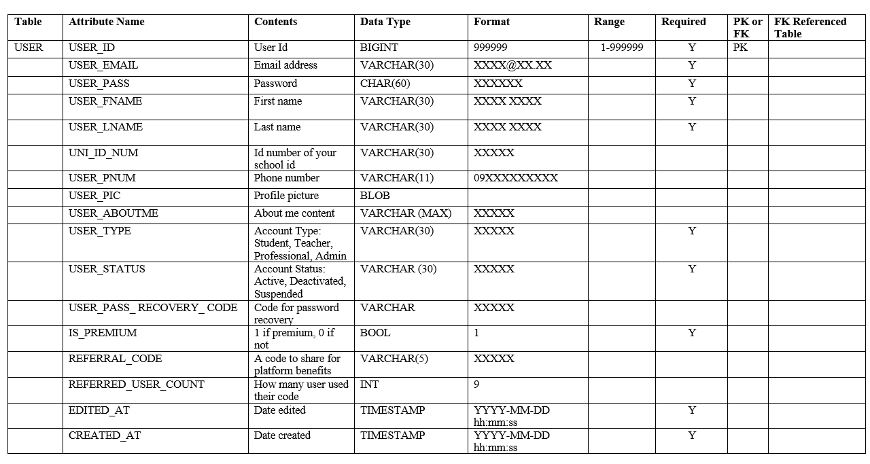

Table 6: **User Table**

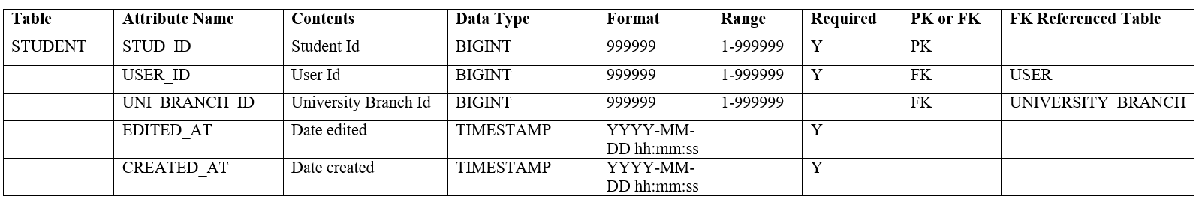

Table 7: **Student Table**

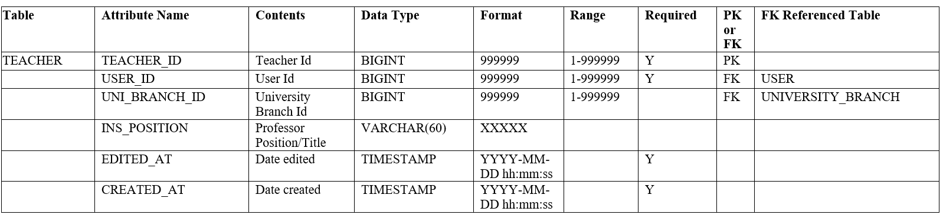

Table 8: **Faculty Table**

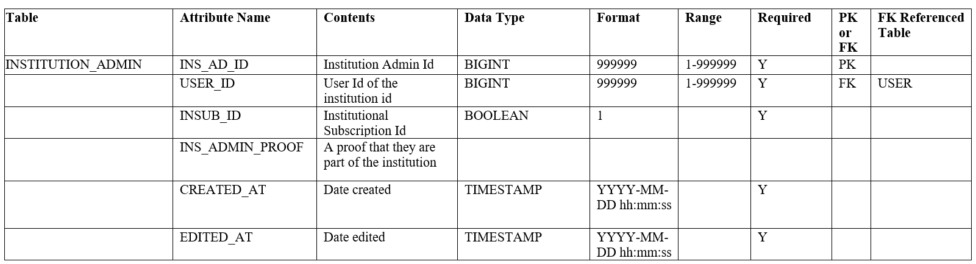

Table 9: **Institution Admin Table**

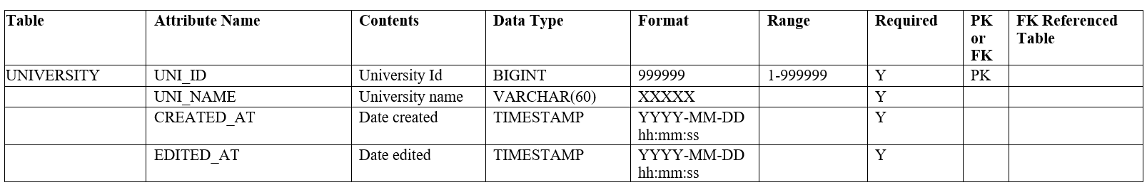

Table 10: **University Table**

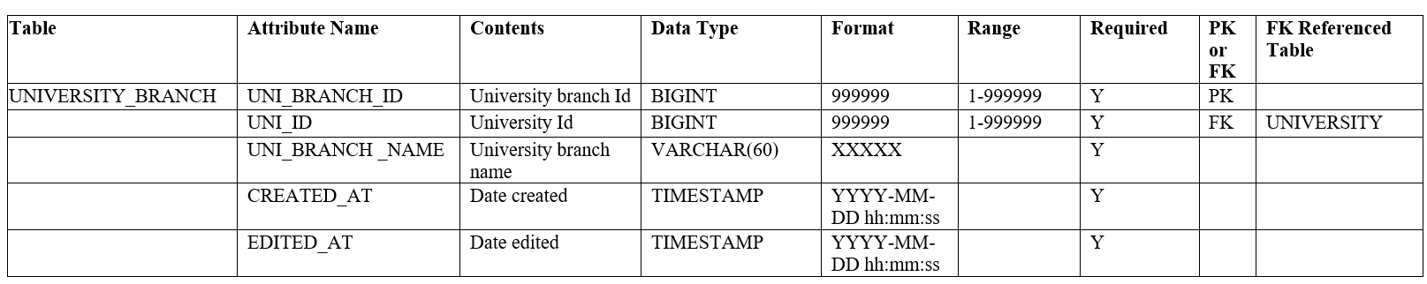

Table 11: **University Branch Table**

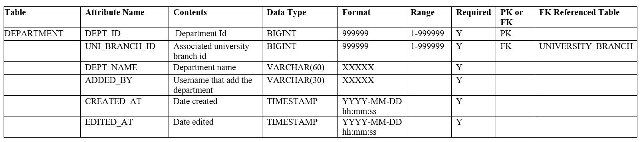

Table 12: **Department Table**

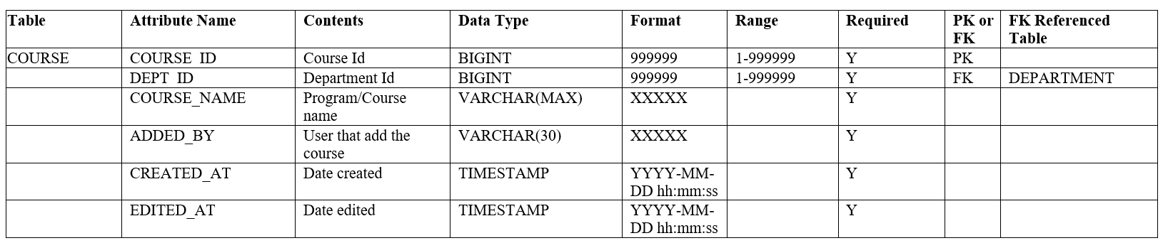

Table 13: **Course Table**

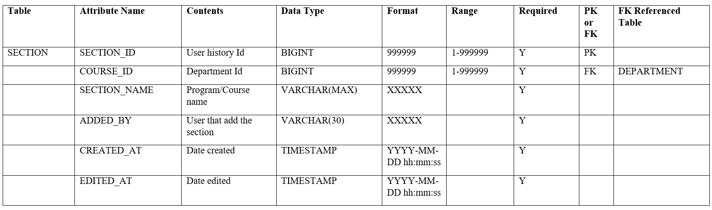

Table 14: **Section Table**

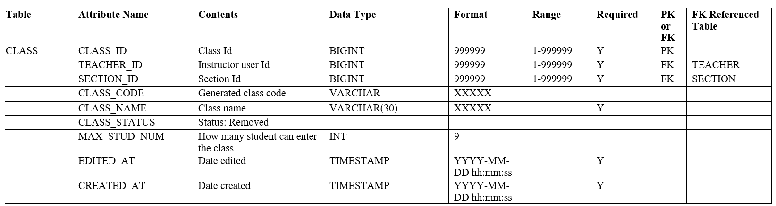

Table 15: **Class Table**

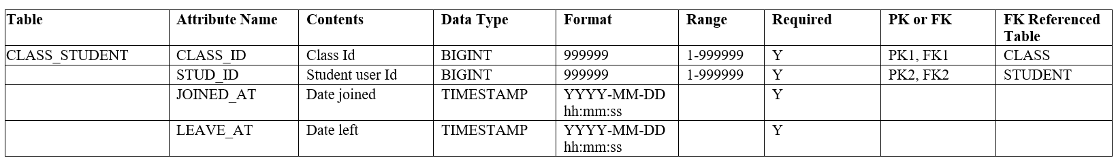

Table 16: **Class Student Table**

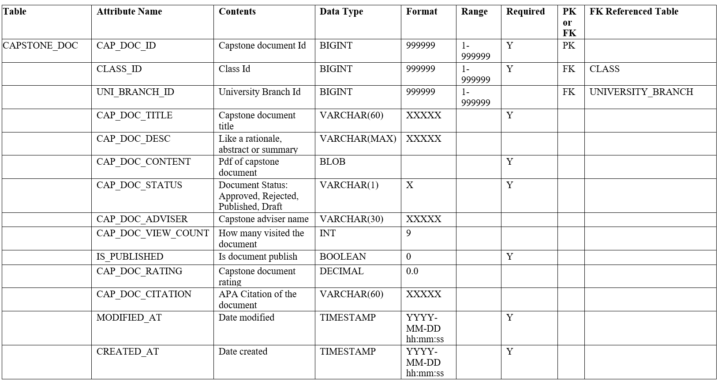

Table 17: **Capstone Document Table**

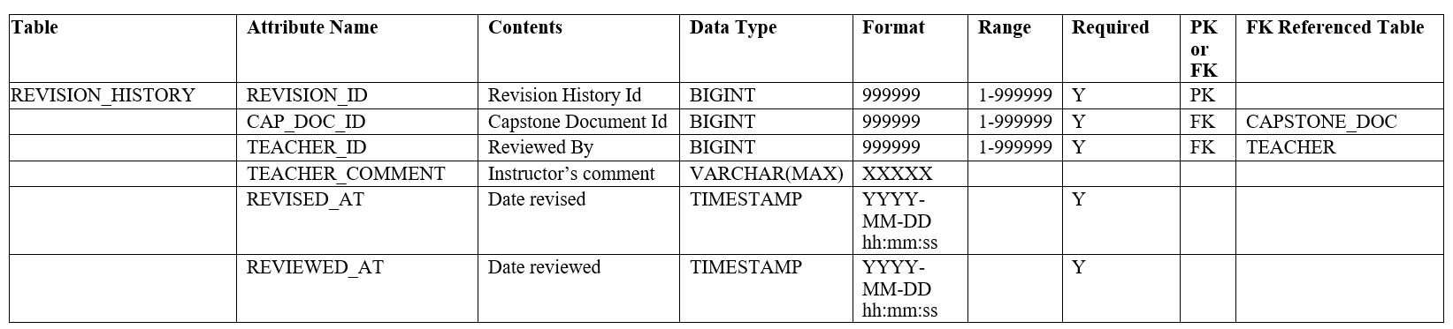

Table 18: **Revision History Table**



Table 19: **Author Table**

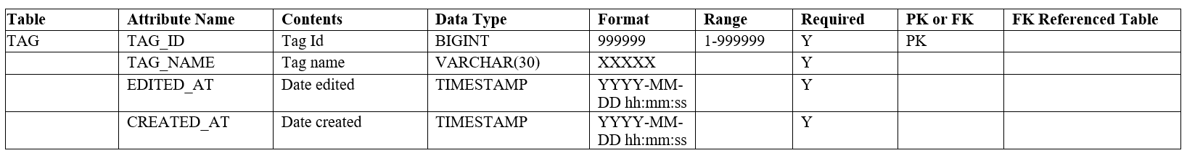

Table 20: **Tag Table**



Table 21: **Capstone Document Tag Table**

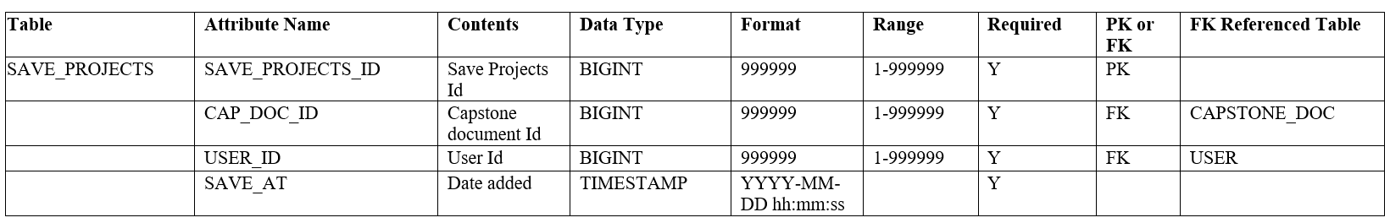

Table 22: **Saved Projects Table**

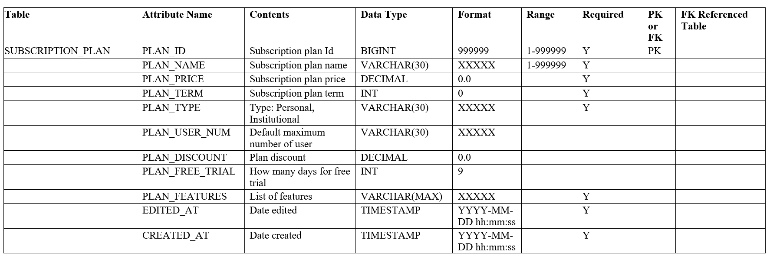

Table 23: **Subscription Plan Table**

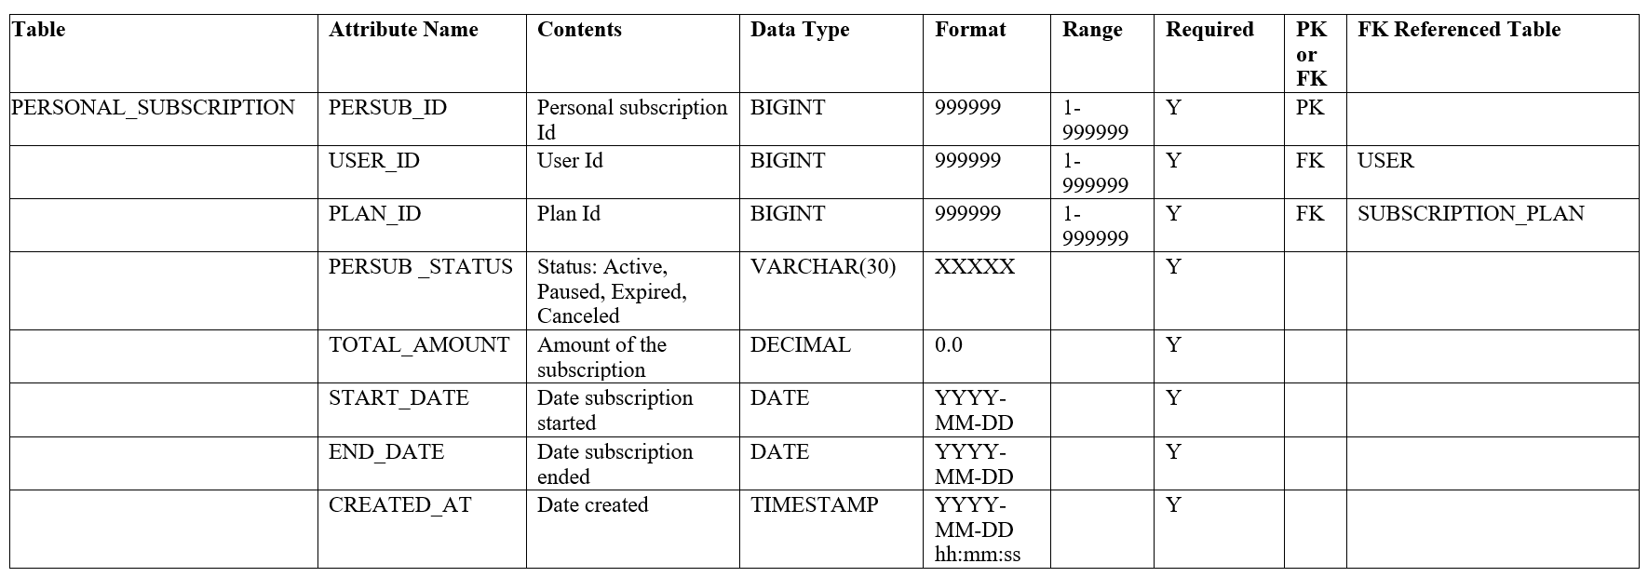

Table 24: **Personal Subscription Table**

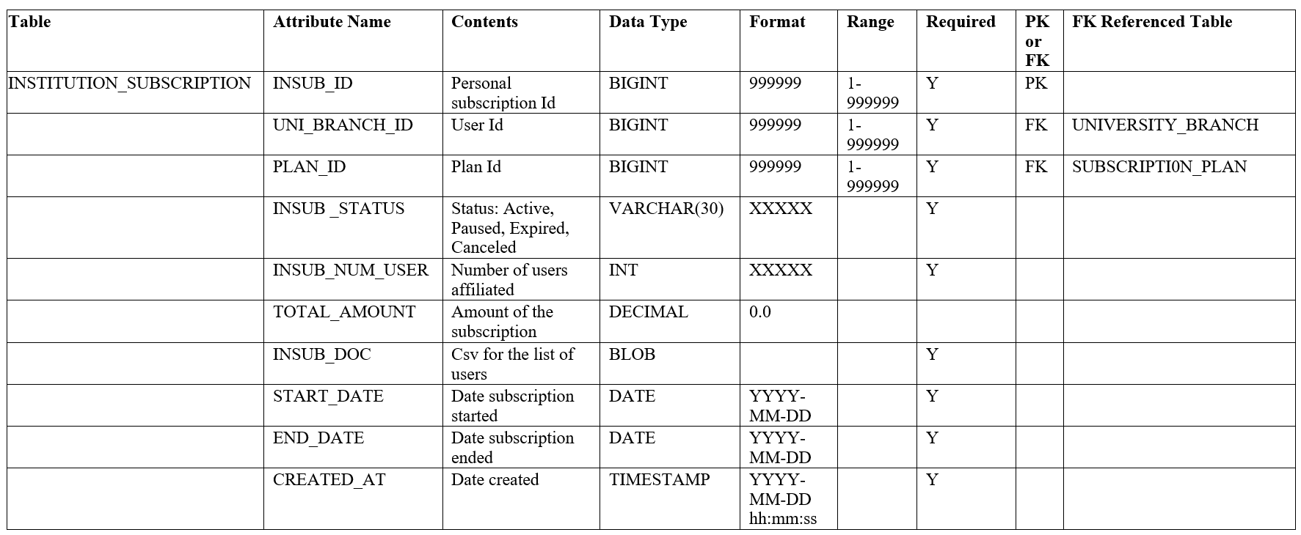

Table 25: **Institutional SubscriptionTable**

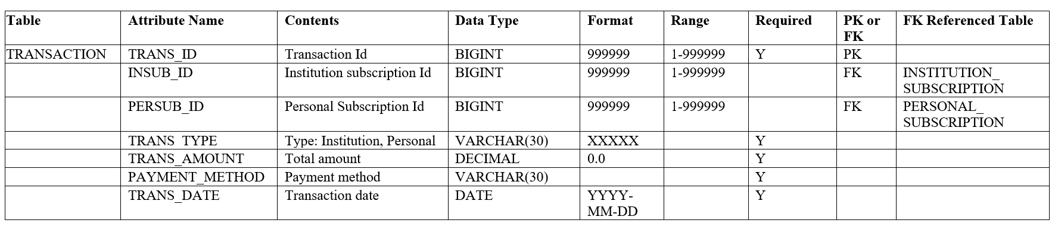

Table 26: **Transaction Table**

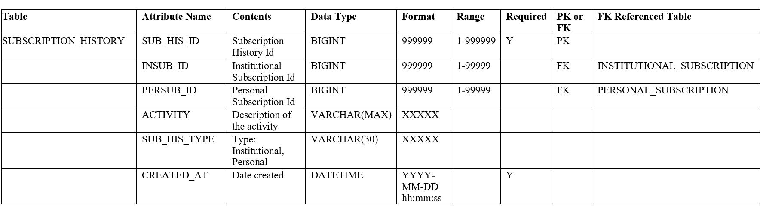

Table 27: **Subscription History Table**

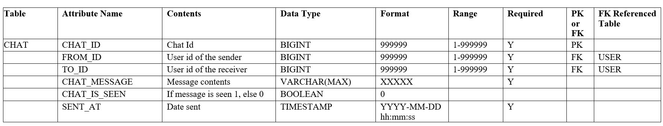

Table 28: **Chat Table**

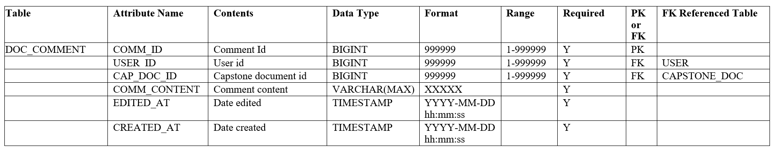

Table 29: **Document Comment Table**

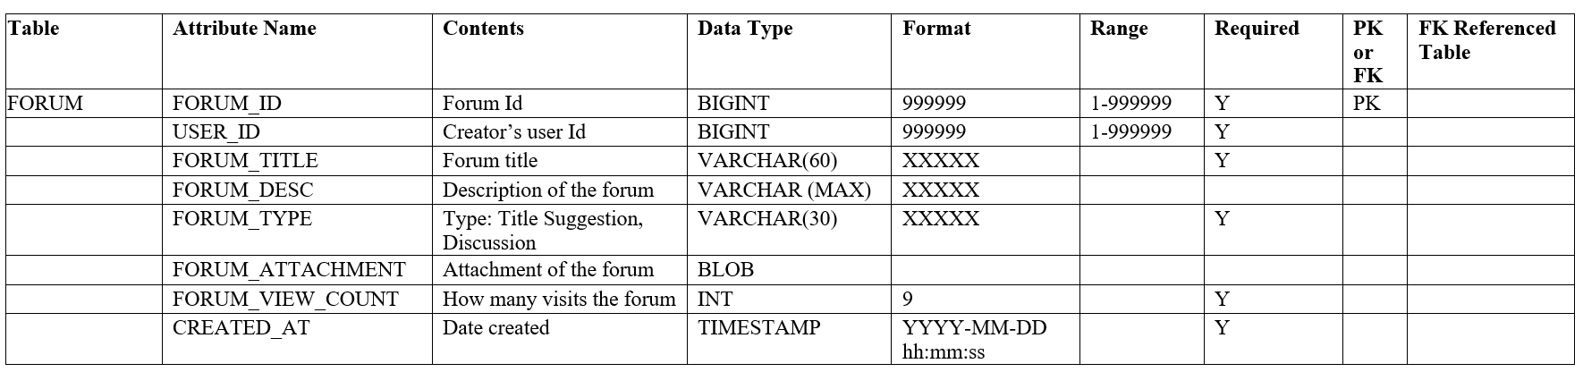

Table 30: **Forum Table**

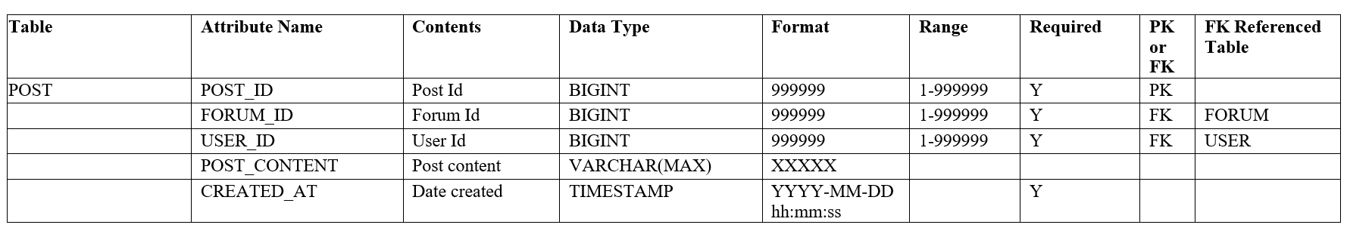

Table 31: **Post Table**

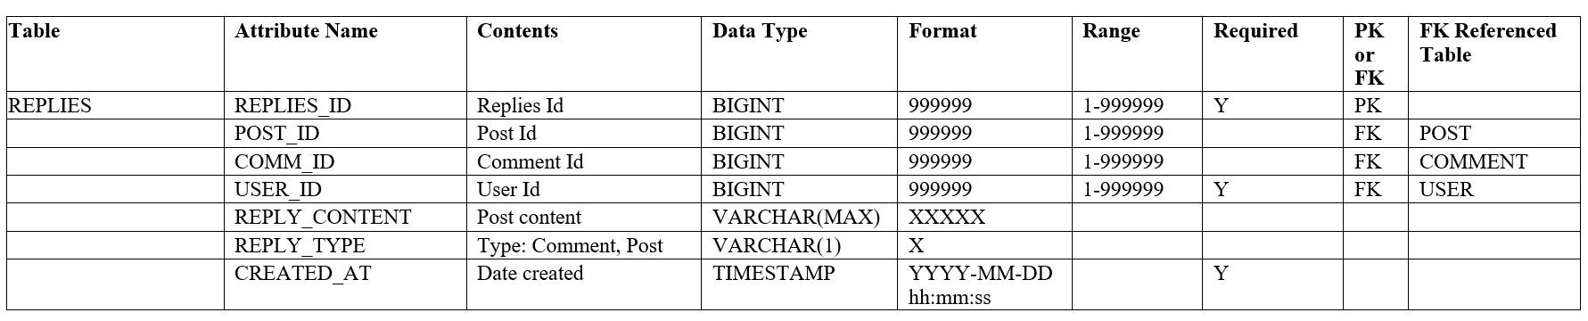

Table 32: **Replies Table**



Table 33: **Forum Tag Table**

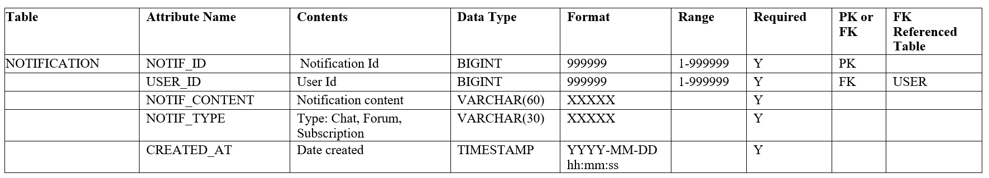

Table 34: **Notification Table**

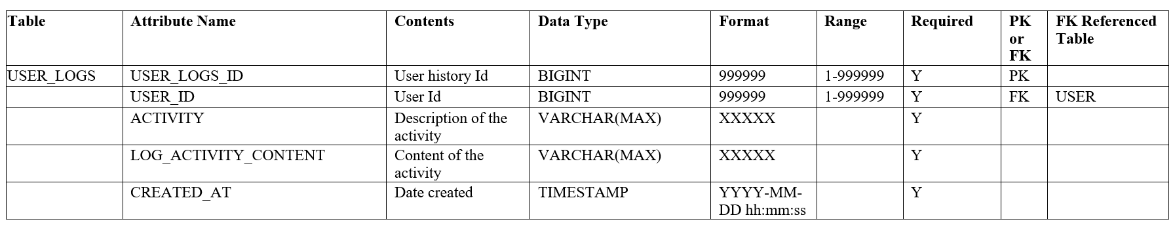

Table 35: **User Logs Table**

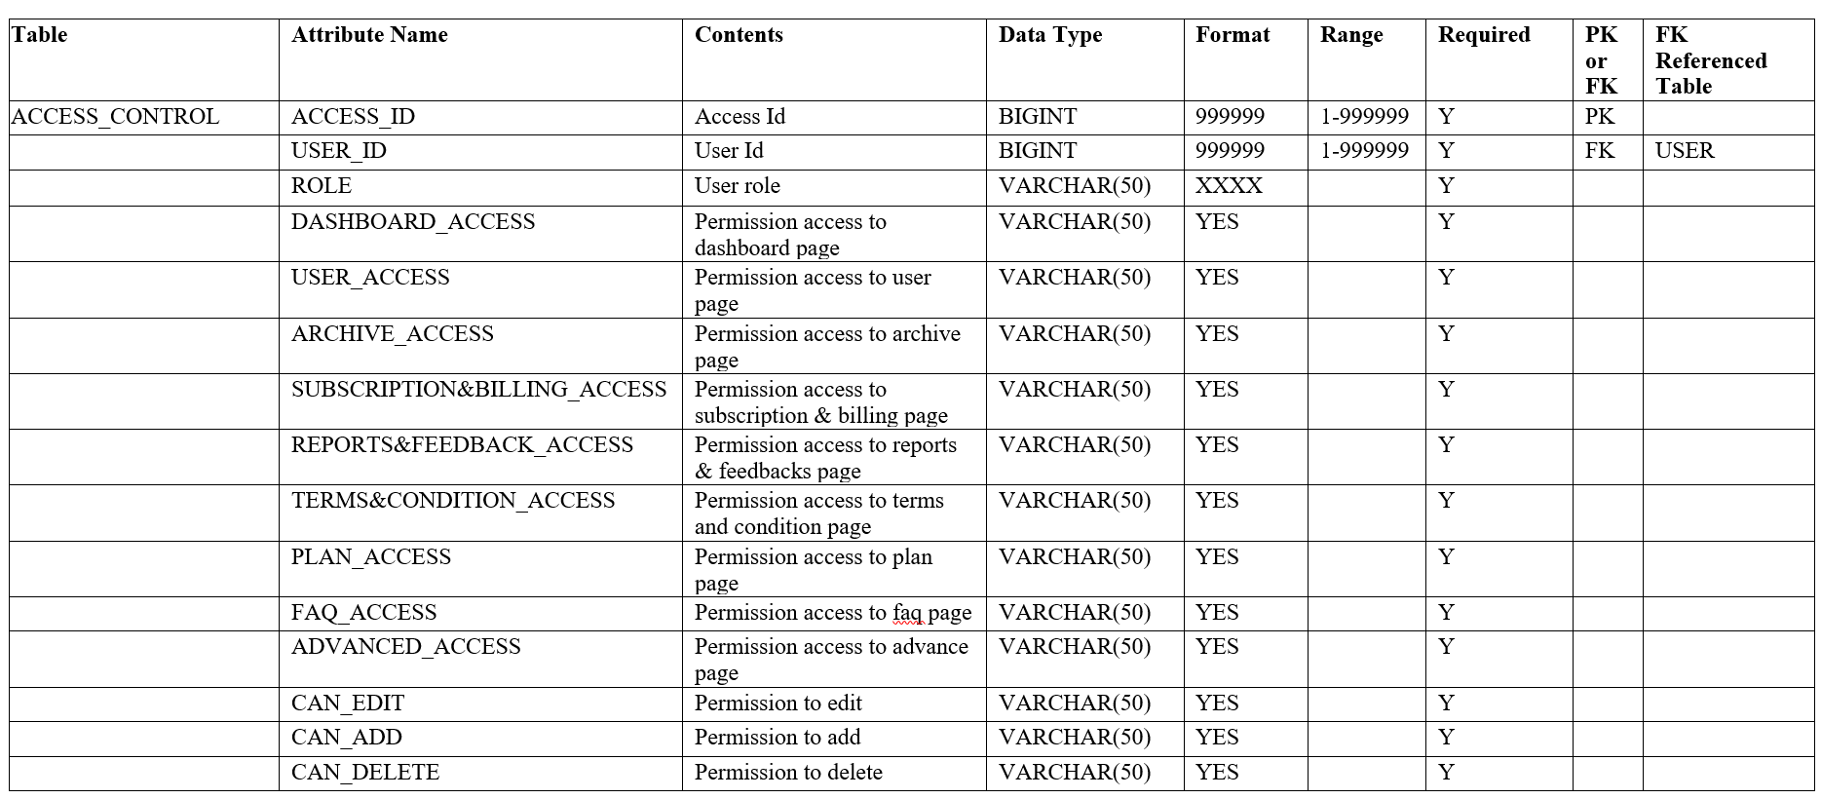

Table 36: **Access Control Table**

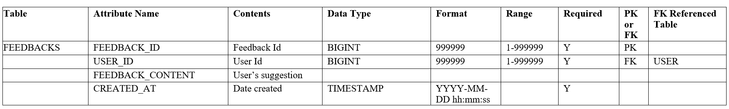

Table 37: **Feedbacks Table**

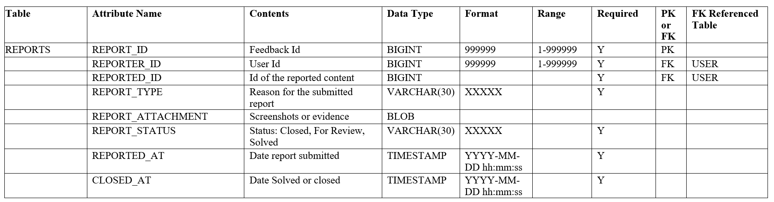

**Table 38: Reports Table**

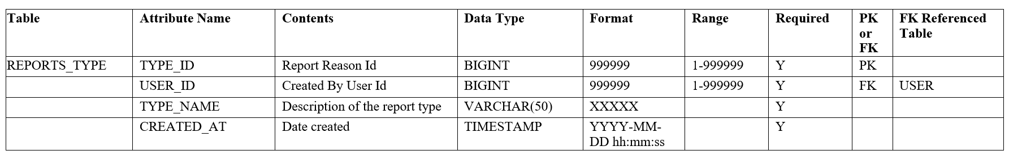

**Table 39: Reports Type Table**

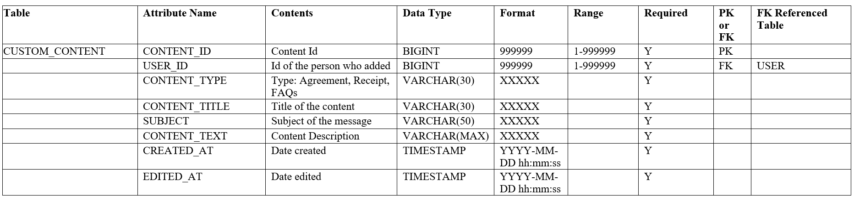

**Table 40: Custom Content Table**

## Network Design

### Network Model

Our network model is based on MySQL, a relational database management system (RDBMS) that stores, retrieves, and manages data. It arranges data into tables, each of which contains rows and columns. This relational model allows for efficient querying and manipulation of structured data using SQL (Structured Query Language) commands.





Users Internet Web Server MySQL Server





### 

Super admin

Figure 85: **Client-Server Mode**

### Network Topology

The local database for The Archival Alchemist, Cebu Technological University's capstone projects repository, follows a star network setup. It has one main campus database serving as the core hub, connected directly to 23 other campuses' databases. This design ensures straightforward data management and access, allowing each campus to interact with the central repository easily.

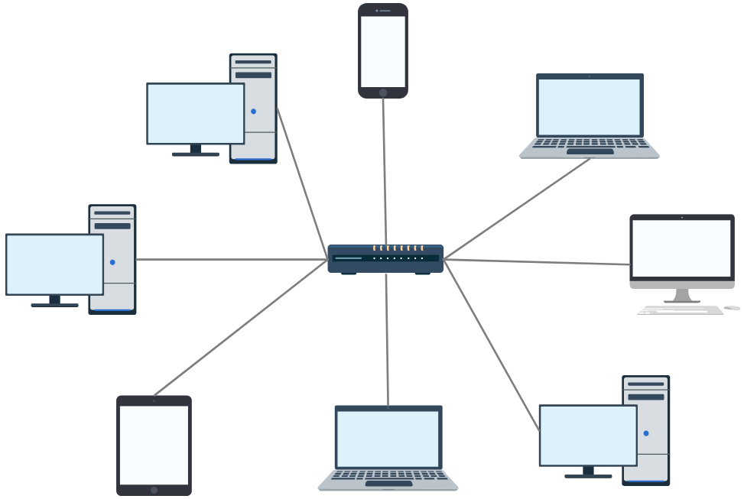

Figure 86: **Star Topology**

## Development Phase

### Technology Stack Diagram

The software tools and programming languages that will be used to develop The Archival Alchemist are detailed below. The web is the software component that makes up The Archival Alchemist.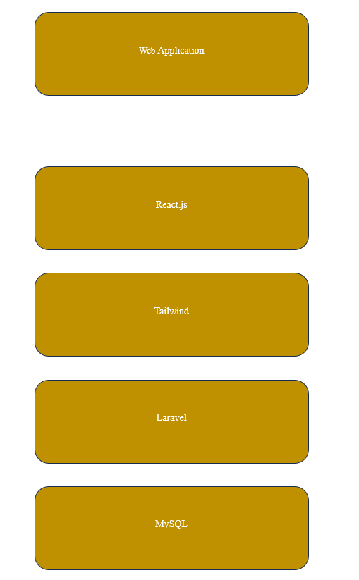

### 

### 

### 

### 

### 

### 

### 

### 

### 

### 

### 

### 

### 

### 

### 

### 

### 

### 

### 

### 

Figure 87: **Technology Stack Diagram**

### Software Specification

To successfully implement the proposed system, the researchers will be using the following specification. For the front end, the researchers will use ReactJS. It is a JavaScript library known for its component-based architecture which allows for the creation of reusable and maintainable user interface elements, fostering a dynamic and responsive user experience. Complementing ReactJS is Tailwind CSS which will be streamlining the development process and ensuring a consistent visual style throughout the application. For the back end of the application, the Laravel framework will be used which is built on the foundation of PHP, a mature and versatile programming language. Laravel streamlines common development tasks such as user authentication, database interaction, and routing which will help the researchers to focus on the core functionalities of the system. Finally, MySQLwhich is a widely-adopted relational database management system will be used for the database of the system. The following technologies – ReactJS, Tailwind CSS, Laravel, and MySQL– will help the researcher in the development of the system.

The figure below shows the software specification for the development of the web application:

| Language | HTML5, CSS, JAVASCRIPT, PHP |
| --- | --- |
| DBMS | MySQL |
| Operating System | Windows 10/11 |
| IDE | Visual Studio |
| Image Editor | Canva |
| Web Browser | Mozilla, Chrome, Microsoft Edge |
| Web Development Environment | Visual Studio Code |

### 

Table 41: **Software Specification for Web Application Implementation Stage**

| Language | HTML5, CSS, JAVASCRIPT, PHP |
| --- | --- |
| DBMS | MySQL |
| Operating System | Windows 10/11 |
| IDE | Visual Studio |
| Image Editor | Canva |
| Web Browser | Mozilla, Chrome, Microsoft Edge |
| Web Development Environment | Visual Studio Code |

### 

### 

### 

### 

### 

### 

### 

### 

### 

Table 42: **Software Specification for Web Application Development Stage**

### 

### 

### Hardware Specification

Determining the hardware specification of the system is a crucial part of the development of the system since knowing the minimum and recommended hardware requirements helps ensure the system runs smoothly on the target devices. The central processing unit (CPU) needed for building the application is Intel Core i3 seventh generation or AMD Ryzen and higher versions. The random access memory (RAM) should be at least 4GB and the internal storage must be a solid state drive (SSD) for faster loading times. Since the system is a web-based application, it requires connectivity. The suitable connectivity for the system would be WiFi, DSL, and Fiber Optic internet connection.

| CPU | Intel Core i3 (Minimum) |
| --- | --- |
| RAM | 8GB (Minimum) |
| Internal Storage | 50GB (Minimum) |
| Connection | WiFi, DSL/Fiber Optic |

Table 43: **Hardware Specification for Web Application Implementation Stage**

| CPU | Intel Core i3 (Minimum) |
| --- | --- |
| RAM | 4GB (Minimum) |
| Internal Storage | 50GB (Minimum) |
| Connection | WiFi, DSL/Fiber Optic |

Table 44: **Hardware Specification for Web Application Development Stage**

### Program Specification

**List of Modules**

| Programmers | Module | Super Admin | Student | Faculty | Institution admin |
| --- | --- | --- | --- | --- | --- |
| User Interface Module (Done : Red Color) | | | | | |
| Jeylsie Caro | **Account Management** | | | | |
| 1. Register and login |  | * | * | * |
| 2. Profile Management | * | * | * | * |
| 3. Change Password | * | * | * | * |
| Jeylsie Caro | **Document Management** | | | | |
| 1. Download documents | * | * | * | * |
| 2. Upload and modify capstone projects |  | * | * |  |
| 3. Save favorite Projects |  | * | * |  |
| 4. Rate Projects |  | * | * |  |
| Jeylsie Caro | **Client Search and Discovery** | | | | |
| 1. Search and browse projects |  | * | * | * |
| 2. Filter projects such as title, university, author, or tags |  | * | * | * |
| Maria Carmel Tabada | **Notifications** | | | | |
| 1. View Notifications | * | * | * | * |
| 2.Delete Notifications | * | * | * | * |
| **User Guide** | | | | |
| Maria Carmel Tabada | 1. View System Tour |  | * | * | * |
| 2. View Terms and Conditions |  | * | * | * |
| Maria Carmel Tabada | **Forum** | | | | |
| 1. Search and browse discussions |  | * | * |  |
| 2. Filter discussions such as title, author, or tags |  |  |  |  |
| 3. Posting |  | * | * |  |
| 4. Commenting |  | * | * |  |
| 5. Report post |  | * | * |  |
| Maria Carmel Tabada | **Chat** | | | | |
| 1. Send or Receive Message |  | * | * | * |
| Jeylsie Caro | **Client Subscription Plan Option** | | | | |
| 1. Purchase and renew Subscription |  | * | * | * |
| 2. Cancel Subscription |  | * | * | * |
| Administrative Module | | | | | |
| David Jhonson  Basnillo | **User and Institutional Management**: | | | | |
| 1. Access Control | * |  |  | * |
| 2. User Listing/Viewing | * |  |  | * |
| 3. User Updating | * |  |  |  |
| 4. User Activation/Deactivation | * |  |  |  |
|  | 5. Manage department and courses |  |  |  | * |
| David Jhonson  Basnillo | **Multi-University Archive Viewing** | | | | |
| 1. View archives | * |  |  |  |
| 2. Filter projects such as title, university, author, or tags | * |  |  |  |
| David Jhonson  Basnillo | **Subscription and Billing Management** | | | | |
| 1. User Subscription Listing/Viewing | * |  |  | * |
| 2. Subscription Activation/Deactivation | * |  |  |  |
| 4. Billing and Receipt | * |  |  | * |
| David Jhonson  Basnillo | **Transaction Management** | | | | |
| 1. Transaction Listing/Viewing | * |  |  | * |
| 2. Transaction Search and Filtering | * |  |  | * |
| Kyla Hubahib | **Dynamic Content** | | | | |
| 1. Mange Forums | * |  |  | * |
| 2. Manage dropdowns | * |  |  |  |
| 3. Manage personalize messages | * |  |  |  |
| 4. Manage tags | * |  |  |  |
|  | 5. Manage Subscription plan | * |  |  |  |
|  | 6. Manage FAQ’s | * |  |  |  |
|  | 7. Manage Terms & Conditions | * |  |  |  |
| Kyla Hubahib | **Dashboard** | | | | |
| 1. Generate records | * |  |  |  |
| 2. Generate sales | * |  |  |  |
| 3.Admin Notifications | * |  |  | * |
| Kyla Hubahib | **Communication Support** | | | | |
| 1. Technical Support |  | * | * | * |
| 2.Manage the client reports & system feedback | * |  |  |  |
|  | | | | | |
| No of Points (1 per module per user) | |  |  |  |  |
| Number of Modules per User (equals no.of points per user) | |  |  |  |  |
| Total Number of Modules | |  |  |  |  |

# REFERENCES

Achmad, F., Kholis, N., Dianawati, R., Rahmatullah, D., Nugroho, Y. S., & Uulaa, R. F. R. (2023). The Influence of Industrial Work Practice Experience-Career Information on Student Competence with Work Motivation as an Intervening Variable in Bachelor of Electrical Engineering Education Graduates. IJORER : International Journal of Recent Educational Research, 4(6), 700-709. <https://doi.org/10.46245/ijorer.v4i6.430>

About Google Scholar. (n.d.).<https://scholar.google.com/intl/en/scholar/about.html>

About us | ResearchGate. (n.d.-b).<https://www.researchgate.net/about>

Academia.edu | about. (n.d.).<https://www.academia.edu/about>

April Krukowski. 2001. Providing file storage & web space for students: which path to take? In Proceedings of the 29th annual ACM SIGUCCS conference on User services (SIGUCCS '01). Association for Computing Machinery, New York, NY, USA, 70–72. <https://doi.org/10.1145/500956.500975>

Chapman, C., Ramondt, L., & Smiley, G. (2005). Strong community, deep learning: exploring the link. Innovations in Education and Teaching International, 42(3), 217–230. <https://doi.org/10.1080/01587910500167910>

Christianah Oluwanifemi Itiola, Babatunde Gabriel Iwasokun, Johnson Damilola Adetooto. Development of an Online Repository forAcademic Research Works in FUTA. International Journal of Sustainability Management and Information Technologies. <https://www.academia.edu/81955833/Development_of_an_Online_Repository_for_Academic_Research_Works_in_FUTA>

D'Angelo, C. (2018). The impact of technology: Student engagement and success. Technology and the Curriculum: Summer 2018. <https://pressbooks.pub/techandcurriculum/chapter/engagement-and-success/>

Digital Libraries to Ease Learning in the Philippines – OpenGov Asia. (n.d.). Digital Libraries to Ease Learning in the Philippines – OpenGov Asia. Retrieved April 22, 2024, from <https://opengovasia.com/2021/08/20/digital-libraries-to-ease-learning-in-the-philippines/>

Embracing the future: embedding digital repositories in the University of London. Briefing paper. (n.d.). Embracing the future: embedding digital repositories in the University of London. Briefing paper. Retrieved April 4, 2024, from <http://www.rand.org/pubs/research_briefs/RB9411/>

Hoorens, Stijn, Jeff Rothenberg, Constantijn van Oranje-Nassau, Martin van der Mandele, and Ruth Levitt, Addressing the uncertain future of preserving the past: Towards a robust strategy for digital archiving and preservation. Santa Monica, CA: RAND Corporation, 2007. <https://www.rand.org/pubs/technical_reports/TR510.html>.

How many scholarly papers are on the Web? At least 114 million, professor finds. (n.d.). How many scholarly papers are on the Web? At least 114 million, professor finds. Retrieved April 23, 2024, from <https://www.psu.edu/news/research/story/how-many-scholarly-papers-are-web-least-114-million-professor-finds/>

J. Bughin et al. Skill shift, Skill shift: Automation and the future of the workforce (2018)What is a Research Repository? Benefits and Uses. (n.d.). What is a Research Repository? Benefits and Uses. Retrieved May 14, 2024, from <https://dovetail.com/research/what-is-a-research-repository/>

Jeffery, D. (2010). The Project Fragmentation Problem on the Web. Proceedings of the Irish Human Computer Interaction (iHCI), Dublin, Ireland. <https://scholarworks.umt.edu/cgi/viewcontent.cgi?article=1795&context=etd>

Jianzhong Xu, Jianxia Du, & Xitao Fan. (2015). Students’ Groupwork Management in Online Collaborative Learning Environments. Journal of Educational Technology & Society, 18(2), 195–205. <http://www.jstor.org/stable/jeductechsoci.18.2.195>

Kamila, K. Institutional Repository Building through GSDL: A Case Study of Burdwan University.<https://www.researchgate.net/profile/Kanchan-Kamila/publication/286439483_Institutional_Repository_Building_through_GSDL_A_Case_Study_of_Burdwan_University/links/5668f4c308ae8d6928fbcc98/Institutional-Repository-Building-through-GSDL-A-Case-Study-of-Burdwan-University.pdf>

LibGuides: Google for school: Google Scholar. (n.d.).<https://resources.nu.edu/c.php?g=1110227&p=8097118>

Library Guides: Researcher Profiles, Identifiers and Social Networks: Maximise your Impact: Academia.edu. (n.d.).<https://unimelb.libguides.com/researcher_profiles/academiaedu>

Macha, A. S. (2012). Towards the establishment and implementation of an institutional repository at the University of Cape Town (UCT): a case study. (Thesis). University of Cape Town ,Library and Information Studies Centre (LISC). Retrieved from <http://hdl.handle.net/11427/12077>

Mutsvunguma, G. (2019). Institutional repositories as platforms for open access in South African universities: the case of University of KwaZulu-Natal (Doctoral dissertation). <https://core.ac.uk/download/pdf/250414258.pdf>

Nevgi, A., Virtanen, P., & Niemi, H. (2006). Supporting students to develop collaborative learning skills in technology‐based environments. British journal of educational technology, 37(6), 937-947. <https://bera-journals.onlinelibrary.wiley.com/doi/abs/10.1111/j.1467-8535.2006.00671.x>

O’Brien K. (2019). ResearchGate. Journal of the Medical Library Association : JMLA, 107(2), 284–285.<https://doi.org/10.5195/jmla.2019.643>

Okon, R., Eleberi, E.L. and Uka, K.K. (2020) A Web Based Digital Repository for Scholarly Publication. Journal of Software Engineering and Applications, 13, 67-75. <https://doi.org/10.4236/jsea.2020.134005>

Penta, J. M. (2019). Designing Student-Centric Solutions through Collaboration: Exploring the Experiences of Higher Education Administrators Leading Cross-Functional Projects and Initiatives (Doctoral dissertation, Northeastern University). <https://repository.library.northeastern.edu/files/neu:m044cb48q/fulltext.pdf>

Repositories for Deep, Dark, and Offline Data - Building Grey Literature Repositories and Discoverability. (2017, April 22). Repositories for Deep, Dark, and Offline Data - Building Grey Literature Repositories and Discoverability. <https://ui.adsabs.harvard.edu/abs/2017AGUFMIN13C0078K>

Sappaile, B. I., Fauziah Lasinggaru, E. D., & Sabil Mokodenseho. (2023). Analyzing the Influence of Digital Learning Platforms on Student Engagement and Academic Performance. West Science Interdisciplinary Studies, 1(02), 65–73. <https://doi.org/10.58812/wsis.v1i6.89>

SASÍN, J. Web application supporting effective search of project opportunities and collaboration. <https://is.muni.cz/th/sruye/Masters_thesis.pdf>

Stouffs, R., Tunçer, B., & Sariyildiz, S. (2002). Empowering individuals to design and build collaborative information spaces. In Proceedings of 19th W78 Conference: Distributing Knowledge in Building, Aarhus, Denmark.

The Pros and Cons of Digital Textbooks vs. Traditional Textbooks. (n.d.). The Pros and Cons of Digital Textbooks vs. Traditional Textbooks. Retrieved April 22, 2024, from <https://www.mbu.edu/blog/student-interests/pros-cons-digital-traditional-textbooks/>

Understanding the role of digital technologies in education: A review. (2024, April 3). Understanding the role of digital technologies in education: A review. Sustainable Operations and Computers.<https://www.sciencedirect.com/science/article/pii/S2666412722000137>

Web-based Repository of Research Outputs for City College of Tagaytay. (2024, April 4). <https://www.academia.edu/114091992/Web_based_Repository_of_Research_Outputs_for_City_College_of_Tagaytay>

Yi Jia, "Building a Web-based collaborative learning environment," 2005 6th International Conference on Information Technology Based Higher Education and Training, Santo Domingo, Dominican Republic, 2005, pp. F2D/7-F2D/9, doi: 10.1109/ITHET.2005.1560279. <https://ieeexplore.ieee.org/stamp/stamp.jsp?tp=&arnumber=1560279&isnumber=33131>

# CURRICULUM VITAE

# 

JEYLSIE A. CARO

Hustler



PERSONAL INFORMATION

* Date of Birth: December 05, 2001
* Place of Birth: Mandaue, City
* Email: [carojeylsie18@gmail.com](mailto:carojeylsie18@gmail.com)
* Contact Number: 09751896320
* Age: 22
* Gender: Female
* Civil Status: Single
* Religion: Christian
* Language: Bisaya, Tagalog, English
* Nationality: Filipino



EDUCATIONAL ATTAINMENT

* College Cebu Technological University - Main Campus

M.J. Cuenco Ave, Cor R. Palma Street, Cebu City

2021-Present

* Senior High School Manguiao National High School

Manguiao, Asturias, Cebu

2019-2021

* Junior High School Manguiao National High School

Manguiao, Asturias, Cebu

2015-2019

* Elementary Manguaio Elementary School

Manguiao, Asturias, Cebu

2009-2015



KYLA A. HUBAHIB

Hacker



PERSONAL INFORMATION

* Date of Birth: August 20, 2002
* Place of Birth: Toledo City, Cebu
* Email: [kyla.hubahib@ctu.edu.ph](mailto:kyla.hubahib@ctu.edu.ph)
* Contact Number: 09750695756
* Age: 21
* Gender: Female
* Civil Status: Single
* Religion: Christian
* Language: Bisaya, Tagalog, English
* Nationality: Filipino



EDUCATIONAL ATTAINMENT

* College Cebu Technological University - Main Campus

M.J. Cuenco Ave, Cor R. Palma Street, Cebu City

2021-Present

* Senior High School University of Cebu Main Campus

J. Alcantara St, Cebu City

2019-2021

* Junior High School Toledo City Science High School

Ilihan Heights, Toledo City

2015-2019

* Elementary South City Central School

Diosdado Macapagal Hwy, Toledo City

2009-2015





MARIA CARMEL A. TABADA

Hipster



PERSONAL INFORMATION

* Date of Birth: September 25, 2002
* Place of Birth: Cebu City
* Email: mariacarmel.tabada@ctu.edu.ph
* Contact Number: 09393754760
* Age: 21
* Gender: Female
* Civil Status: Single
* Religion: Christian
* Language: Bisaya, Tagalog, English
* Nationality: Filipino



EDUCATIONAL ATTAINMENT

* College Cebu Technological University - Main Campus

M.J. Cuenco Ave, Cor R. Palma Street, Cebu City

2021-Present

* Senior High School Cebu Institute of Technology - University

Natalio B. Bacalso Ave, Cebu City

2019-2021

* Junior High School Pardo National High School

Poblacion, Gabuya St, Cebu City

2015-2019

* Elementary Pardo Elementary School

A. Gabuya St, Cebu City

2009-2015





DAVID JHONSON BASNILLO

Hipster



PERSONAL INFORMATION

* Date of Birth: February 15, 2002
* Place of Birth: Sitio Villa San Pedro II, Basak Pardo, Cebu City
* Email: [davidjhonsonm.basnillo@gmail.com](mailto:davidjhonsonm.basnillo@gmail.com)
* Contact Number: 09266050154
* Age: 22
* Gender: Male
* Civil Status: Single
* Religion: Christian
* Language: Bisaya, Tagalog, English
* Nationality: Filipino



EDUCATIONAL ATTAINMENT

* College Cebu Technological University - Main Campus

M.J. Cuenco Ave, Cor R. Palma Street, Cebu City

2021-Present

* Senior High School Don Vicente Rama Memorial National High School

Macopa Street, Basak Pardo, Cebu City

2019-2021

* Junior High School Don Vicente Rama Memorial National High School

Macopa Street, Basak Pardo, Cebu City

2015-2019

* Elementary Don Vicente Rama Memorial Elementary School

Macopa Street, Basak Pardo, Cebu City

2009-2015

# APPENDICES

# Appendix A. Capstone I Oath of Confirmation

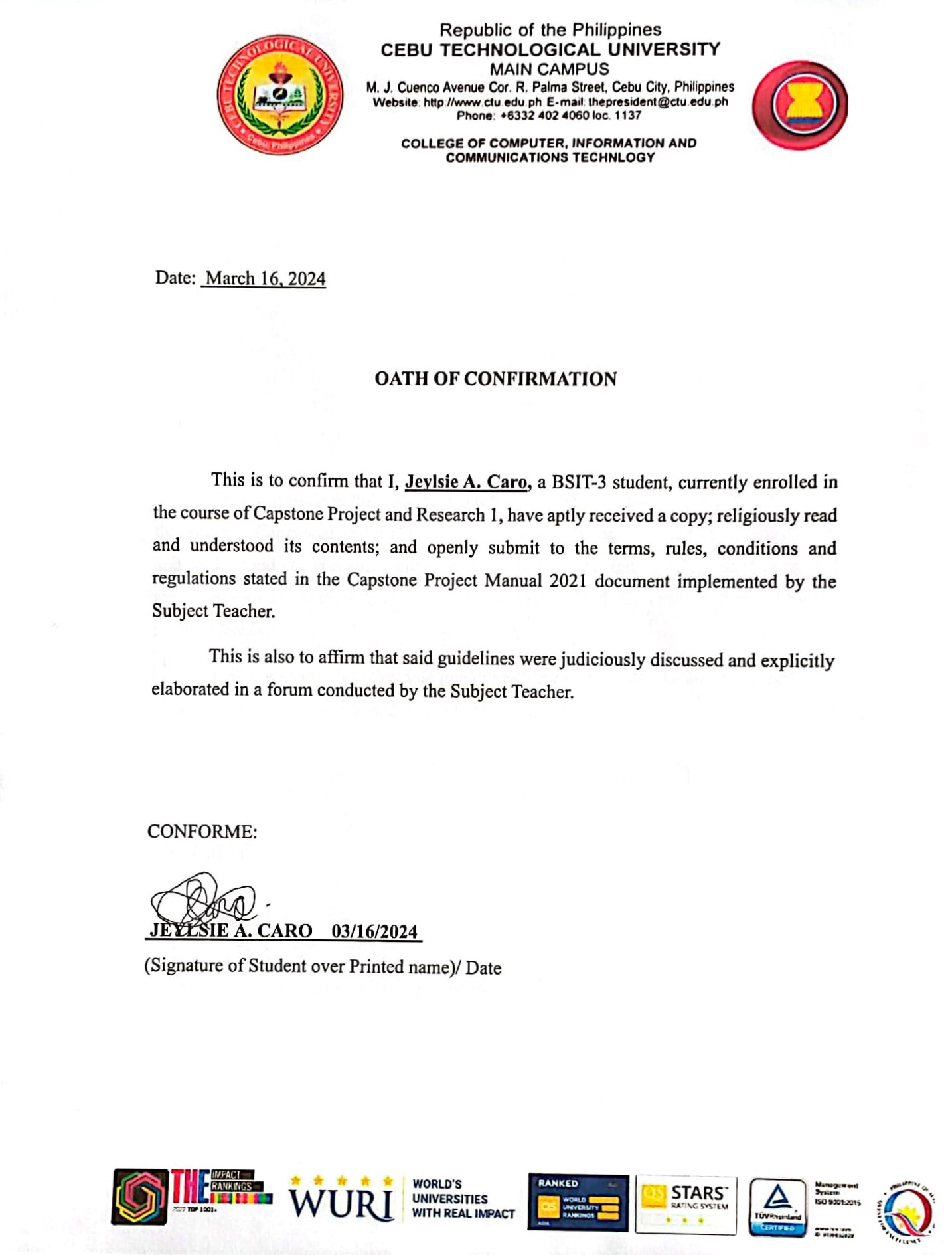



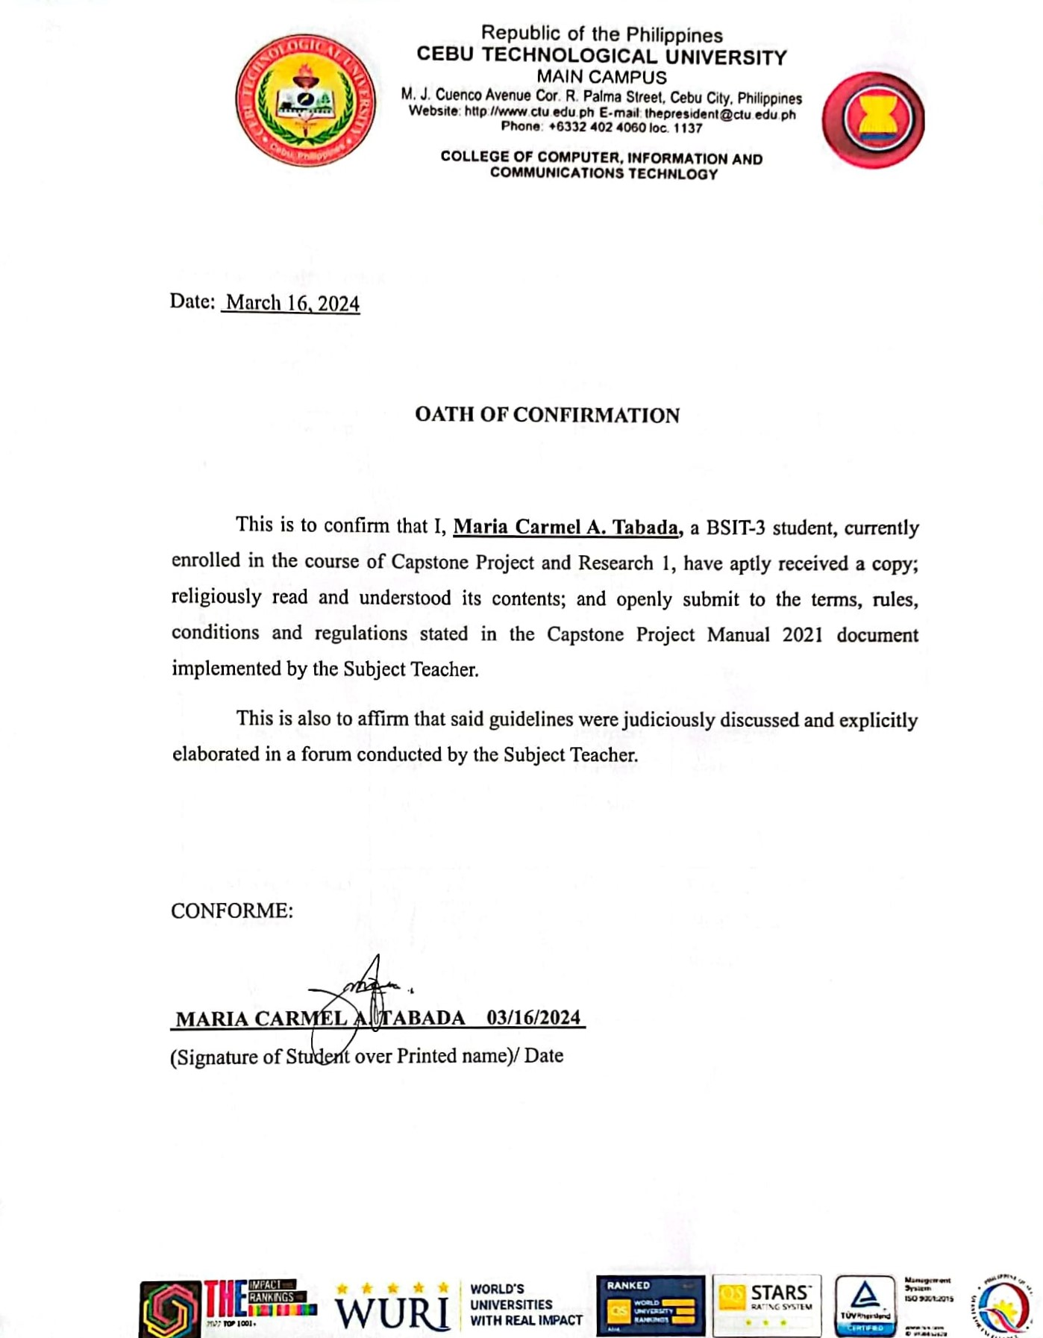

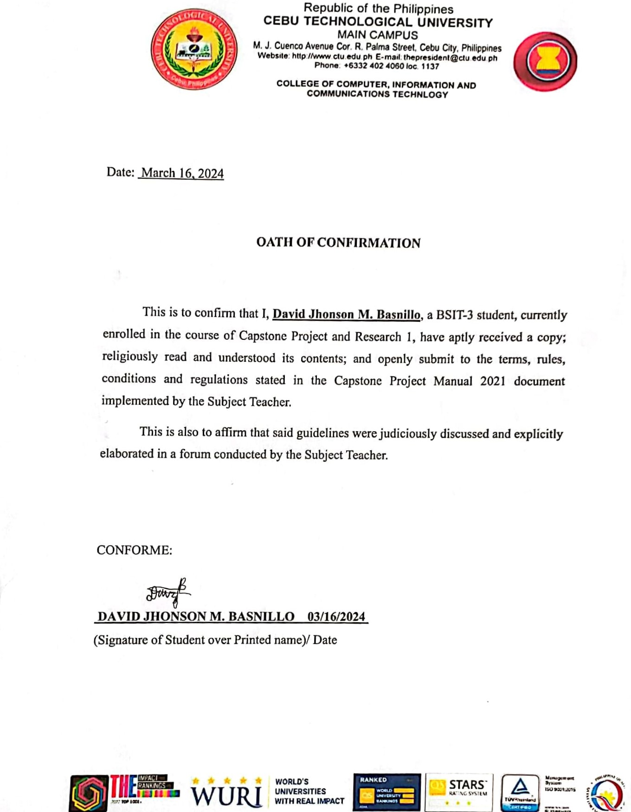

### Appendix B. Capstone Project Team Composition Form

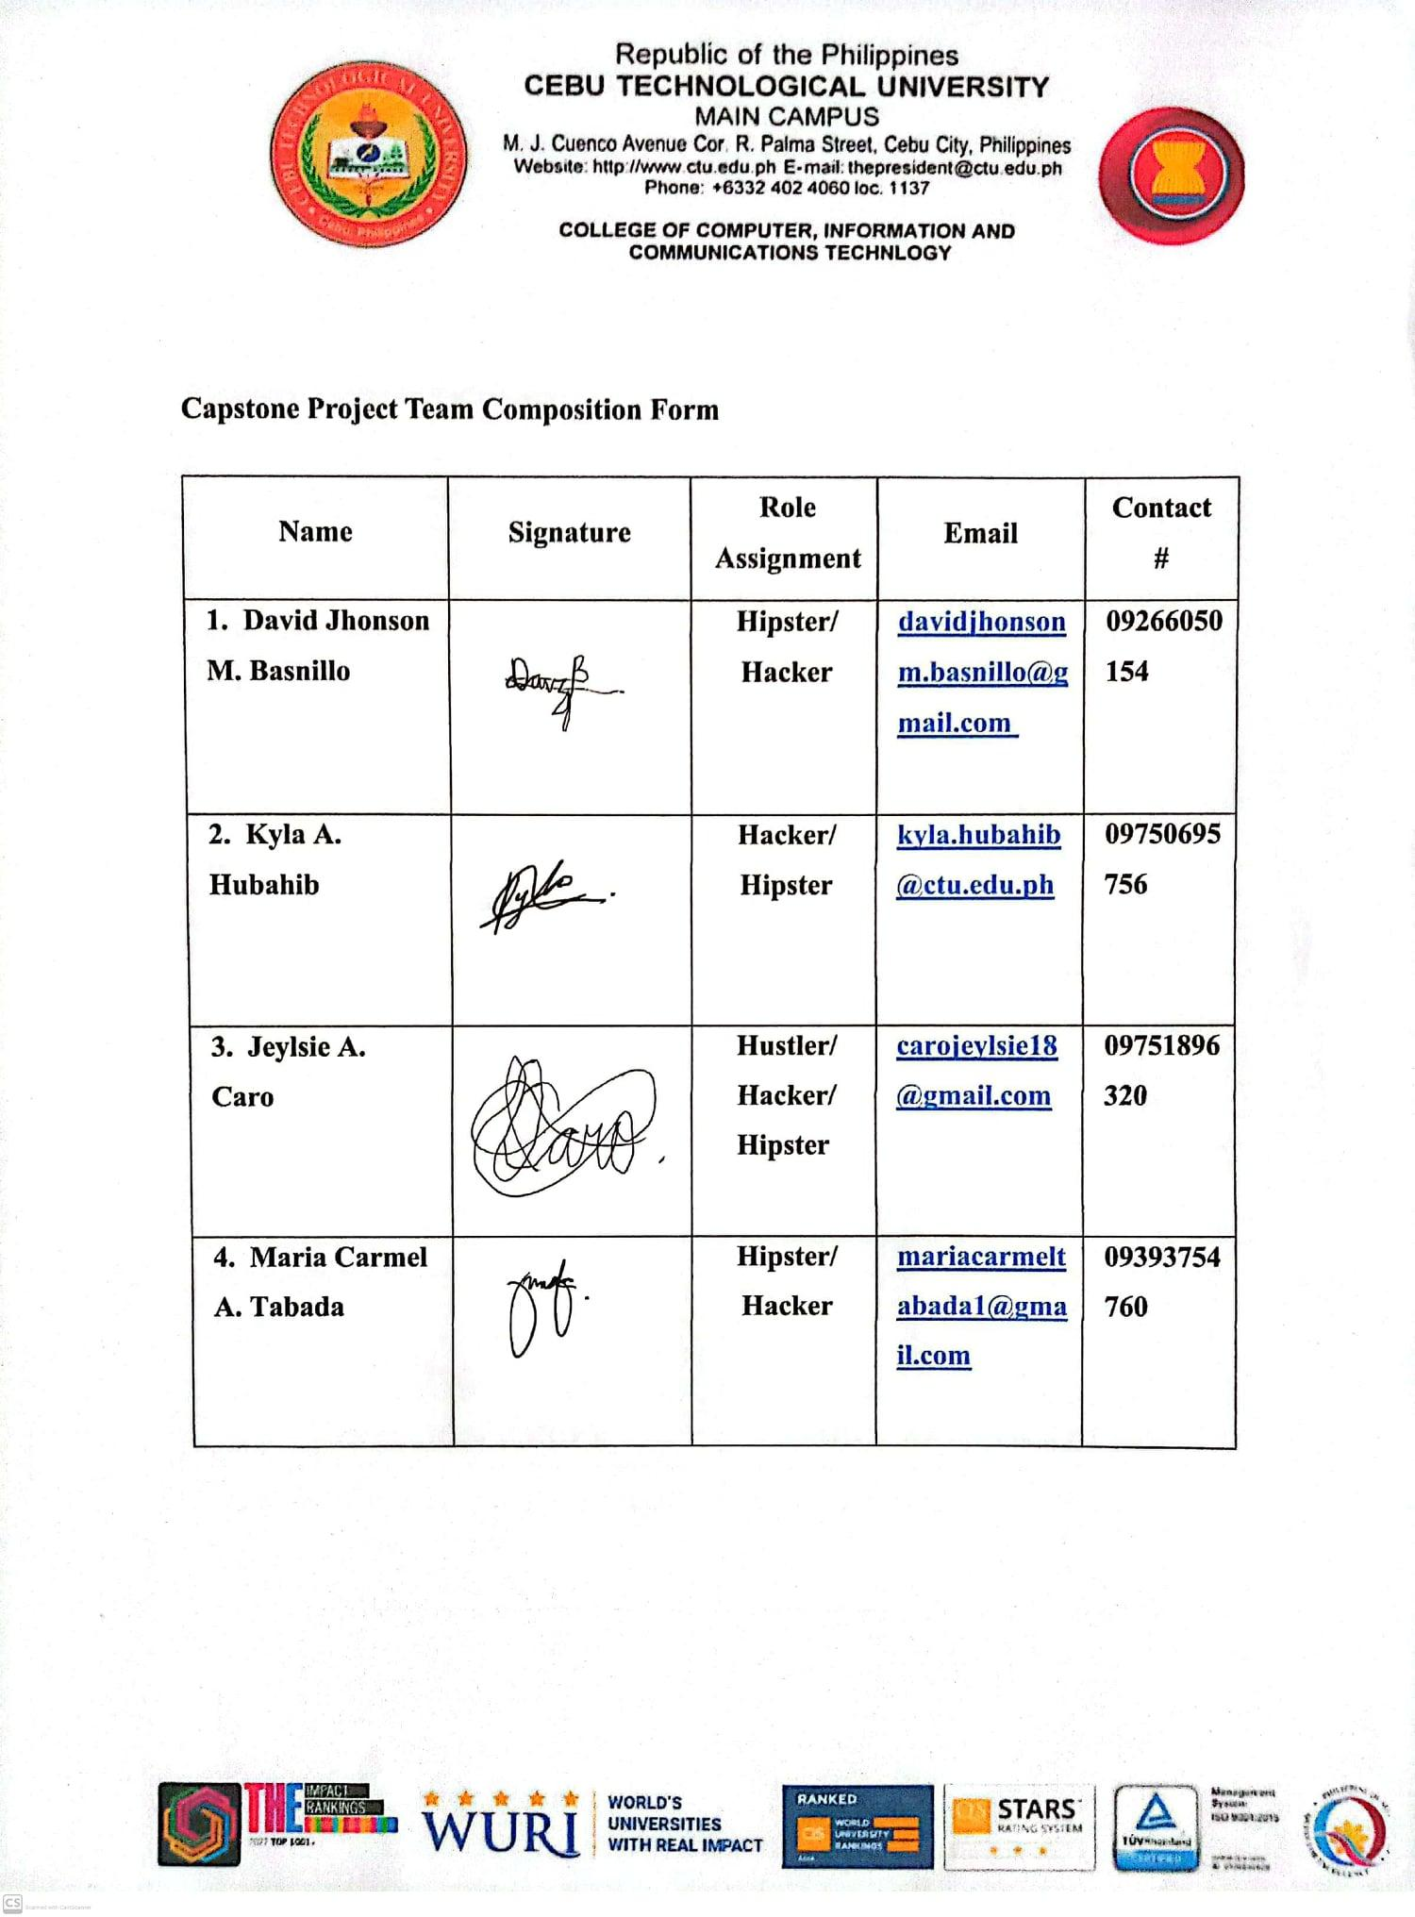

## Appendix C. Acceptance of Capstone Adviser



## Appendix D. Research Working Title Form

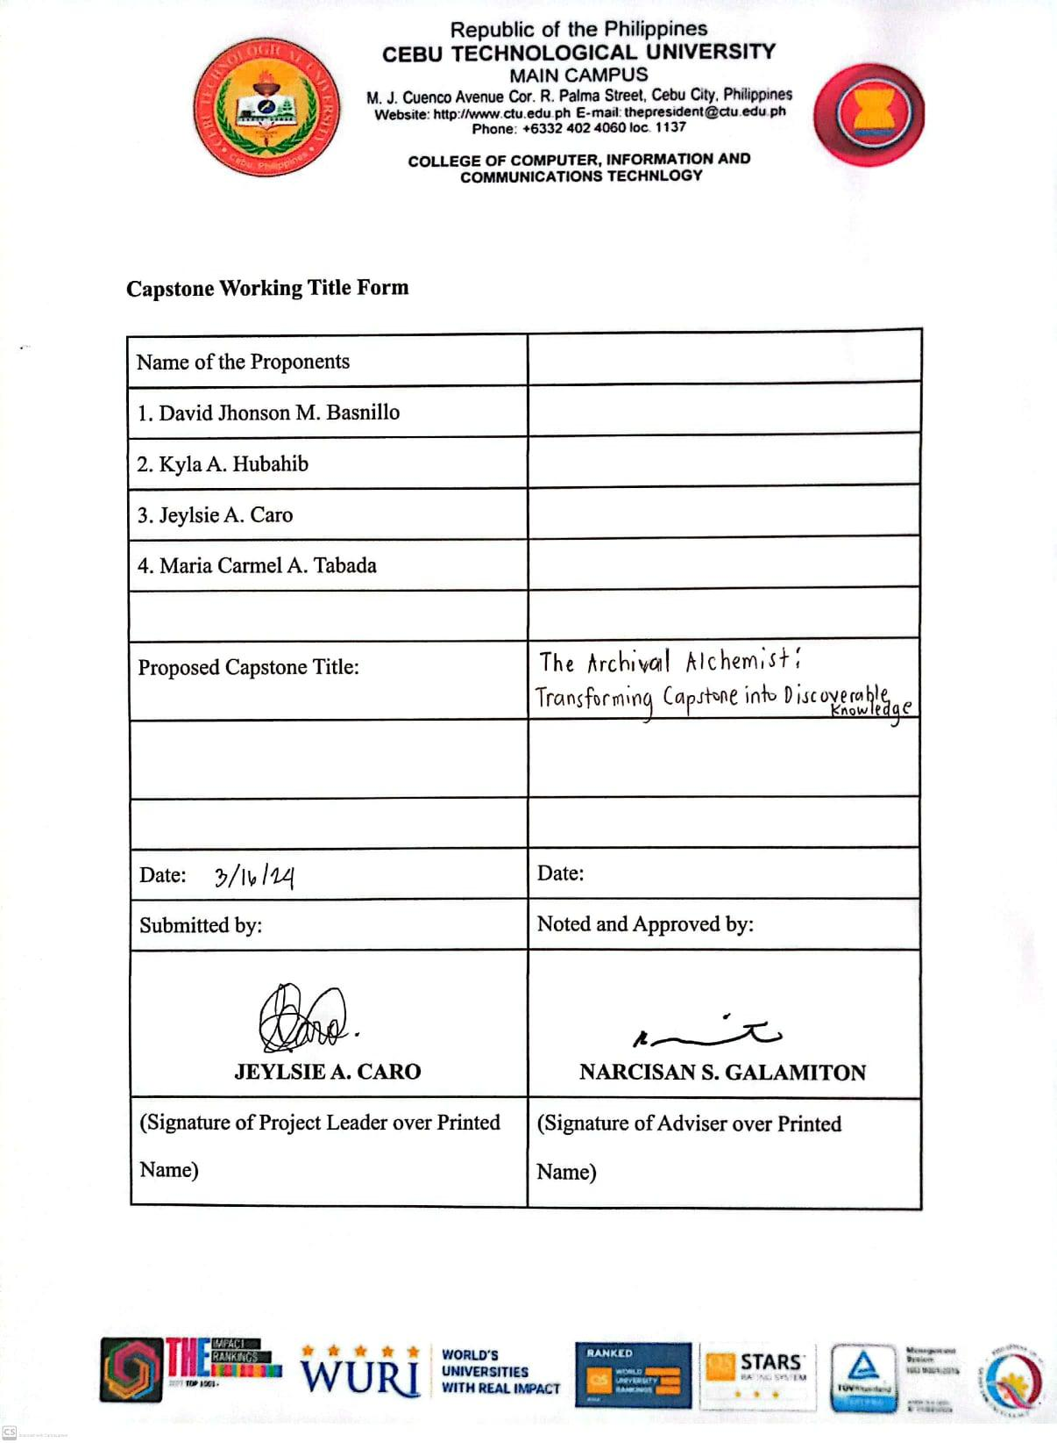

**Appendix E.** Capstone I Consultation Logs Form

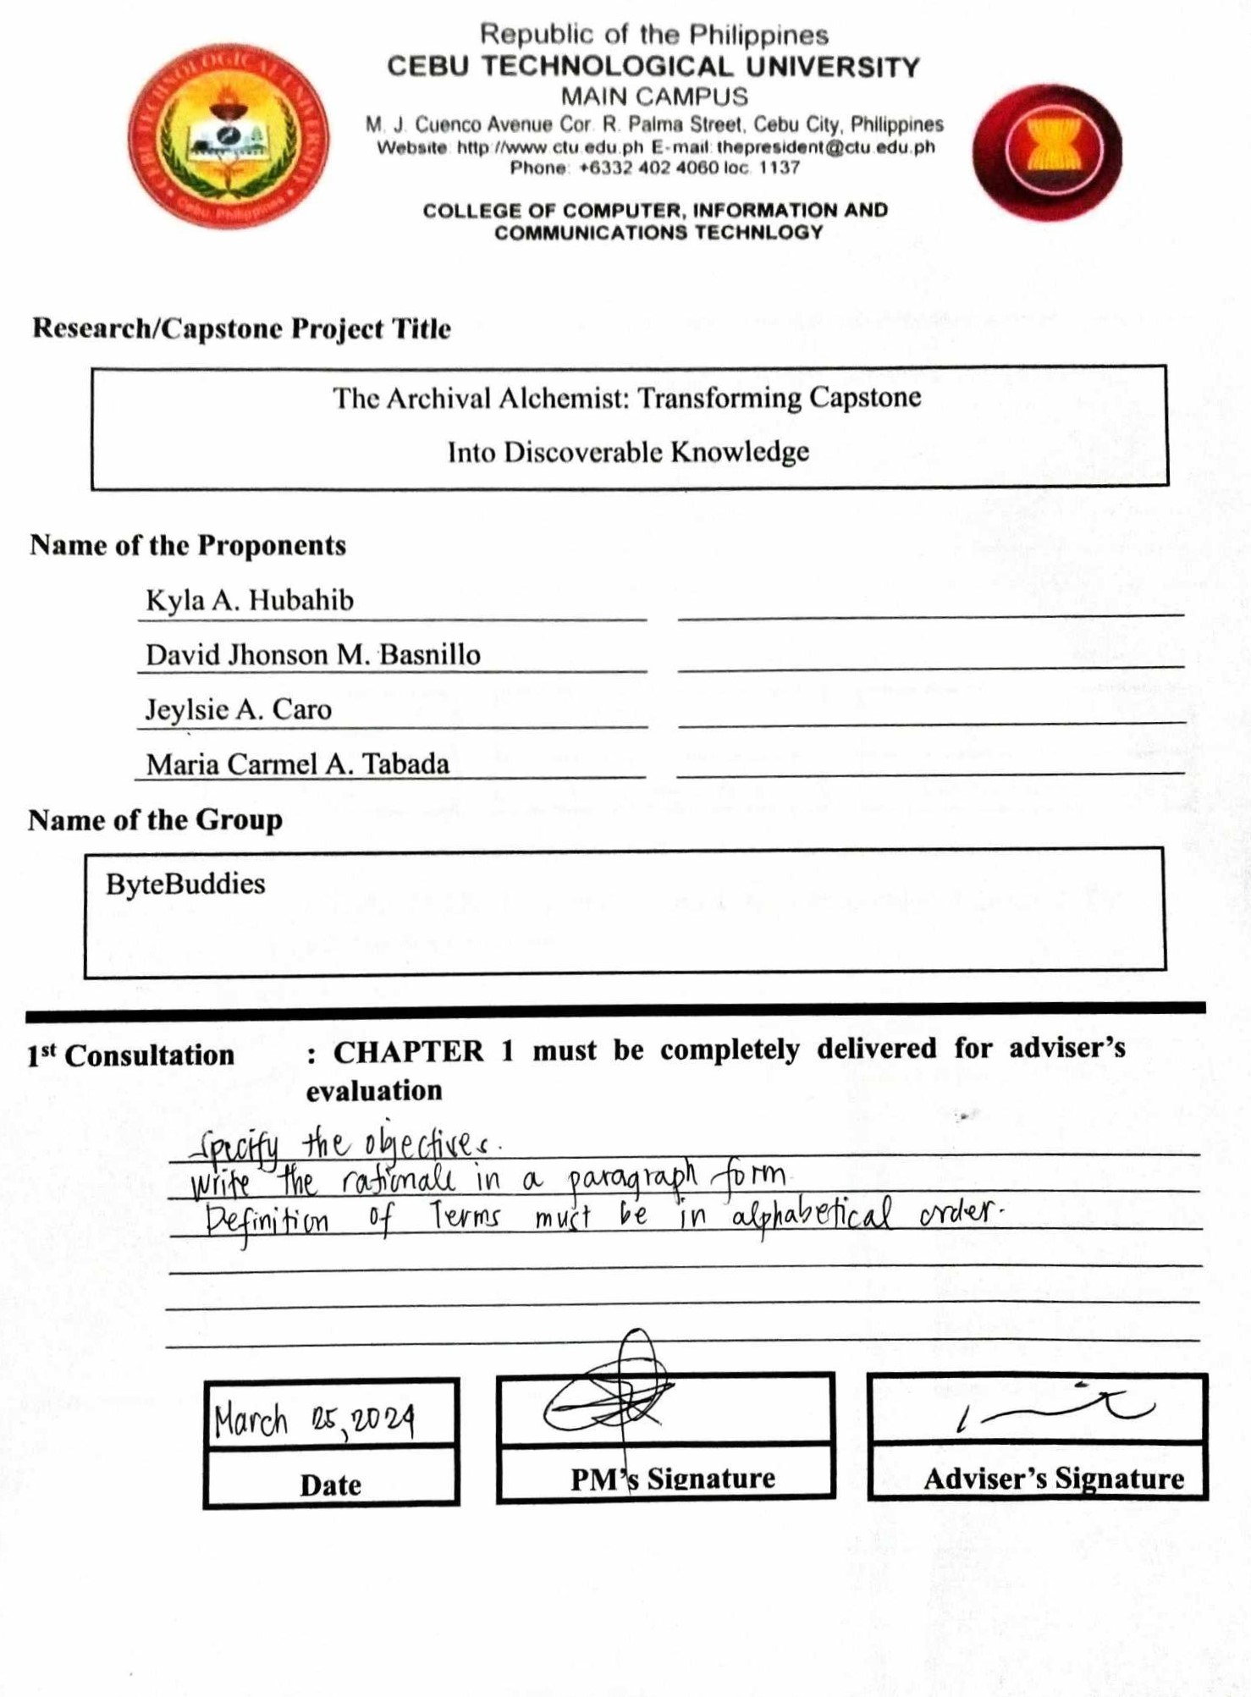

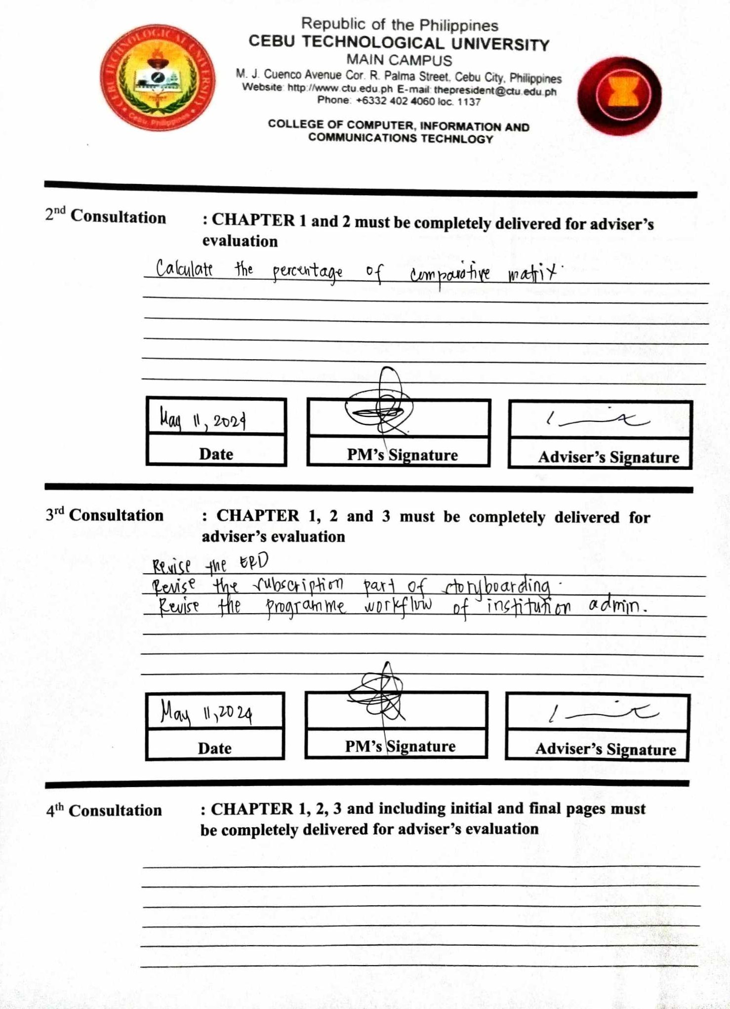

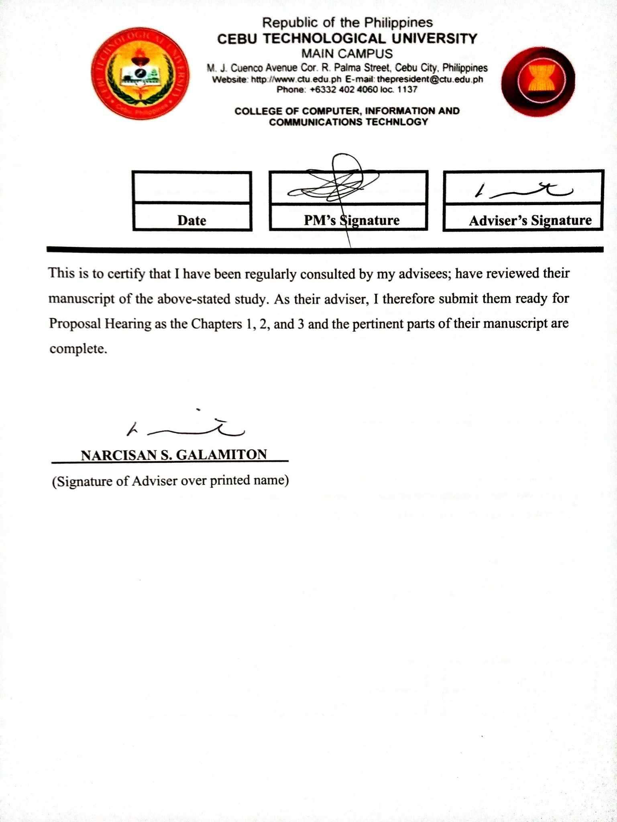

**Appendix F.** Capstone Project & Research (Proposal Sheet)

